LABORATORY RECORD
Course: Full Stack Web Development
Course Code: 23CM4121
Experiment No.: 3
Student Name: B Pranathi
Roll No.: A24126552071
Date: 30-08-2026

TITLE
JavaScript ES6 Array Methods and Object-Oriented Programming – Library Management System

AIM
To develop JavaScript programs for array manipulation (calculating total and average marks, adding elements) and implement an Object-Oriented Library Management System using ES6 classes with methods for adding, displaying, totaling, and removing books.

OBJECTIVE
The objectives of this experiment are:
- To write modular JavaScript functions for array data processing.
- To implement total and average calculation algorithms using loops.
- To manipulate arrays dynamically using push() and pop() methods.
- To define ES6 classes with constructors and instance methods.
- To manage collections of object literals inside class instances.

THEORY
JavaScript provides robust array operations and ES6 Classes for Object-Oriented Programming.
Functions encapsulate reusable logic (e.g. iterating over marks to compute totals).
Classes encapsulate state (this.books array) and behaviors (addBook, displayBooks, totalPrice, removeBook), enabling clean, modular software architecture.
Application Flow:
Initialize Array/Class -> Execute Processing Functions -> Manage Book Objects -> Print Output to Console

ALGORITHM / PROCEDURE
- Create function.js and define an array of student marks [85, 90, 78, 88, 95].
- Implement displayMarks(), totalMarks(), averageMarks(), and addMark().
- Calculate and log initial total (436) and average (87.2).
- Add a new mark (92) and log updated total (528).
- Create object.js and define ES6 class Library with constructor() initializing an empty books array.
- Implement addBook(name, price), displayBooks(), totalPrice(), and removeBook().
- Instantiate Library, add books (Python, Java, HTML, JS), display catalog, calculate total price (■1800), remove a book, and print updated total (■1400).
- Execute scripts using Node.js/browser console and verify output.

PROGRAM

function.js
// Array let marks = [85, 90, 78, 88, 95];
// Function to display marks function displayMarks(arr) { console.log("Student Marks:", arr); }
// Function to calculate total function totalMarks(arr) { let total = 0;
for (let i = 0; i < arr.length; i++) { total += arr[i]; }
return total; }
// Function to calculate average function averageMarks(arr) { return totalMarks(arr) / arr.length; }
// Function to add a new mark function addMark(arr, mark) { arr.push(mark); return arr; }
displayMarks(marks);
console.log("Total Marks:", totalMarks(marks));
console.log("Average Marks:", averageMarks(marks));
console.log("After Adding New Mark:");
addMark(marks, 92);
displayMarks(marks);
console.log("New Total:", totalMarks(marks));

object.js
console.log("===== Library Management System =====");
class Library {
constructor() { this.books = []; }
// Add Book addBook(name, price) { this.books.push({ title: name, cost: price });
console.log(name + " book added successfully."); }
// Display Books displayBooks() {
console.log("\nBooks in Library:");
for (let i = 0; i < this.books.length; i++) {
console.log( (i + 1) + ". " + this.books[i].title + " - ■" + this.books[i].cost );
}
}
// Calculate Total Price totalPrice() {
let total = 0;
for (let i = 0; i < this.books.length; i++) {
total += this.books[i].cost; }
return total; }
// Remove Last Book removeBook() {
let removedBook = this.books.pop();
console.log("\nRemoved Book: " + removedBook.title); } }
const lib = new Library();
lib.addBook("Python", 500); lib.addBook("Java", 600); lib.addBook("HTML", 300); lib.addBook("JavaScript", 400);
lib.displayBooks();
console.log("\nTotal Price: ■" + lib.totalPrice()); lib.removeBook();
console.log("\nAfter Removing One Book:");
lib.displayBooks();
console.log("\nNew Total Price: ■" + lib.totalPrice());

CODE EXPLANATION
Code / Syntax | Explanation
function totalMarks(arr) | Iterates through array elements and computes cumulative sum.
averageMarks(arr) | Divides total marks by array length to compute arithmetic mean.
arr.push(mark) | Appends a new mark to the end of the array.
class Library { constructor() { this.books = [];  } } | ES6 class encapsulating the library state with an internal books array.
addBook(name, price) | Pushes an object literal { title, cost } into the books array.
this.books.pop() | Removes and returns the last book from the books collection.
totalPrice() | Iterates through all book objects and calculates total inventory cost.

TEST CASES AND EXECUTION DATA
The experiment was executed with the following test cases to verify functionality:
Test Case | Input / Action | Expected Result | Actual Result | Status
TC-01 | Marks Display | Call displayMarks(marks) | Displays initial array [85, 90, 78,  88, 95] | Pass
TC-02 | Total & Average | Call totalMarks & averageMarks | Total: 436, Average: 87.2 calculated accurately | Pass
TC-03 | Add Mark | Call addMark(marks, 92) | Mark appended; new total: 528 logged | Pass
TC-04 | Library Add Books | Add 4 books to Library | Books added and catalog displayed with prices | Pass
TC-05 | Total Price & Remove | Calculate total and remove book | Initial total ■1800, after removal new total ■1400 | Pass

OUTPUT

Output 1: JavaScript Array Functions Output (Total & Average Marks)
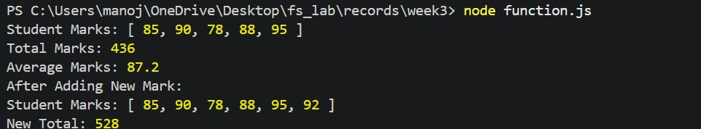

Output 2: ES6 Library Management Class Output (Catalog & Total Price)
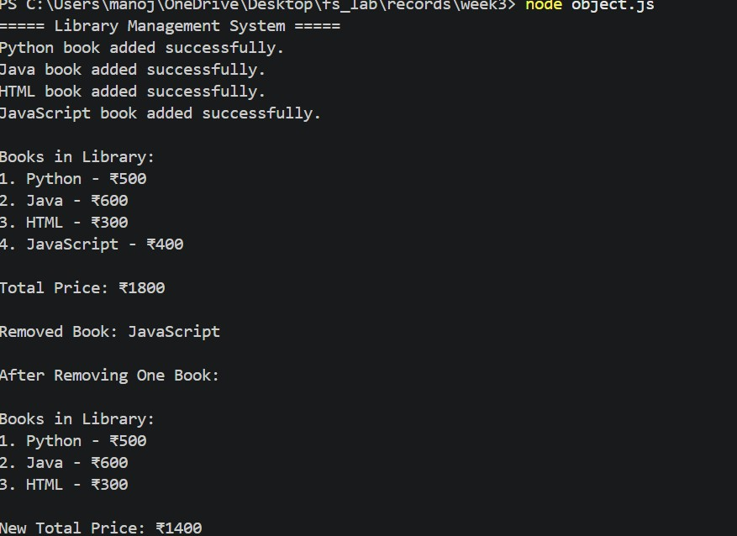
10
. RESULT
Thus, JavaScript array manipulation functions and the ES6 Object-Oriented Library Management System were successfully developed, executed, and verified with accurate outputs.

