DineSync
Smart Restaurant Management System
with IoT-Based Kitchen Monitoring
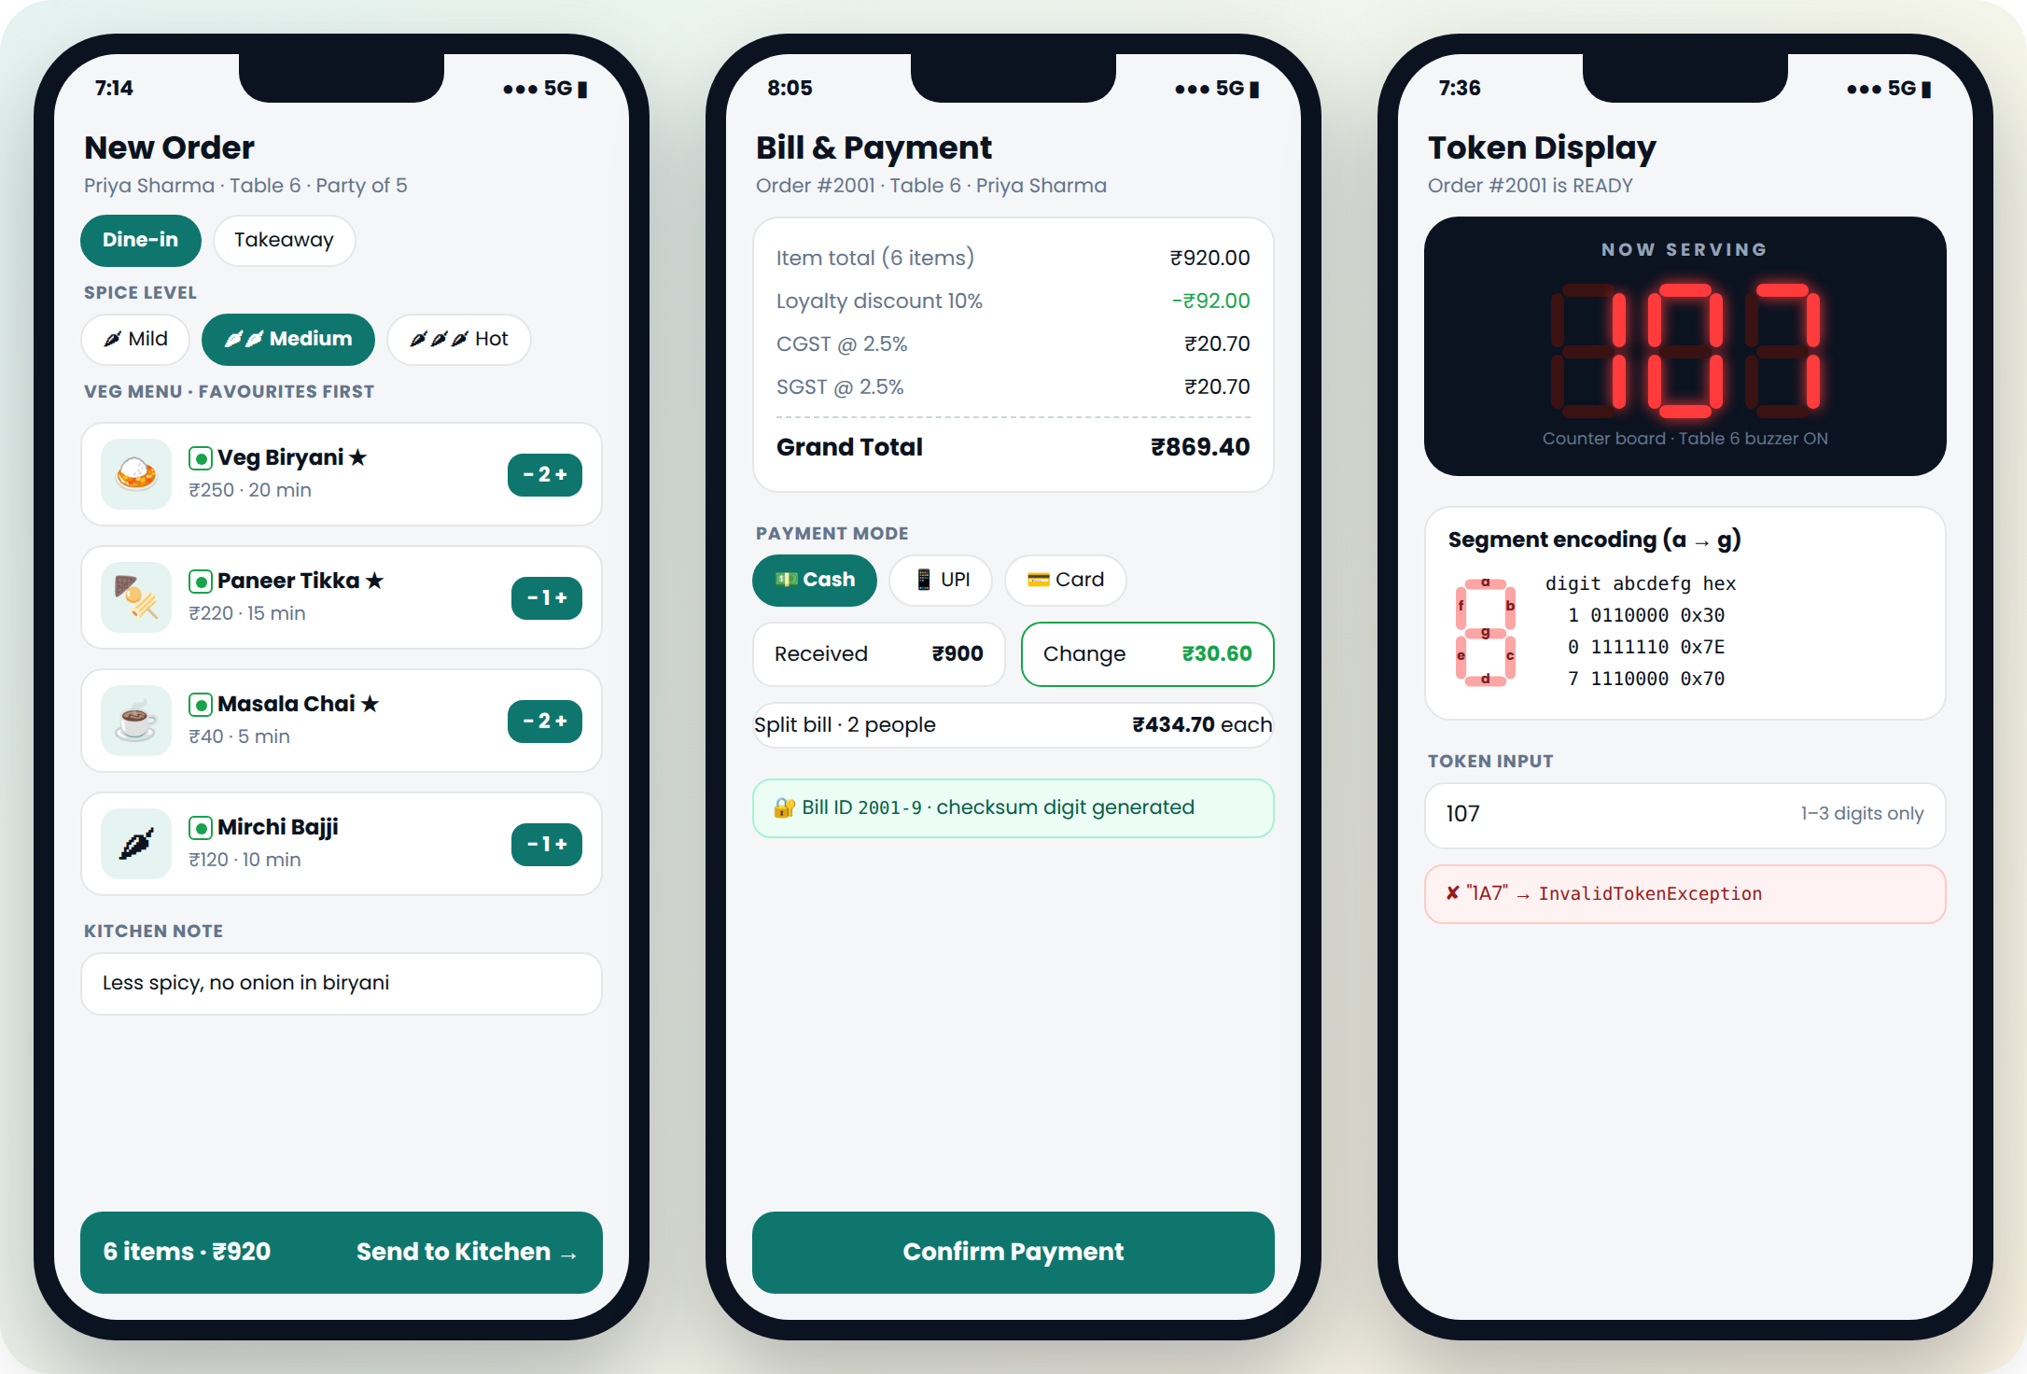
Project Documentation
Domain  Money & Commerce | Technology  Core Java | Platform  Console Application

Contents
1 Project Overview
2 System Architecture
3 Core Restaurant Modules (M01 to M08)
4 Smart Monitoring Modules (M09 to M13)
5 End-to-End Scenario
6 Exception Summary
7 Integration Testing
8 Future Scope and Conclusion

Module Index
No. | Module | Type
M01 | Login & Access Control | Core Restaurant Module
M02 | Menu Management | Core Restaurant Module
M03 | Customer Profile & Favourites | Core Restaurant Module
M04 | Order Taking | Core Restaurant Module
M05 | Kitchen Queue | Core Restaurant Module
M06 | Billing & Payment | Core Restaurant Module
M07 | Feedback & Ratings | Core Restaurant Module
M08 | Reports & Analytics | Core Restaurant Module
M09 | Table Occupancy Register | Smart Monitoring Module
M10 | Kitchen Sensor Monitoring | Smart Monitoring Module
M11 | Seven-Segment Token Display | Smart Monitoring Module
M12 | Bill Checksum Security | Smart Monitoring Module
M13 | Kitchen Energy Meter | Smart Monitoring Module

1. Project Overview

1.1 Introduction
DineSync is a restaurant management system that connects the waiter, kitchen, cashier and management into a single order flow. An order is entered once and then moves automatically through preparation, billing and feedback, while a set of monitoring modules keeps track of table occupancy, kitchen safety and energy use.

1.2 Problem Statement
Restaurants that depend on paper order slips and manual calculation commonly face the following issues:
- Delays in communication between the service floor and the kitchen during busy hours.
- Lost, misread or duplicated orders.
- Errors in discounts, tax and bill totals.
- No record of regular customers or their preferences.
- Kitchen hazards such as overheating or gas leaks that are not detected early.
- No clear view of daily sales, popular dishes or running costs.

1.3 Proposed Solution
DineSync replaces the manual process with 13 connected modules. Staff log in by role, customers are identified by mobile number, tables are allocated by party size, orders are sent straight to a kitchen queue, bills are calculated with discount and GST automatically, and every bill carries a check digit for verification. Monitoring modules simulate kitchen sensors, display ready tokens on a seven-segment style display and calculate daily energy consumption.

1.4 Objectives
- Provide a single, connected order flow from table to kitchen to bill.
- Calculate bills accurately, including loyalty discount, CGST and SGST.
- Remember customer preferences and show favourite dishes first.
- Validate every input and handle every error without stopping the program.
- Monitor kitchen conditions and raise alerts with automatic actions.
- Give management daily reports on revenue, dishes, ratings, alerts and energy cost.

1.5 Key Features
Feature | Description
Role-based access | Separate menus for Waiter, Chef, Cashier and Admin, protected by Staff ID and PIN.
Dynamic menu | Dishes can be added, repriced or marked unavailable while the system is running.
Customer favourites | Dish counts per customer; top three dishes are shown first. Veg-only preference supported.
Loyalty reward | Every 7th visit receives a 10% discount automatically.
Smart table allocation | Suggests the smallest free table that fits the party; status stored in an 8-bit register.
Kitchen queue | Urgent orders first, estimated ready time, chef assignment and status tracking.
Automatic billing | Discount, CGST 2.5% and SGST 2.5%, cash/UPI/card payment and split bills.
Bill verification | Each bill ID carries a check digit that detects wrong or swapped digits.
Feedback | Overall rating, per-dish rating and comments with running averages.
Kitchen monitoring | Temperature, gas, smoke and humidity readings compared with configurable limits.
Token display | Ready orders shown as seven-segment digits with their segment codes.
Energy meter | Appliance power with power factor, daily kWh and slab-tariff cost.
Reports | Daily revenue, orders, top dishes, rating, alert count and energy cost.

2. System Architecture

2.1 Module Structure
The system is organised into two groups of modules:
Core Restaurant Modules | M01 Login and Access Control, M02 Menu Management, M03 Customer Profile and Favourites, M04 Order Taking, M05 Kitchen Queue, M06 Billing and Payment, M07 Feedback and Ratings, M08 Reports and Analytics
Smart Monitoring Modules | M09 Table Occupancy Register, M10 Kitchen Sensor Monitoring, M11 Seven-Segment Token Display, M12 Bill Checksum Security, M13 Kitchen Energy Meter

2.2 Module Flow
A typical customer visit passes through the modules in this order:
M01 Login → M03 Customer → M09 Table → M04 Order → M05 Kitchen → M11 Token → M06 Bill → M07 Feedback → M08 Report
Supporting modules: M02 supplies the menu used by M04. M12 generates and verifies bill IDs for M06 and M07. M10 and M13 run alongside the order flow and send their results to M08.

2.3 Layered Design
Layer | Package | Classes
Presentation | ui | Main, ConsoleUI, InputHelper, Colors
Business logic | service | AuthService, MenuService, CustomerService, OrderService, Kitchen, BillingService, FeedbackService, ReportService
Data model | model | Staff, MenuItem, VegItem, NonVegItem, Beverage, Customer, Order, OrderItem, Bill, Billable, Feedback, Appliance
Monitoring | monitor | TableRegister, Sensor, TemperatureSensor, GasLeakSensor, SmokeSensor, HumiditySensor, KitchenMonitor, SevenSegment, EnergyMeter
Error handling | exception | Custom exception classes for each module

2.4 Package Structure
DineSync/src/com/dinesync/
├── Main.java
├── ui/ ConsoleUI, InputHelper, Colors
├── model/ Staff, MenuItem, VegItem, NonVegItem, Beverage, Customer,
│ Order, OrderItem, Bill, Billable, Feedback, Appliance
├── service/ AuthService, MenuService, CustomerService, OrderService,
│ Kitchen, BillingService, FeedbackService, ReportService
├── monitor/ TableRegister, Sensor (+4 sensors), KitchenMonitor,
│ SevenSegment, EnergyMeter
└── exception/ custom exception classes

2.5 Technology
Language | Java (JDK 17 or later)
Interface | Console with formatted text, box-drawn menus and ANSI colours
Concepts used | Classes and objects, encapsulation, inheritance, abstract classes, interfaces, polymorphism, arrays, strings, bitwise operators, custom exceptions
Data storage | In-memory arrays
Tools | IntelliJ IDEA or VS Code, Git and GitHub

2.6 Order Life Cycle
Status | Set by | Meaning
PLACED | Waiter (M04) | Order created and sent to the kitchen
PREPARING | Chef (M05) | Cooking has started
READY | Chef (M05) | Food is ready; token shown on display (M11)
SERVED | Waiter (M05) | Food delivered to the table
BILLED | Cashier (M06) | Payment completed; table released (M09)

3. Core Restaurant Modules
These eight modules handle the day-to-day work of the restaurant, from staff login to the daily report.
No. | Module | Used by | Main classes
M01 | Login & Access Control | All staff | Staff, AuthService
M02 | Menu Management | Admin | MenuItem «abstract», VegItem, NonVegItem, Beverage, MenuService
M03 | Customer Profile & Favourites | Waiter | Customer, CustomerService
M04 | Order Taking | Waiter | Order, OrderItem, OrderService
M05 | Kitchen Queue | Chef | Kitchen, Order
M06 | Billing & Payment | Cashier | Bill, BillingService, Billable «interface»
M07 | Feedback & Ratings | Customer (via waiter) | Feedback, FeedbackService
M08 | Reports & Analytics | Admin | ReportService

Module 01: Login & Access Control
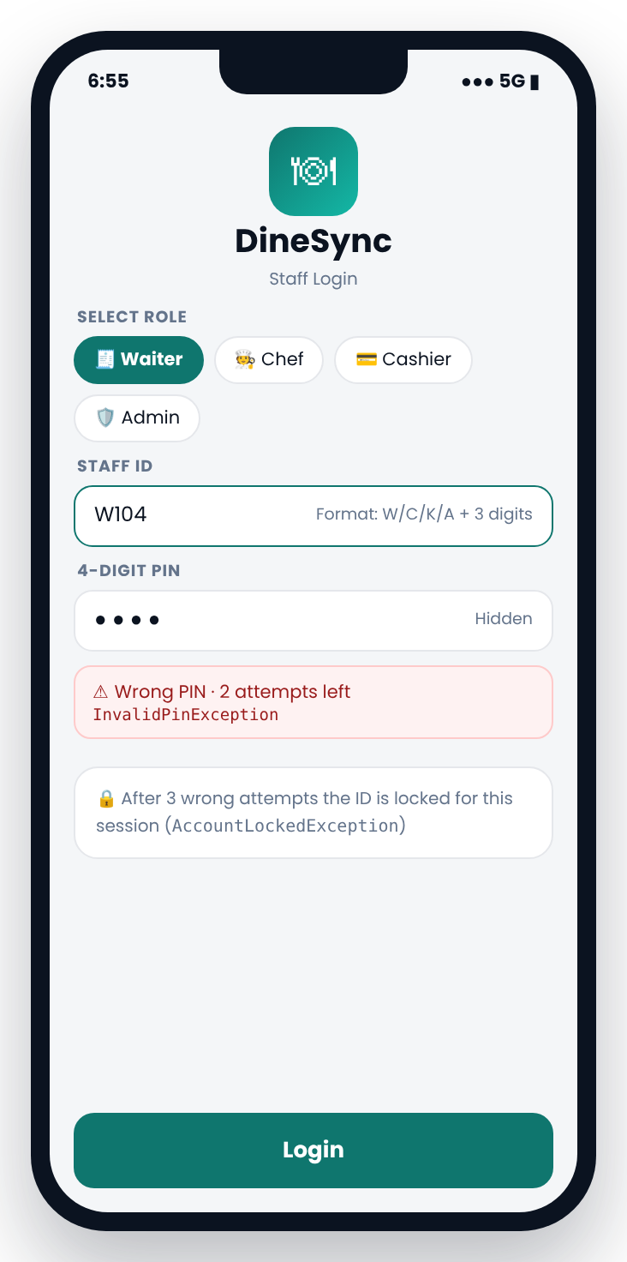 | Purpose  Verifies each staff member and opens only the menu for their role, so a waiter cannot bill and a chef cannot change prices.  Output  Welcome message with staff name and role menu, or a lock message after 3 failures.  Sample Run
  Module type | Core Restaurant Module
  Used by | All staff
  Classes | Staff, AuthService
  Connected to | Start → M3 / M5 / M6 / M2
  Select role [1-4] ▸ 1
  Staff ID ▸ C104
  ✘ InvalidStaffIdException: Waiter IDs start with 'W'
  Staff ID ▸ W104
  PIN ▸ ****
  ✘ InvalidPinException: Wrong PIN (2 attempts left)
  PIN ▸ ****
  ✔ Welcome, Waiter Kiran (W104)

Inputs
Field | Type | Validation rule | Sample value
Role | int | 1 Waiter · 2 Chef · 3 Cashier · 4 Admin | 1
Staff ID | String | Role letter (W/C/K/A) + 3 digits; letter must match role | W104
PIN | int | Exactly 4 digits | 4821
Attempts | int (system) | Maximum 3 per session | 3

Processing
- Read role with readInt(); outside 1–4 throws InvalidMenuChoiceException.
- Check Staff ID length is 4, first letter matches role, rest are digits (charAt(), Character.isDigit()).
- Search Staff[] array for the ID and compare PIN.
- Wrong PIN reduces attempts; at 0 throw AccountLockedException.
- Success opens the role menu.

Exceptions
Exception | Raised when
InvalidStaffIdException | ID format wrong or letter does not match role
InvalidPinException | PIN does not match
AccountLockedException | 3 wrong attempts

Test Cases
# | Input | Expected result
T1 | W104 + correct PIN | Waiter menu opens
T2 | C104 while role = Waiter | InvalidStaffIdException
T3 | Wrong PIN 3 times | AccountLockedException, login blocked

Module 02: Menu Management
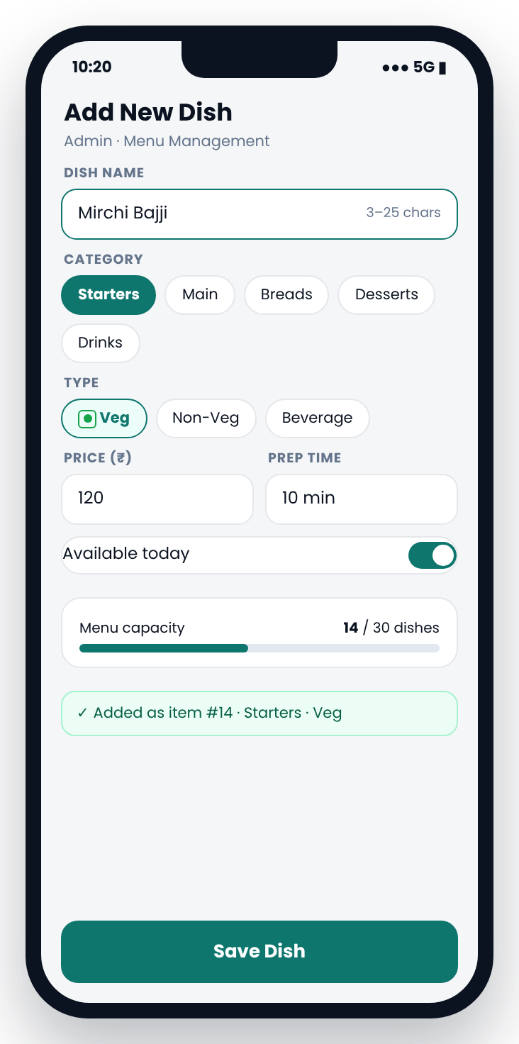 | Purpose  Lets the admin add dishes, change prices and mark items unavailable at run time, instead of hard-coding the menu.  Output  Dish saved with the next item number. Unavailable dishes are hidden from the order menu in M4.  Sample Run
  Module type | Core Restaurant Module
  Used by | Admin
  Classes | MenuItem «abstract», VegItem, NonVegItem, Beverage, MenuService
  Connected to | Feeds M4 (order menu)
  Dish name ▸ paneer tikka
  ✘ DuplicateDishException: "Paneer Tikka" exists
  Dish name ▸ Mirchi Bajji
  Category ▸ 1 Type ▸ 1 Price ▸ 5
  ✘ InvalidPriceException: price must be ₹10–₹2000
  Price ▸ 120 Prep ▸ 10 Available ▸ y
  ✔ Added #14 Mirchi Bajji · Starters · Veg · ₹120

Inputs
Field | Type | Validation rule | Sample value
Dish name | String | 3–25 chars, must not already exist | Mirchi Bajji
Category | int | 1 Starters … 5 Beverages | 1
Type | int | 1 Veg · 2 Non-Veg · 3 Beverage | 1
Price | double | ₹10 – ₹2000 | 120
Prep time | int | 1 – 60 minutes | 10
Available | char | y / n | y

Processing
- Check space in MenuItem[] menu (capacity 30).
- Compare new name with existing names using equalsIgnoreCase().
- Validate price and prep-time ranges.
- Create VegItem, NonVegItem or Beverage by type and store it in the array (polymorphism).

Exceptions
Exception | Raised when
MenuFullException | 30 dishes already stored
DuplicateDishException | Name already on the menu
InvalidPriceException | Price outside ₹10 – ₹2000

Test Cases
# | Input | Expected result
T1 | New dish "Mirchi Bajji", ₹120 | Stored as item #14
T2 | "paneer tikka" | DuplicateDishException
T3 | Price 5 | InvalidPriceException

Module 03: Customer Profile & Favourites
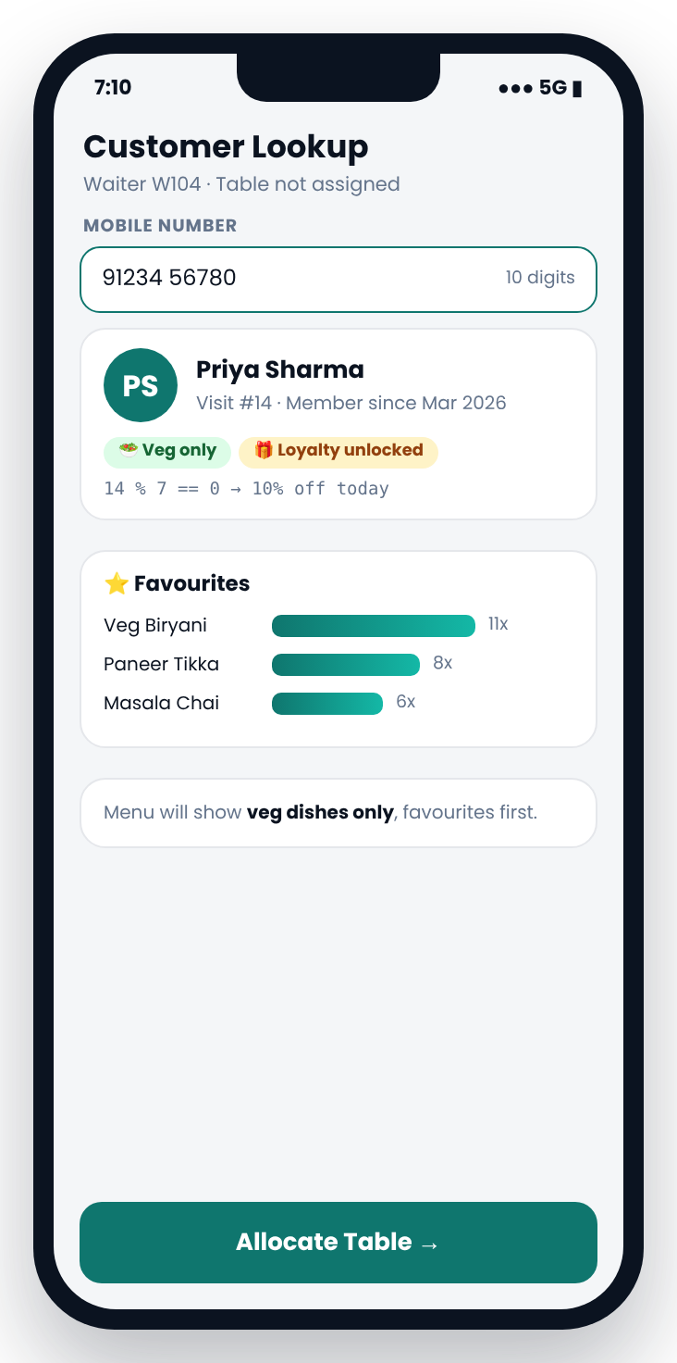 | Purpose  Identifies the customer by mobile number, remembers what they like, applies their diet preference and unlocks loyalty rewards.  Output  Welcome message, visit number, loyalty status and top 3 favourites with counts.  Sample Run
  Module type | Core Restaurant Module
  Used by | Waiter
  Classes | Customer, CustomerService
  Connected to | M1 → M3 → M9
  Mobile ▸ 5123456780
  ✘ InvalidPhoneNumberException: must start 6–9
  Mobile ▸ 9123456780
  ★ Welcome back, Priya Sharma! Visit #14
  🎁 Loyalty visit (14 % 7 = 0) → 10% off
  Preference: Veg only
  Favourites: Veg Biryani (11x) · Paneer Tikka (8x)
  Masala Chai (6x)

Inputs
Field | Type | Validation rule | Sample value
Mobile number | String | 10 digits, first digit 6–9 | 9123456780
Name (new only) | String | Letters and spaces, 2–30 chars | Priya Sharma
Diet preference | int | 1 Any · 2 Veg only | 2

Processing
- Validate the number: length 10, all digits, starts with 6–9.
- Linear search Customer[]; create a new profile if not found.
- Increase visit count; loyalty applies when visits % 7 == 0.
- Find top 3 dishes from int[] dishCount.
- Prepare the menu for M4: diet filter applied, favourites first.

Exceptions
Exception | Raised when
InvalidPhoneNumberException | Not 10 digits or starts with 0–5
InvalidNameException | Name has digits or symbols
CustomerLimitException | 100 customers already stored

Test Cases
# | Input | Expected result
T1 | 5123456780 | InvalidPhoneNumberException
T2 | New number | Asks name, profile created, visit #1
T3 | Priya, visit #14 | Loyalty ON, veg-only menu, favourites first

Module 04: Order Taking
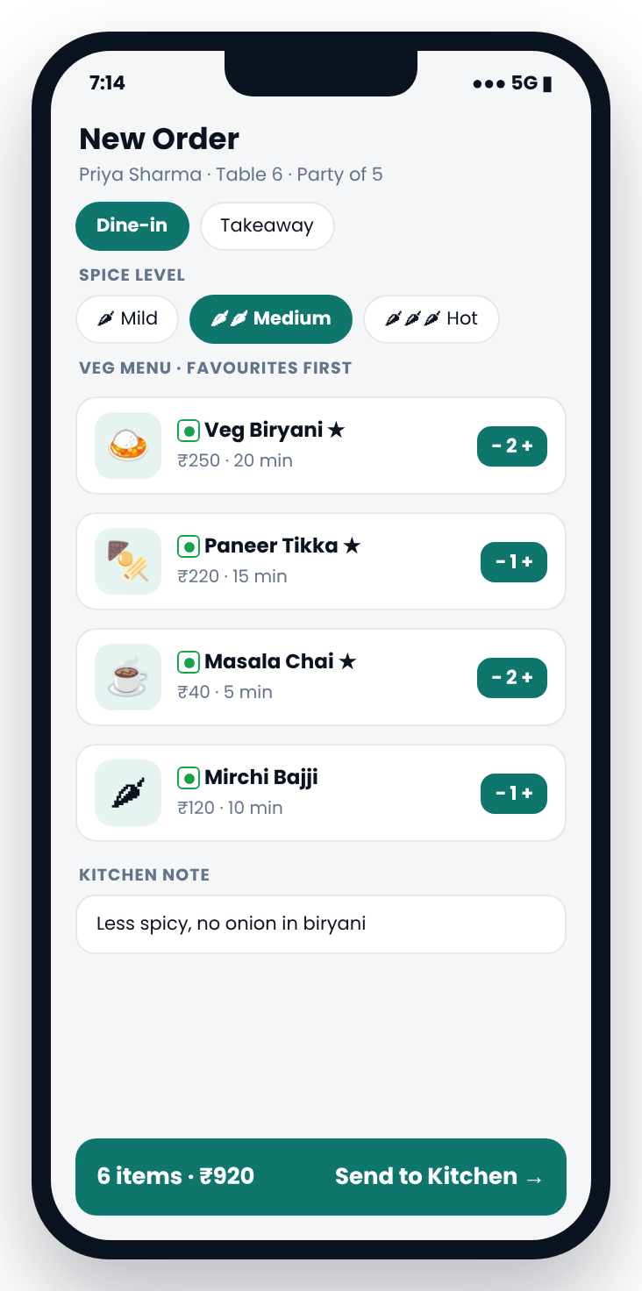 | Purpose  Builds the order for a table from the filtered menu, records kitchen instructions and sends it to the kitchen queue.  Output  Order #2001: 6 items, ₹920, Medium spice, with the note. Sent to the kitchen queue.  Sample Run
  Module type | Core Restaurant Module
  Used by | Waiter
  Classes | Order, OrderItem, OrderService
  Connected to | M9 → M4 → M5
  Dish no. ▸ 3 Qty ▸ 2 ✔ Veg Biryani ×2
  Dish no. ▸ 7
  ✘ ItemUnavailableException: Chicken 65 is
  non-veg (Veg only customer)
  Dish no. ▸ 4 Qty ▸ 15
  ✘ InvalidQuantityException: qty must be 1–10
  Dish no. ▸ 4 Qty ▸ 1 ✔ Paneer Tikka ×1
  … Spice ▸ 2 Note ▸ Less spicy, no onion…
  ✔ Order #2001 → kitchen · 6 items · ₹920.00

Inputs
Field | Type | Validation rule | Sample value
Order type | int | 1 Dine-in · 2 Takeaway | 1
Dish number | int | Valid, available, allowed by diet | 3
Quantity | int | 1 – 10 per dish | 2
Spice level | int | 1 Mild · 2 Medium · 3 Hot | 2
Kitchen note | String | Optional, max 60 chars | Less spicy, no onion in biryani
Finish | int | 0 ends the order | 0

Processing
- Loop: show menu, read dish number and quantity.
- If dish is already in the order, add to its quantity; else create a new OrderItem.
- Block unavailable dishes and non-veg dishes for veg-only customers.
- Stop at 20 items; calculate subtotal (₹920).
- Set order ID #2001, status PLACED; update customer dish counts.

Exceptions
Exception | Raised when
ItemUnavailableException | Dish unavailable or not allowed by diet
InvalidQuantityException | Quantity outside 1–10
OrderLimitExceededException | More than 20 items

Test Cases
# | Input | Expected result
T1 | Veg-only customer picks Chicken 65 | ItemUnavailableException
T2 | Quantity 15 | InvalidQuantityException
T3 | Full valid order | #2001, 6 items, ₹920.00

Module 05: Kitchen Queue
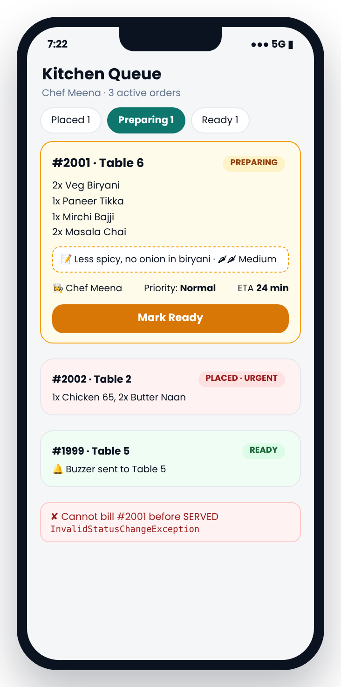 | Purpose  Shows active orders with urgent ones first, estimates ready time, tracks each status change and alerts the table when food is ready.  Output  Updated queue with ETA, assigned chef and status. READY alert with token 107.  Sample Run
  Module type | Core Restaurant Module
  Used by | Chef
  Classes | Kitchen, Order
  Connected to | M4 → M5 → M11 → M6
  ── KITCHEN QUEUE · Chef Meena ──
  #2002 T2 URGENT PLACED Chicken 65…
  #2001 T6 Normal PREPARING ETA 24 min
  📝 Less spicy, no onion in biryani
  Order ID ▸ 2010
  ✘ OrderNotFoundException: no active #2010
  Order ID ▸ 2001 Action ▸ 1
  ✔ #2001 → READY · Token 107 · Table 6 🔔

Inputs
Field | Type | Validation rule | Sample value
Order ID | int | Must exist in the active queue | 2001
Action | int | 1 Next stage · 2 Mark urgent · 3 Assign chef | 1
Chef name | String | Must be a chef in Staff[] | Meena
Priority | int | 1 Normal · 2 Urgent | 1

Processing
- Print active orders: urgent first, then oldest first.
- ETA = longest prep time + 2 min × orders ahead → 20 + 2×2 = 24 min.
- Move status one step: PLACED → PREPARING → READY → SERVED.
- On READY: show token on the 7-segment display (M11) and ring the table buzzer.

Exceptions
Exception | Raised when
OrderNotFoundException | ID not in the active queue
InvalidStatusChangeException | Skipping or reversing a stage
InvalidChefException | Name is not a chef

Test Cases
# | Input | Expected result
T1 | #2001 with 2 orders ahead | ETA 24 min
T2 | Order ID 2010 | OrderNotFoundException
T3 | PLACED → SERVED directly | InvalidStatusChangeException

Module 06: Billing & Payment
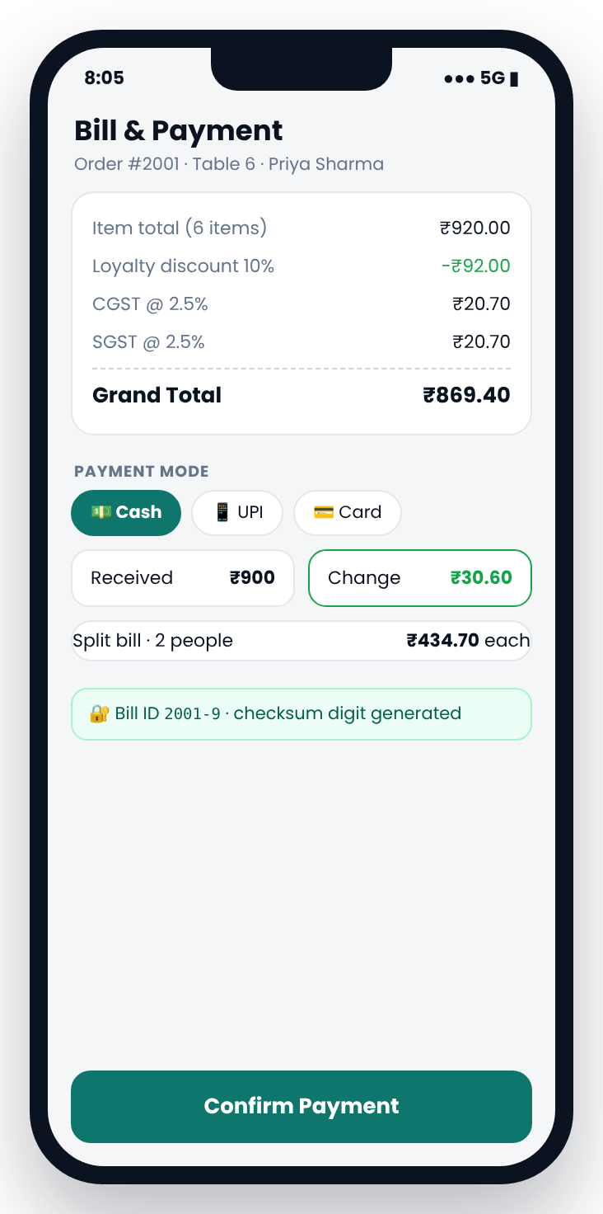 | Purpose  Calculates the bill automatically with discount and GST, accepts cash, UPI or card, supports split bills and issues a checksum-protected bill ID.  Output  Printed receipt, change, split share and bill ID 2001-9.  Sample Run
  Module type | Core Restaurant Module
  Used by | Cashier
  Classes | Bill, BillingService, Billable «interface»
  Connected to | M5 → M6 (+M12) → M7, frees table in M9
  ──────── BILL 2001-9 ────────
  Item total 920.00
  Loyalty discount (10%) -92.00
  CGST 2.5% 20.70
  SGST 2.5% 20.70
  GRAND TOTAL ₹ 869.40
  Mode ▸ 1 Received ▸ 800
  ✘ InsufficientPaymentException: ₹69.40 due
  Received ▸ 900 Split ▸ 2
  ✔ Change ₹30.60 · ₹434.70 per person

Inputs
Field | Type | Validation rule | Sample value
Order ID | int | Status must be SERVED | 2001
Payment mode | int | 1 Cash · 2 UPI · 3 Card | 1
Amount received | double | Cash only; ≥ grand total | 900
Split count | int | 1 – 8 people | 2
UPI reference | String | 12 digits (UPI only) | —

Processing
- Subtotal through the Billable interface: ₹920.00.
- Loyalty discount 10%: −₹92.00 → taxable ₹828.00.
- CGST 2.5% = ₹20.70, SGST 2.5% = ₹20.70 → total ₹869.40.
- Change = 900 − 869.40 = ₹30.60; split = 869.40 ÷ 2 = ₹434.70.
- Generate bill ID 2001-9 (M12), set BILLED, free Table 6 (M9).

Exceptions
Exception | Raised when
InsufficientPaymentException | Cash received less than total
InvalidSplitException | Split count outside 1–8
InvalidPaymentException | UPI reference not 12 digits

Test Cases
# | Input | Expected result
T1 | Cash ₹800 | InsufficientPaymentException (₹69.40 due)
T2 | Cash ₹900, split 2 | Change ₹30.60, ₹434.70 each
T3 | Split 0 | InvalidSplitException

Module 07: Feedback & Ratings
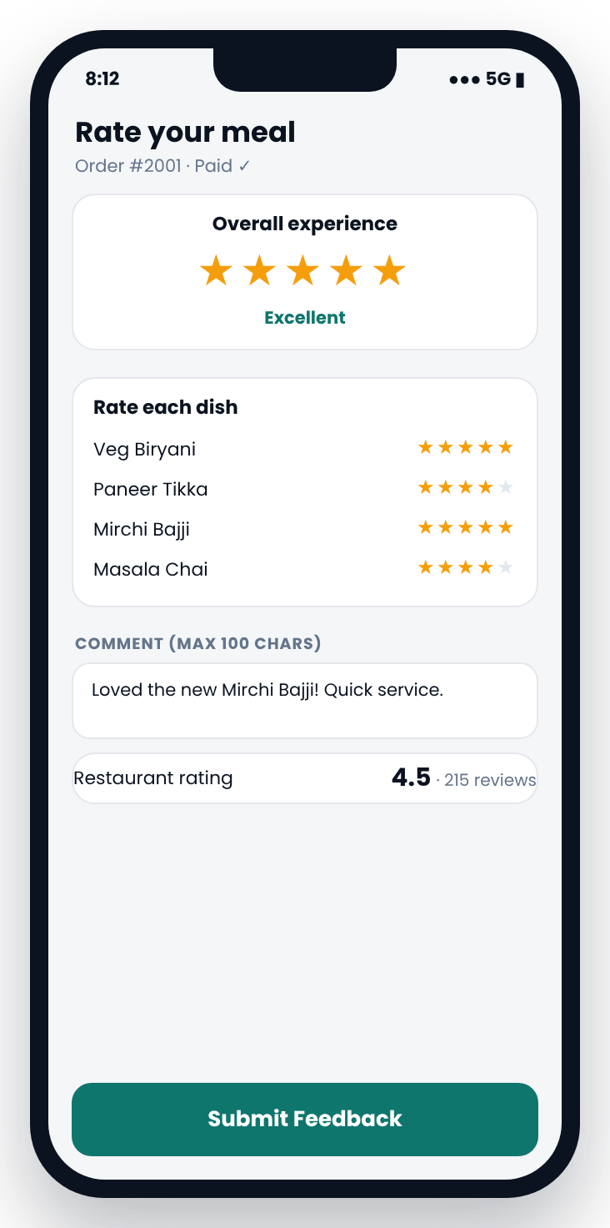 | Purpose  Collects an overall rating, a rating for each dish and a comment, then updates restaurant and dish averages.  Output  Thank-you message and updated restaurant and dish averages, used by M8.  Sample Run
  Module type | Core Restaurant Module
  Used by | Customer (via waiter)
  Classes | Feedback, FeedbackService
  Connected to | M6 → M7 → M8
  Bill ID ▸ 2001-9 ✔ verified
  Overall [1-5] ▸ 6
  ✘ InvalidRatingException: must be 1–5
  Overall [1-5] ▸ 5
  Veg Biryani ▸ 5 Paneer Tikka ▸ 4
  Mirchi Bajji ▸ 5 Masala Chai ▸ 4
  Comment ▸ Loved the new Mirchi Bajji!
  ✔ Thank you, Priya! Rating 4.5★ (215)

Inputs
Field | Type | Validation rule | Sample value
Bill ID | String | Valid checksum, BILLED, feedback not given yet | 2001-9
Overall rating | int | 1 – 5 | 5
Dish ratings | int per dish | 1 – 5 for each dish ordered | 5, 4, 5, 4
Comment | String | Optional, max 100 chars | Loved the new Mirchi Bajji!

Processing
- Verify the bill ID with the checksum from M12.
- Reject if feedback for this bill already exists.
- Store ratings in arrays; loop through the order items for dish ratings.
- New average = (old total + 5) ÷ (count + 1) → 4.5 from 215 reviews.

Exceptions
Exception | Raised when
InvalidRatingException | Rating outside 1–5
DuplicateFeedbackException | Feedback already given for this bill
InvalidBillException | Bill ID fails checksum

Test Cases
# | Input | Expected result
T1 | Rating 6 | InvalidRatingException
T2 | Second feedback for 2001-9 | DuplicateFeedbackException
T3 | Valid ratings | Average updated to 4.5 (215 reviews)

Module 08: Reports & Analytics
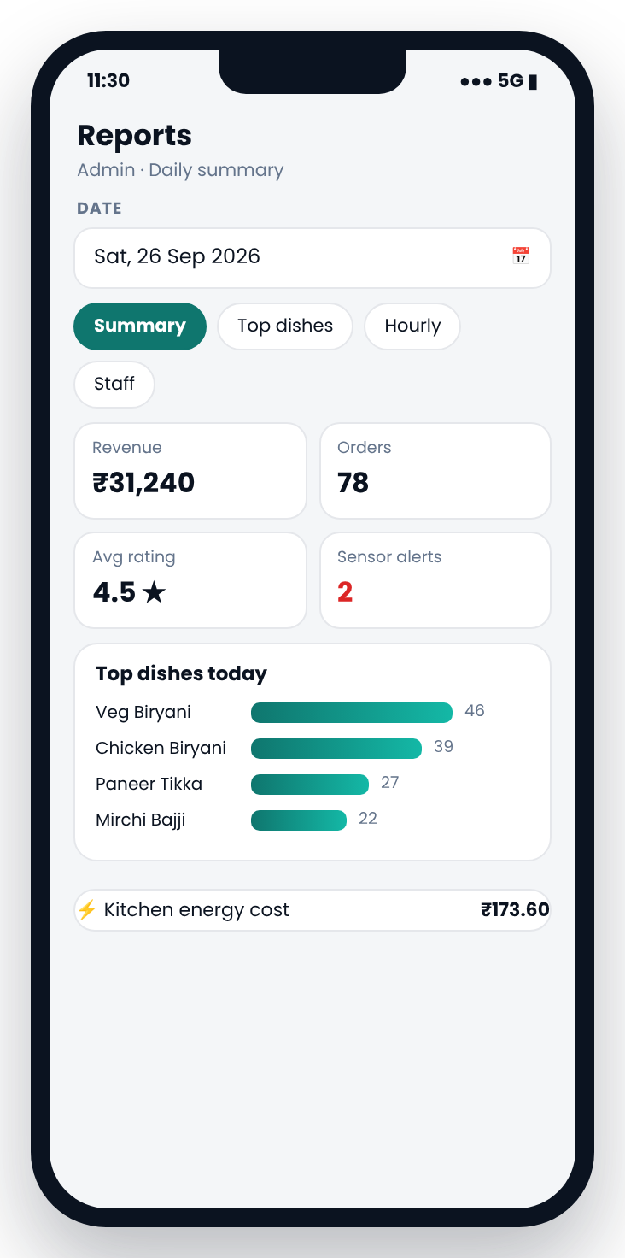 | Purpose  Gives the admin a daily summary of sales, popular dishes, ratings, kitchen alerts and energy cost.  Output  Revenue ₹31,240 · 78 orders · 4.5★ · 2 alerts · energy ₹173.60 · top 4 dishes.  Sample Run
  Module type | Core Restaurant Module
  Used by | Admin
  Classes | ReportService
  Connected to | Reads M4, M6, M7, M10, M13
  Date ▸ 31-09-2026
  ✘ InvalidDateException: September has 30 days
  Date ▸ 26-09-2026 Type ▸ 1
  ═══ DAILY SUMMARY · 26-09-2026 ═══
  Revenue ₹31,240 · Orders 78 · Rating 4.5★
  Alerts 2 · Energy cost ₹173.60
  Top: Veg Biryani 46 · Chicken Biryani 39
  Paneer Tikka 27 · Mirchi Bajji 22

Inputs
Field | Type | Validation rule | Sample value
Report date | String | dd-mm-yyyy, valid date, not in the future | 26-09-2026
Report type | int | 1 Summary · 2 Top dishes · 3 Hourly · 4 Staff | 1
Top N | int | 1 – 10 | 4

Processing
- Split the date with split("-") and Integer.parseInt(); check day range for the month.
- Loop over Order[] for BILLED orders on that date.
- Sum revenue, count orders, count each dish in an int[] and pick top N.
- Add rating (M7), alert count (M10) and energy cost (M13).

Exceptions
Exception | Raised when
InvalidDateException | Wrong format, impossible or future date
NoDataException | No billed orders on that date
NumberFormatException | Letters in the date (built-in, caught)

Test Cases
# | Input | Expected result
T1 | 31-09-2026 | InvalidDateException
T2 | Date with no orders | NoDataException
T3 | 26-09-2026, type 1 | Full daily summary

4. Smart Monitoring Modules
These five modules monitor tables, kitchen conditions, order tokens, bill integrity and energy use. They are modelled in software so that they can later be connected to physical sensors and displays.
No. | Module | Concept | Main classes
M09 | Table Occupancy Register | Registers, bit masking, binary and hexadecimal representation | TableRegister
M10 | Kitchen Sensor Monitoring | Sensors, safety thresholds, alarms and automatic actions | Sensor «interface», TemperatureSensor, GasLeakSensor, SmokeSensor, HumiditySensor, KitchenMonitor
M11 | Seven-Segment Token Display | Seven-segment decoding and segment encoding (a to g) | SevenSegment
M12 | Bill Checksum Security | Error detection using check digits | BillingService (checkDigit, verify)
M13 | Kitchen Energy Meter | Electrical power, power factor, energy units and slab tariff | Appliance, EnergyMeter

Module 09: Table Occupancy Register
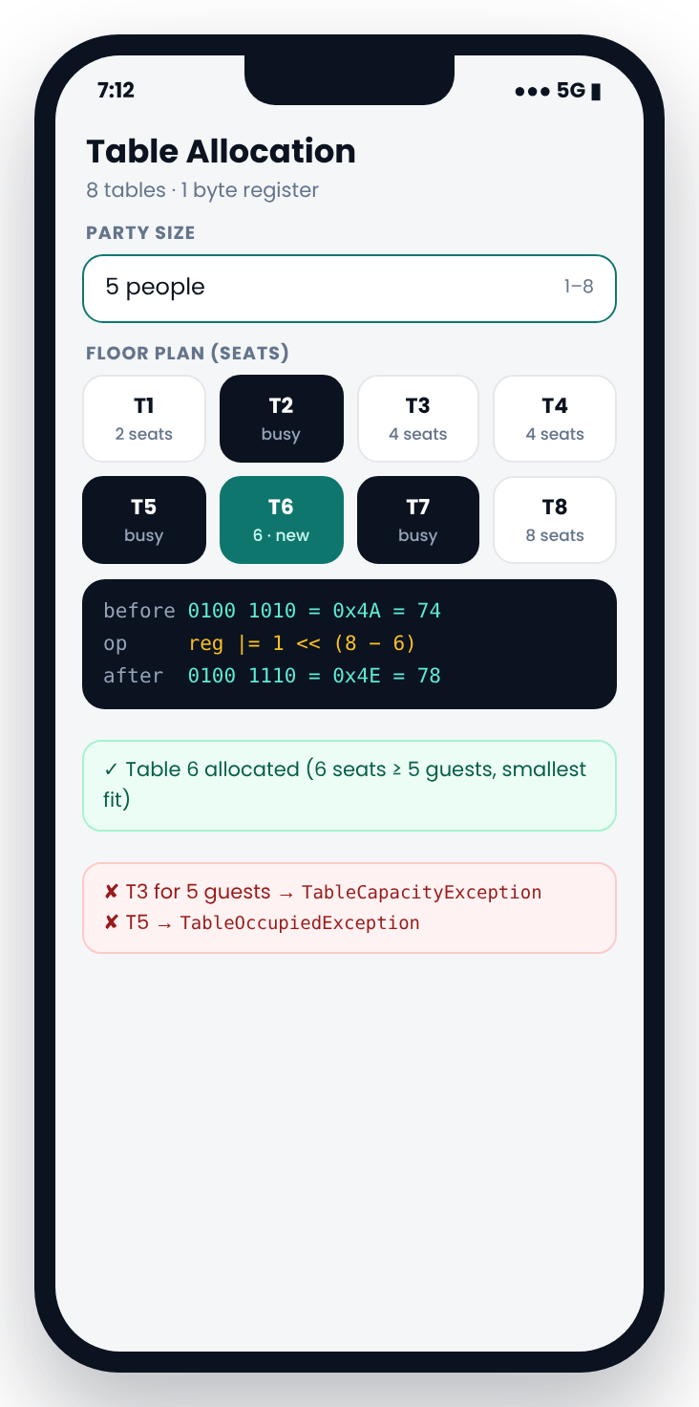 | Purpose  Stores the status of all 8 tables in one 8-bit register, like a hardware status register, and suggests the best table for the party size.  Output  Register shown in binary, hex and decimal: 0100 1010 (0x4A) → 0100 1110 (0x4E).  Sample Run
  Module type | Smart Monitoring Module
  Used by | Waiter
  Classes | TableRegister
  Connected to | M3 → M9 → M4; cleared by M6
  Concept | Registers, bit masking, binary and hexadecimal representation
  Party size ▸ 5
  Tables 0100 1010 = 0x4A · Suggested: T6
  Table ▸ 3
  ✘ TableCapacityException: T3 has 4 seats
  Table ▸ 5
  ✘ TableOccupiedException: T5 is busy
  Table ▸ 6
  ✔ reg |= 1 << 2 → 0100 1110 = 0x4E (78)

Inputs
Field | Type | Validation rule | Sample value
Party size | int | 1 – 8 guests | 5
Table number | int | 1–8, free, seats ≥ party size | 6
Release table | int | 1–8, must be occupied | 6 (after bill)

Processing
- Seats per table in int[] seats = {2,2,4,4,4,6,6,8}.
- Bit test: (reg & (1 << (8 − t))) != 0 means occupied.
- Suggest the smallest free table with seats ≥ party: T6 for 5 guests.
- Allocate with reg |= mask; release with reg &= ~mask after payment.

Exceptions
Exception | Raised when
TableOccupiedException | Bit for that table is already 1
TableCapacityException | Seats less than party size
InvalidTableException | Table number outside 1–8

Test Cases
# | Input | Expected result
T1 | Party 5, T3 | TableCapacityException
T2 | T5 | TableOccupiedException
T3 | T6, then release after bill | 0x4A → 0x4E → 0x4A

Module 10: Kitchen Sensor Monitoring
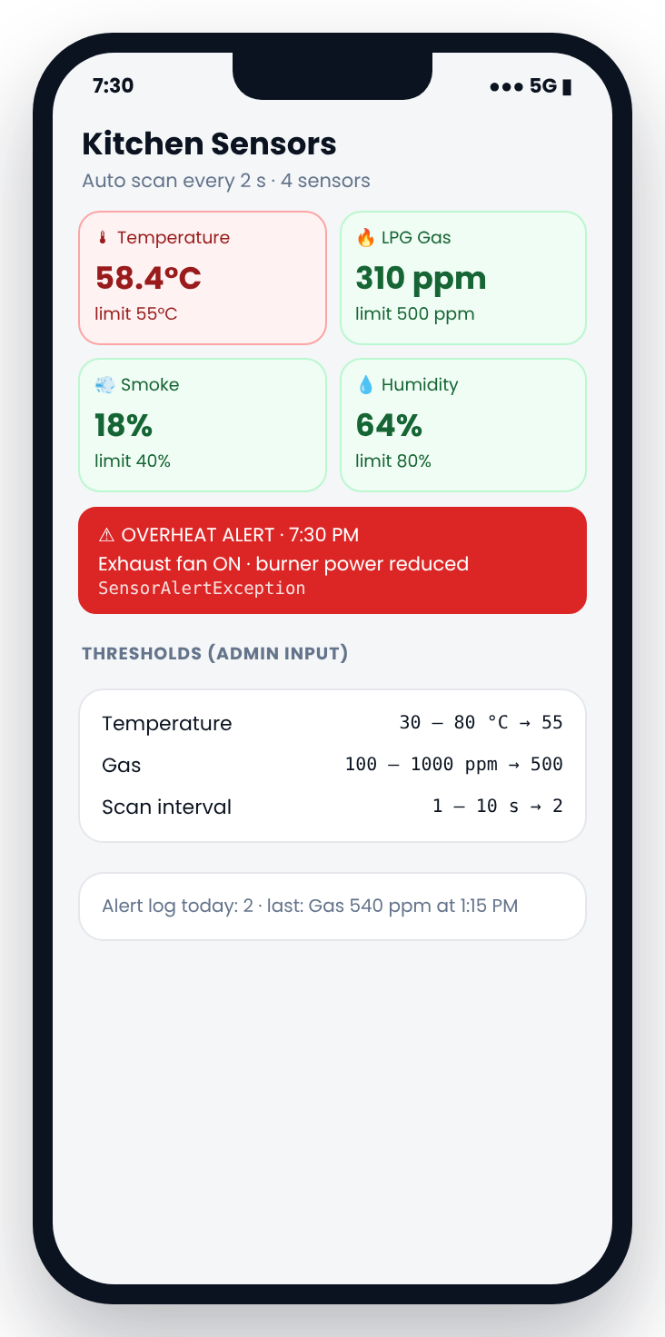 | Purpose  Simulates kitchen safety sensors, compares each reading with a limit set by the admin and raises an alert with an automatic action.  Output  Live readings with OK / ALERT, automatic action and alert count (2 today).  Sample Run
  Module type | Smart Monitoring Module
  Used by | Chef / Admin
  Classes | Sensor «interface», TemperatureSensor, GasLeakSensor, SmokeSensor, HumiditySensor, KitchenMonitor
  Connected to | Runs alongside M5; count sent to M8
  Concept | Sensors, safety thresholds, alarms and automatic actions
  Temp limit ▸ 120
  ✘ InvalidThresholdException: 30–80 °C only
  Temp limit ▸ 55 Scans ▸ 5
  Scan 3 · 7:30 PM
  Temperature 58.4 °C ⚠ ALERT → fan ON,
  burner reduced
  LPG Gas 310 ppm OK
  Smoke 18 % OK
  Humidity 64 % OK

Inputs
Field | Type | Validation rule | Sample value
Temperature limit | double | 30 – 80 °C | 55
Gas limit | double | 100 – 1000 ppm | 500
Scan interval | int | 1 – 10 seconds | 2
Number of scans | int | 1 – 50 | 5

Processing
- Store all four sensors in one Sensor[] array (polymorphism).
- Each scan calls read(), which returns a Math.random() value in a realistic range.
- Reading above the limit throws SensorAlertException with an action.
- Catch it, save time and message in String[] alertLog, continue scanning.
- Wait with Thread.sleep(interval × 1000).

Exceptions
Exception | Raised when
SensorAlertException | Reading crosses its limit
InvalidThresholdException | Limit outside allowed range
InterruptedException | Sleep interrupted (built-in, caught)

Test Cases
# | Input | Expected result
T1 | Temperature limit 120 | InvalidThresholdException
T2 | Reading 58.4 °C, limit 55 | Alert caught, scanning continues
T3 | All readings normal | No alerts, 4 × OK

Module 11: Seven-Segment Token Display
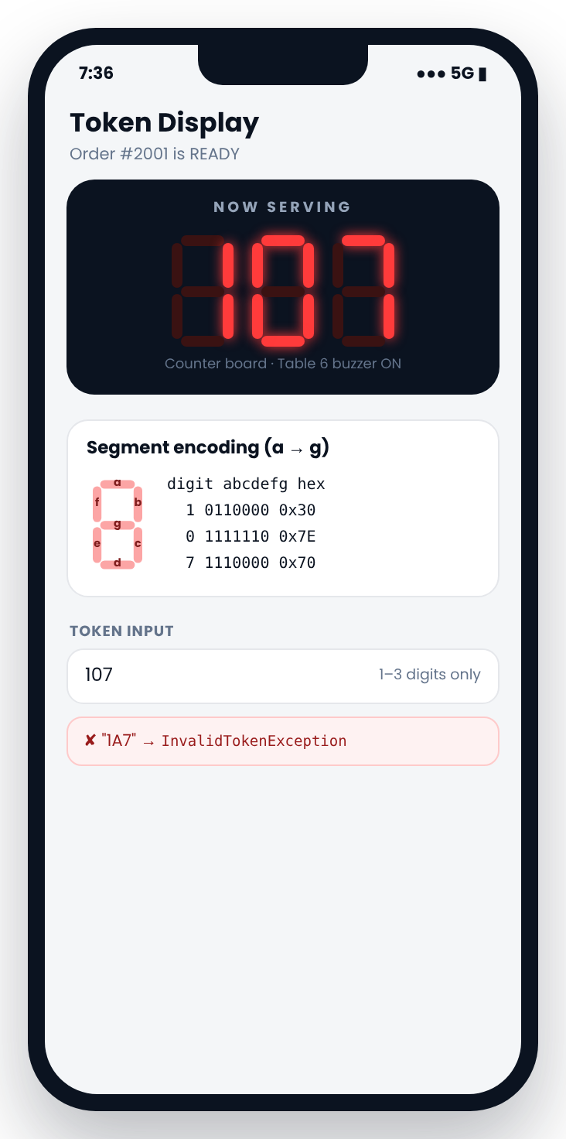 | Purpose  Shows the token of a ready order on a digital 7-segment style display and prints the 7-bit code a real decoder would send to each digit.  Output  Large token 107 and codes: 1 = 0110000 (0x30), 0 = 1111110 (0x7E), 7 = 1110000 (0x70).  Sample Run
  Module type | Smart Monitoring Module
  Used by | Kitchen / Counter
  Classes | SevenSegment
  Connected to | Triggered by M5 (READY)
  Concept | Seven-segment decoding and segment encoding (a to g)
  Token ▸ 1A7
  ✘ InvalidTokenException: digits only
  Token ▸ 107 Style ▸ 3
  _ _
  | | | |
  | |_| |
  1 = 0110000 (0x30)
  0 = 1111110 (0x7E)
  7 = 1110000 (0x70)

Inputs
Field | Type | Validation rule | Sample value
Token | String | 1 – 3 digits only | 107
Display style | int | 1 ASCII · 2 Binary codes · 3 Both | 3

Processing
- Check each character with Character.isDigit(); pad to 3 digits (7 → 007).
- Print digit patterns row by row from String[10][3].
- Look up codes in int[] CODES = {0x7E,0x30,0x6D,0x79,0x33,0x5B,0x5F,0x70,0x7F,0x7B}.
- Print each code with Integer.toBinaryString(), padded to 7 bits.

Exceptions
Exception | Raised when
InvalidTokenException | Letters or more than 3 digits

Test Cases
# | Input | Expected result
T1 | "1A7" | InvalidTokenException
T2 | "7" | Displayed as 007
T3 | "107" | Correct digits and codes 0x30 0x7E 0x70

Module 12: Bill Checksum Security
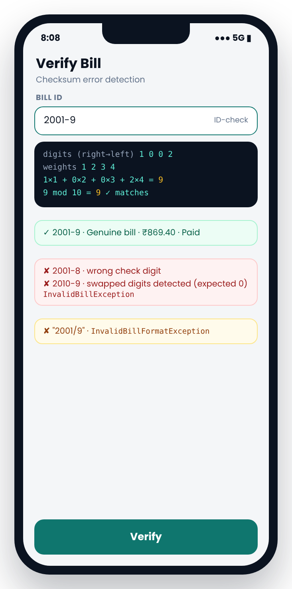 | Purpose  Adds a check digit to every bill number so that typing mistakes, swapped digits and fake bill IDs are detected before a bill is accepted.  Output  "Genuine bill · ₹869.40 · PAID" or the exact reason it was rejected.  Sample Run
  Module type | Smart Monitoring Module
  Used by | Cashier
  Classes | BillingService (checkDigit, verify)
  Connected to | Used by M6 and M7
  Concept | Error detection using check digits
  Bill ID ▸ 2001/9
  ✘ InvalidBillFormatException: use 2001-9
  Bill ID ▸ 2010-9
  ✘ InvalidBillException: check digit should
  be 0 (swapped digits?)
  Bill ID ▸ 2001-9
  1×1 + 0×2 + 0×3 + 2×4 = 9 → 9 % 10 = 9 ✓
  ✔ Genuine bill · ₹869.40 · PAID

Inputs
Field | Type | Validation rule | Sample value
Bill ID | String | Format NNNN-D (ID, hyphen, 1 digit) | 2001-9

Processing
- Split at "-" using indexOf() and substring(); catch NumberFormatException and throw InvalidBillFormatException.
- Weighted sum: digits right to left × weights 1, 2, 3, 4 → 1×1 + 0×2 + 0×3 + 2×4 = 9.
- Check digit = sum % 10 = 9; compare with the given digit.
- Find the bill in Bill[] and show amount and status.

Exceptions
Exception | Raised when
InvalidBillFormatException | Wrong format, e.g. 2001/9
InvalidBillException | Check digit does not match
BillNotFoundException | Checksum valid but bill does not exist

Test Cases
# | Input | Expected result
T1 | 2001-9 / 2001-8 | Valid / InvalidBillException
T2 | 2010-9 (swapped) | InvalidBillException, expected 0
T3 | 2010-0 / 2001/9 | BillNotFoundException / InvalidBillFormatException

Module 13: Kitchen Energy Meter
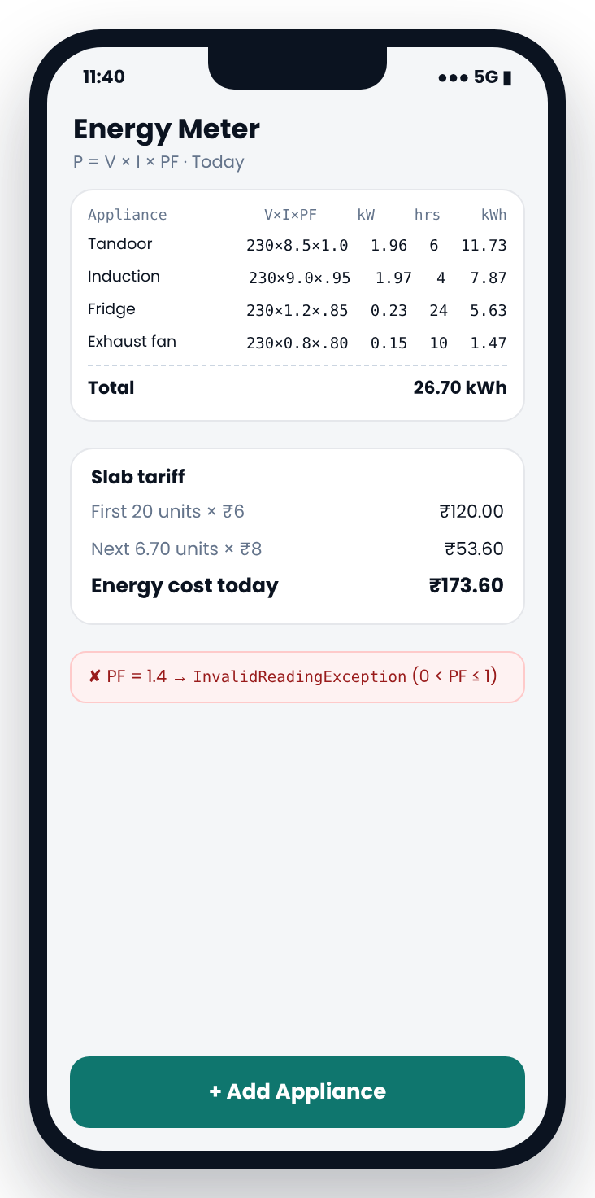 | Purpose  Calculates the power and daily energy of each kitchen appliance, including power factor, and the electricity cost using slab tariff.  Output  Appliance table, total 26.70 kWh, cost ₹120.00 + ₹53.60 = ₹173.60; Tandoor is highest.  Sample Run
  Module type | Smart Monitoring Module
  Used by | Admin
  Classes | Appliance, EnergyMeter
  Connected to | Cost sent to M8
  Concept | Electrical power, power factor, energy units and slab tariff
  Appliance ▸ Induction V ▸ 230 I ▸ 9
  PF ▸ 1.4
  ✘ InvalidReadingException: 0 < PF ≤ 1
  PF ▸ 0.95 Hours ▸ 4 ✔ 1.97 kW → 7.87 kWh
  ──── ENERGY REPORT ────
  Tandoor 11.73 kWh ◀ highest
  Induction 7.87 Fridge 5.63 Fan 1.47
  Total 26.70 kWh
  20×₹6 + 6.70×₹8 = ₹173.60

Inputs
Field | Type | Validation rule | Sample value
Appliance name | String | 2 – 20 chars | Tandoor
Voltage (V) | double | 100 – 250 V | 230
Current (I) | double | 0.1 – 20 A | 8.5
Power factor | double | 0 < PF ≤ 1 | 1.0
Hours per day | double | 0 – 24 | 6
Slab rates | double | Units and ₹ per unit | 20 @ ₹6, rest @ ₹8

Processing
- P (kW) = V × I × PF ÷ 1000.
- Energy (kWh) = P × hours; loop over Appliance[] to add the total.
- Cost = min(units, 20) × 6 + max(units − 20, 0) × 8.
- Find the highest consumer with a max loop.

Exceptions
Exception | Raised when
InvalidReadingException | V, I, PF or hours outside range
ApplianceLimitException | More than 15 appliances

Test Cases
# | Input | Expected result
T1 | PF 1.4 | InvalidReadingException
T2 | 230 V × 8.5 A × 1.0 | 1.96 kW, 6 h = 11.73 kWh
T3 | All 4 appliances | 26.70 kWh, ₹173.60

5. End-to-End Scenario
The following walkthrough shows one customer visit through all modules. The output of each module becomes the input of the next.
Customer | Priya Sharma, mobile 9123456780, visit #14, veg only
Party | 5 guests, dine-in
Order | #2001 at Table 6

Module | Action | Input | Output
M01 | Waiter logs in | W104 + PIN | Waiter menu
M03 | Look up customer | 9123456780 | Priya, visit #14, loyalty on, veg only
M09 | Allocate table | Party of 5 | T6; register 0x4A → 0x4E
M02 | Menu (set by admin) | Mirchi Bajji, ₹120 | Available in veg menu
M04 | Take order | 4 dishes, Medium, note | #2001, 6 items, ₹920
M10 | Sensor scan | Limits 55 °C / 500 ppm | Overheat alert at 58.4 °C, fan on
M05 | Kitchen | Next stage ×2 | PREPARING → READY, ETA 24 min
M11 | Token display | 107 | Digits 107, codes 0x30 0x7E 0x70
M06 | Bill and payment | Cash ₹900, split 2 | ₹869.40, change ₹30.60, ₹434.70 each
M12 | Bill ID | 2001 | Check digit 9 → 2001-9
M09 | Release table | T6 | Register back to 0x4A
M07 | Feedback | Overall 5; dishes 5/4/5/4 | Average 4.5 (215 reviews)
M13 | Energy (end of day) | 4 appliances | 26.70 kWh, ₹173.60
M08 | Daily report | 26-09-2026 | ₹31,240, 78 orders, 2 alerts

Bill Calculation
Item | Amount (₹)
Mirchi Bajji ×1 | 120.00
Paneer Tikka ×1 | 220.00
Veg Biryani ×2 | 500.00
Masala Chai ×2 | 80.00
Item total | 920.00
Loyalty discount (10%) | −92.00
Taxable amount | 828.00
CGST @ 2.5% | 20.70
SGST @ 2.5% | 20.70
Grand total | 869.40
Cash received / change | 900.00 / 30.60
Split between 2 | 434.70 each

6. Exception Summary
Every invalid input and broken business rule is reported through a named exception, caught by the calling menu and shown as a clear message. The program continues running after every error.
Module | Exception | Raised when
M01 Login & Access Control | InvalidStaffIdException | ID format wrong or letter does not match role
 | InvalidPinException | PIN does not match
 | AccountLockedException | 3 wrong attempts
M02 Menu Management | MenuFullException | 30 dishes already stored
 | DuplicateDishException | Name already on the menu
 | InvalidPriceException | Price outside ₹10 – ₹2000
M03 Customer Profile & Favourites | InvalidPhoneNumberException | Not 10 digits or starts with 0–5
 | InvalidNameException | Name has digits or symbols
 | CustomerLimitException | 100 customers already stored
M04 Order Taking | ItemUnavailableException | Dish unavailable or not allowed by diet
 | InvalidQuantityException | Quantity outside 1–10
 | OrderLimitExceededException | More than 20 items
M05 Kitchen Queue | OrderNotFoundException | ID not in the active queue
 | InvalidStatusChangeException | Skipping or reversing a stage
 | InvalidChefException | Name is not a chef
M06 Billing & Payment | InsufficientPaymentException | Cash received less than total
 | InvalidSplitException | Split count outside 1–8
 | InvalidPaymentException | UPI reference not 12 digits
M07 Feedback & Ratings | InvalidRatingException | Rating outside 1–5
 | DuplicateFeedbackException | Feedback already given for this bill
 | InvalidBillException | Bill ID fails checksum
M08 Reports & Analytics | InvalidDateException | Wrong format, impossible or future date
 | NoDataException | No billed orders on that date
 | NumberFormatException | Letters in the date (built-in, caught)
M09 Table Occupancy Register | TableOccupiedException | Bit for that table is already 1
 | TableCapacityException | Seats less than party size
 | InvalidTableException | Table number outside 1–8
M10 Kitchen Sensor Monitoring | SensorAlertException | Reading crosses its limit
 | InvalidThresholdException | Limit outside allowed range
 | InterruptedException | Sleep interrupted (built-in, caught)
M11 Seven-Segment Token Display | InvalidTokenException | Letters or more than 3 digits
M12 Bill Checksum Security | InvalidBillFormatException | Wrong format, e.g. 2001/9
 | InvalidBillException | Check digit does not match
 | BillNotFoundException | Checksum valid but bill does not exist
M13 Kitchen Energy Meter | InvalidReadingException | V, I, PF or hours outside range
 | ApplianceLimitException | More than 15 appliances

7. Integration Testing
Integration tests confirm that the modules work correctly together.
Test | Action | Expected result
Full visit | Run the end-to-end scenario | All outputs match Section 5
Veg-only rule | Veg-only customer selects a non-veg dish | Blocked in M04 using the preference from M03
Table release | Pay bill #2001 | M06 frees T6; register returns to 0x4A in M09
Token trigger | Mark #2001 READY | M05 calls M11; token 107 displayed
Bill reuse | Submit feedback with 2001-9 | M07 verifies with M12; accepted once only
New dish | Admin adds Mirchi Bajji | Dish appears in M04 menu and M08 report
Unavailable dish | Admin marks a dish unavailable | Dish hidden from M04 menu
Background alert | Sensor alert during an order | Alert shown; order flow continues
Report totals | Run M08 after several bills | Revenue equals the sum of M06 bill totals
Invalid input | Letters typed at a number prompt | Message shown; no crash

8. Future Scope and Conclusion

8.1 Future Scope
Enhancement | Description
Hardware integration | Connect real temperature and gas sensors, a seven-segment display and a table buzzer through a microcontroller.
Persistent storage | Save customers, bills and feedback to files or a database.
Graphical interface | Replace console menus with desktop or mobile screens like those shown in this document.
QR table ordering | Let customers scan a code at the table and order from their phone.
Online payments | Integrate a payment gateway for UPI and card transactions.

8.2 Conclusion
DineSync brings order taking, kitchen management, billing, feedback and reporting together in one connected system. Dividing the system into 13 modules keeps each part focused, with clearly defined inputs, validation, processing and error handling. The monitoring modules extend the system beyond everyday restaurant tasks by tracking table occupancy, kitchen safety, bill integrity and energy use.

