CS 6375

ASSIGNMENT ___6_________

Names of students in your group:

Pranathi Peri(pxp162530)

Nitin VasiReddy(nxv162030)

Number of free late days used: __0__________________   
Note: You are allowed a **total** of 4 free late days for the **entire semester**. You can use at most 2 for each assignment. After that, there will be a penalty of 10% for each late day.

Please list clearly all the sources/references that you have used in this assignment.

**Language Used:** Python

**Steps to run the file:**

Browse to the path where the python file is present.

Shift+right click and selct Open command prompt here

To run the file, type the command as below:

python <filename> <noofCluster> <inputfile> <outputfile>

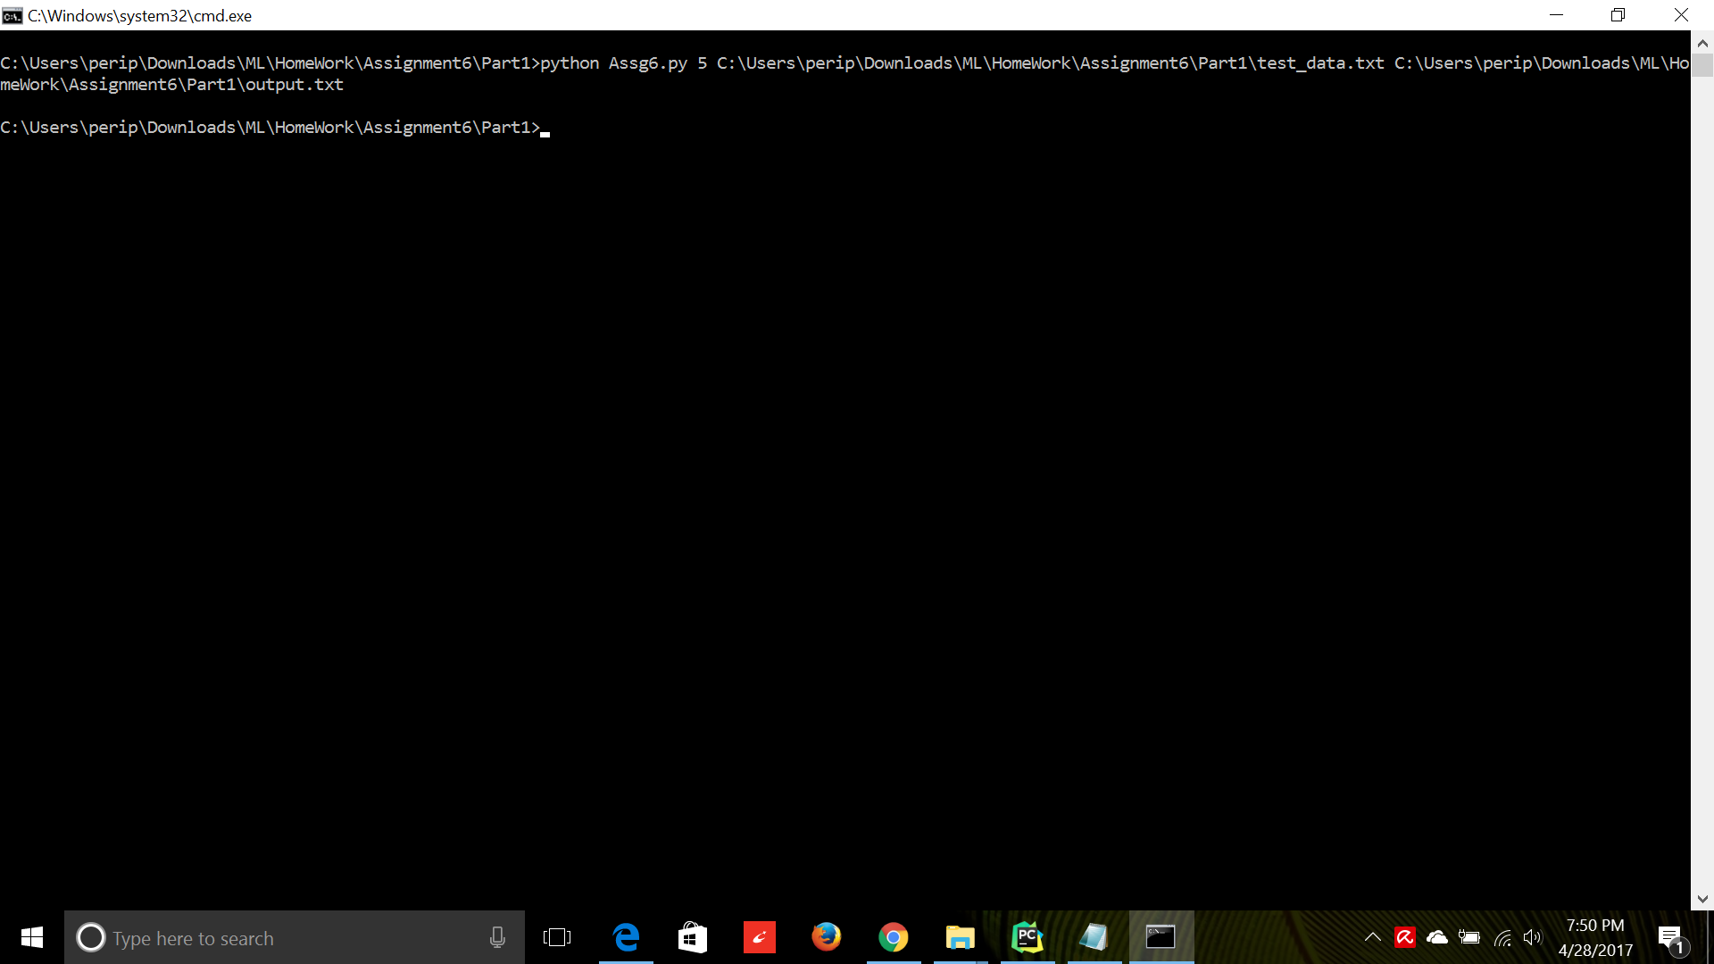

**Details of the Run:**

1)For k=5

Cluster : 1

3,14,16,18,25,26,40,42,50,56,69,80,91,100,

Cluster : 2

5,7,9,15,23,30,31,35,43,44,45,46,47,49,62,66,67,76,79,81,86,87,90,

Cluster : 3

4,11,22,28,32,33,36,37,48,52,59,60,64,68,70,71,72,82,83,84,92,95,96,

Cluster : 4

1,2,6,8,10,12,13,17,19,20,24,27,29,34,38,39,41,51,53,54,55,57,58,61,63,65,73,75,77,78,85,88,89,93,94,97,98,99,

Cluster : 5

21,74,

The value of SSE :0.007265111111111113

2)k=6

Cluster : 1

3,4,11,32,38,52,56,59,60,64,70,

Cluster : 2

22,28,33,36,37,48,68,71,72,82,83,91,92,95,96,

Cluster : 3

5,7,9,15,23,30,31,35,43,44,45,46,47,49,62,66,67,76,79,81,86,87,90,

Cluster : 4

18,21,74,

Cluster : 5

14,16,25,26,40,42,50,69,80,84,100,

Cluster : 6

1,2,6,8,10,12,13,17,19,20,24,27,29,34,39,41,51,53,54,55,57,58,61,63,65,73,75,77,78,85,88,89,93,94,97,98,99,

The value of SSE :0.057407912049861475

3)k=7

Cluster : 1

21,74,

Cluster : 2

1,2,8,17,24,29,34,39,51,53,57,58,61,63,65,94,98,99,

Cluster : 3

14,18,25,26,40,42,50,69,80,100,

Cluster : 4

6,10,12,13,19,20,27,41,54,55,73,75,77,78,85,88,89,93,97

Cluster : 5

11,22,28,33,36,37,48,68,70,71,72,82,83,84,91,92,95,96,

Cluster : 6

5,7,9,15,23,30,31,35,43,44,45,46,47,49,62,66,67,76,79,81,86,87,90,

Cluster : 7

3,4,16,32,38,52,56,59,60,64,

The value of SSE :0.0009230578512396713

4)k=10

Cluster : 1

1,2,8,17,24,29,34,39,51,53,57,58,61,63,65,94,98,99,

Cluster : 2

Cluster : 3

3,4,11,22,25,26,32,42,52,56,59,60,64,70,100,

Cluster : 4

5,7,9,15,23,30,31,35,43,44,45,46,47,49,62,66,67,76,79,81,86,87,90,

Cluster : 5

21,

Cluster : 6

28,36,37,48,68,71,72,82,83,92,95,96,

Cluster : 7

16,69,80,

Cluster : 8

14,18,33,40,50,74,84,91,

Cluster : 9

10,19,20,27,41,54,55,73,77,78,85,88,89,

Cluster : 10

6,12,13,38,75,93,97,

The value of SSE :0.0050019531250000025

5)k=12

Cluster : 1

1,2,8,17,24,29,34,39,51,53,57,58,61,63,65,94,98,99,

Cluster : 2

10,19,20,27,41,54,55,73,77,78,85,88,89,

Cluster : 3

74,

Cluster : 4

16,25,42,69,80,100,

Cluster : 5

21,

Cluster : 6

28,36,37,48,68,71,72,82,83,92,95,96,

Cluster : 7

Cluster : 8

14,18,33,40,50,84,91,

Cluster : 9

5,7,9,15,23,30,31,35,43,44,45,46,47,49,62,66,67,76,79,81,86,87,90,

Cluster : 10

3,4,11,22,26,32,52,56,59,60,64,70,

Cluster : 11

6,12,13,38,75,93,97,

Cluster : 12

The value of SSE :0.0050019531250000025