**Work/Task/Title:** Sketch to make connection between Piera Particle Sensor and Catena 4610

**Expected Result:** To display the Particles reading

**Issue 1 (Screenshots):**

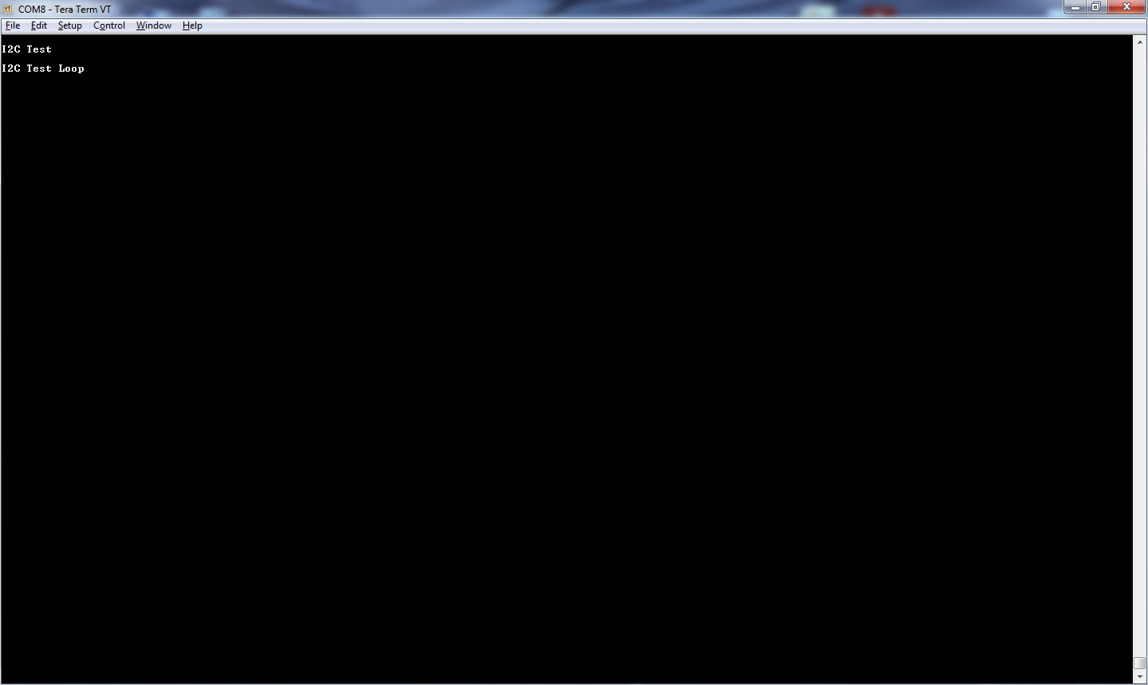

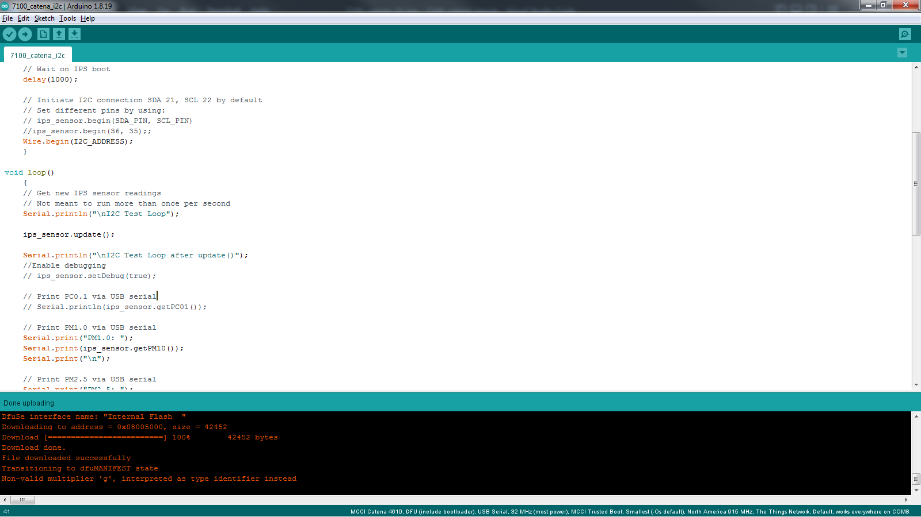

The sketch is not producing an output after Setup () function. The problem is inside Void Loop () function. Void loop () -> update () -> read_i2c (unsigned char command, int reply_size, uint8_t res_array[], bool checksum).

Inside the read_i2c () function, there is while loop which is looping infinite times without getting a proper termination condition. The termination condition is;

* The expected checksum should be equal to the received checksum.

But here we are getting expected checksum = 12475 and received checksum = 65535.

**Issue 2 (Screenshots):**

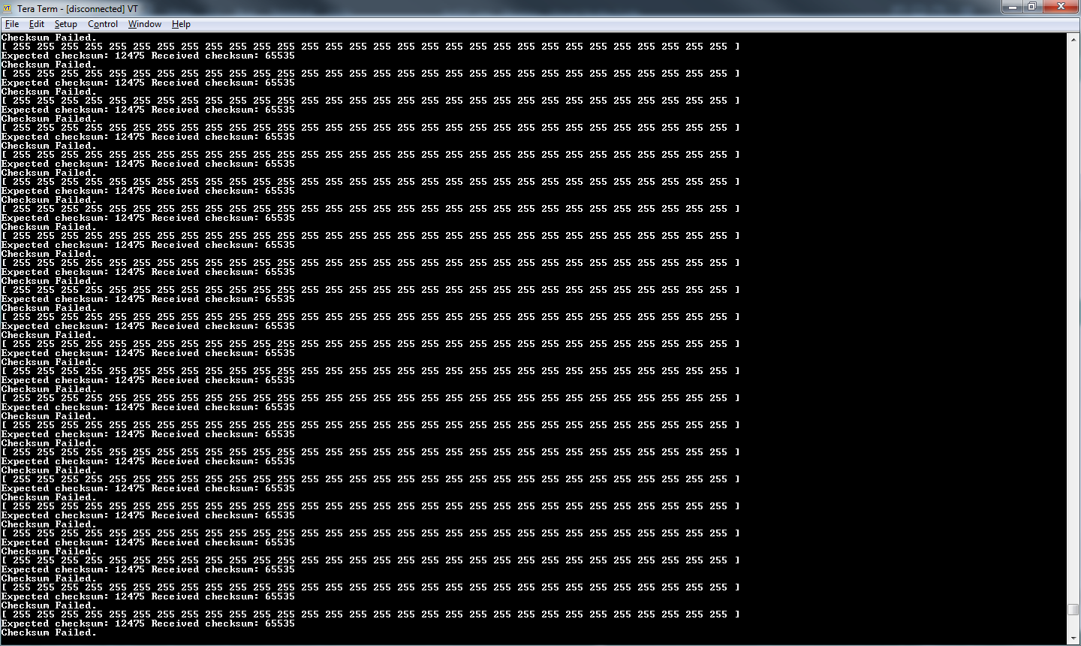

**Link Referred:**

* [7100-I2C-example/IpsI2C.cpp at main · PieraSystems/7100-I2C-example (github.com)](https://github.com/PieraSystems/7100-I2C-example/blob/main/lib/IpsI2C/IpsI2C.cpp)
* [https://github.com/HelTecAutomation/CubeCell-Arduino/blob/master/cores/asr650x/Wire/Wire.cpp#:~:text=i2c_err_t%20TwoWire%3A%3AwriteTransmission(uint16_t%20address%2C%20uint8_t%20*buff%2C%20uint16_t%20size%2C%20bool%20sendStop)](https://github.com/HelTecAutomation/CubeCell-Arduino/blob/master/cores/asr650x/Wire/Wire.cpp#:~:text=i2c_err_t%20TwoWire%3A%3AwriteTransmission(uint16_t%20address%2C%20uint8_t%20*buff%2C%20uint16_t%20size%2C%20bool%20sendStop))
* [arduino-esp32/Wire.h at master · espressif/arduino-esp32 (github.com)](https://github.com/espressif/arduino-esp32/blob/master/libraries/Wire/src/Wire.h)

**Issue Log File:** run-time_issue1_log_20220622a.txt