**Work/Task/Title:** Banking System

**Expected Result:** To create a Menu which can perform various banking operation such as open account, close account and account management.

**Issue (Screenshot 1):**

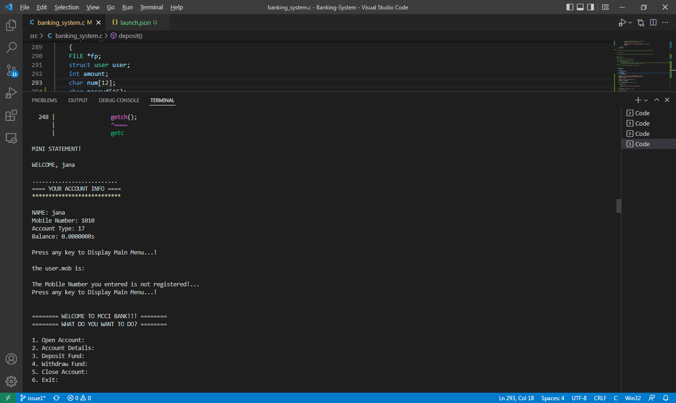

Instead of writing and reading multiple accounts, here we can able to write multiple accounts but can able to read only one account information (only first written account). If we try to read any other account information other than first account, we cannot able to access it and thus producing as output like Screen shot 2 (see below).

**Screenshot 2:**

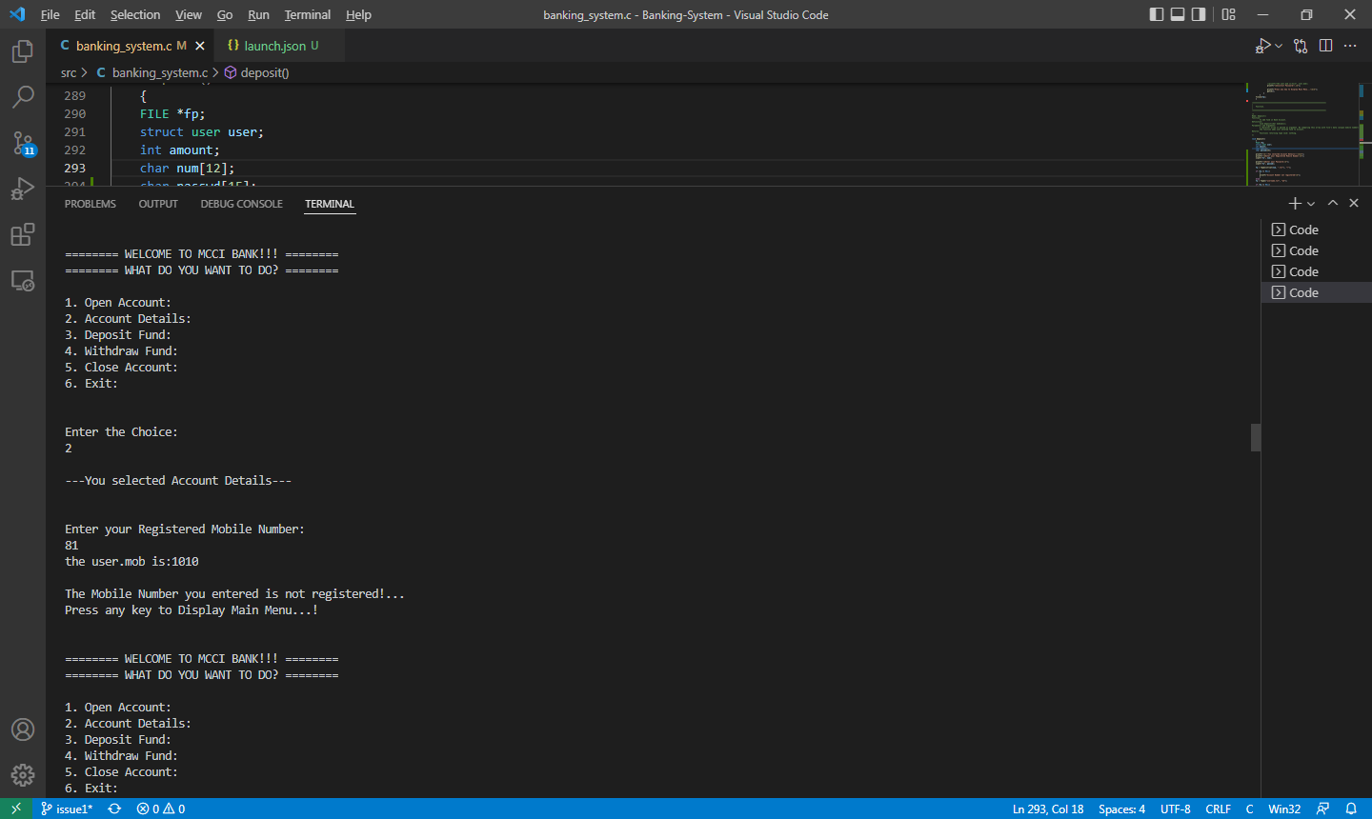

**Issue Log File:** display_issue1_log1_20220412a.txt