**Work/Task/Title:** Banking System

**Expected Result:** To create a Menu which can perform various banking operation such as open account, close account and account management.

**Issue (Screenshot 1):**

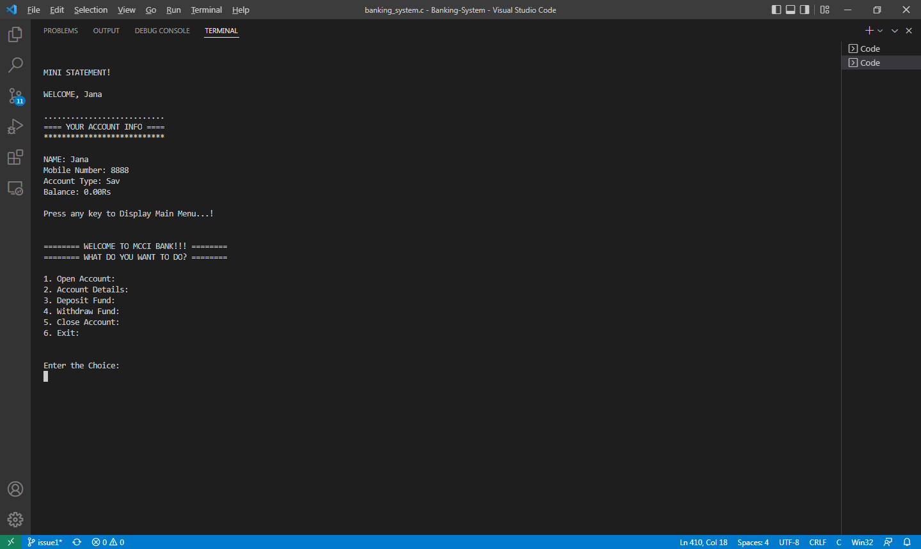

**Screenshot 2:**

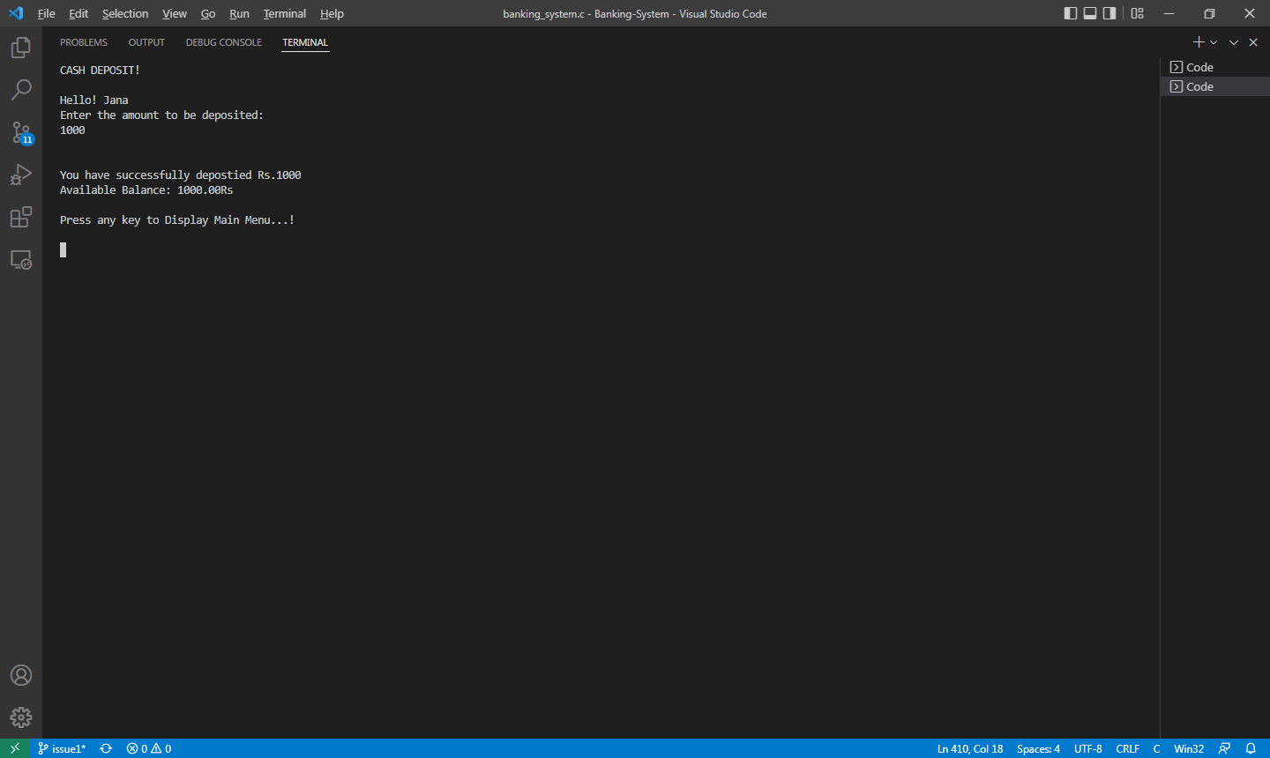

In deposit function, the new balance is added and stored in data member but after writing it to file, the changes are not reflected in file. Sometimes, changes are reflected in new balance but it truncates the other necessary data.

Same is happening in withdraw function as well.

**Issue Log File:**

* deposit_issue1_log1_20220413a
* deposit_issue1_log2_20220413a

**Link Referred:**

[How to overwrite only part of a file in c++ - Stack Overflow](https://stackoverflow.com/questions/2530274/how-to-overwrite-only-part-of-a-file-in-c)

[Why does fwrite print garbage to the end of the file (C++, C, and development)? - Quora](https://www.quora.com/Why-does-fwrite-print-garbage-to-the-end-of-the-file-C-C-and-development)