**Work/Task/Title:** Banking System

**Expected Result:** To create a Menu which can perform various banking operation such as open account, close account and account management.

**Issue (Screenshot 1):**

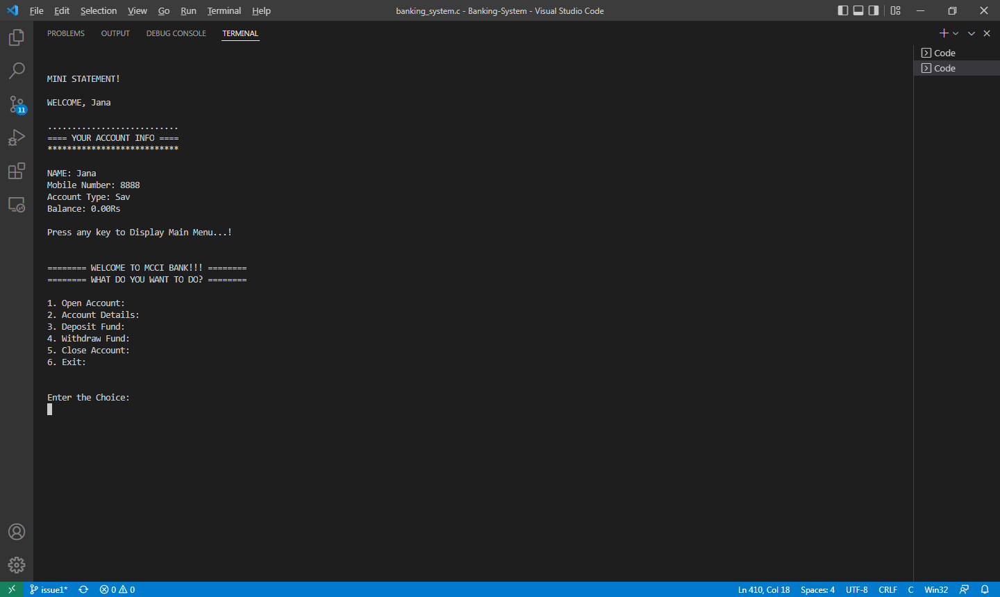

**Screenshot 2:**

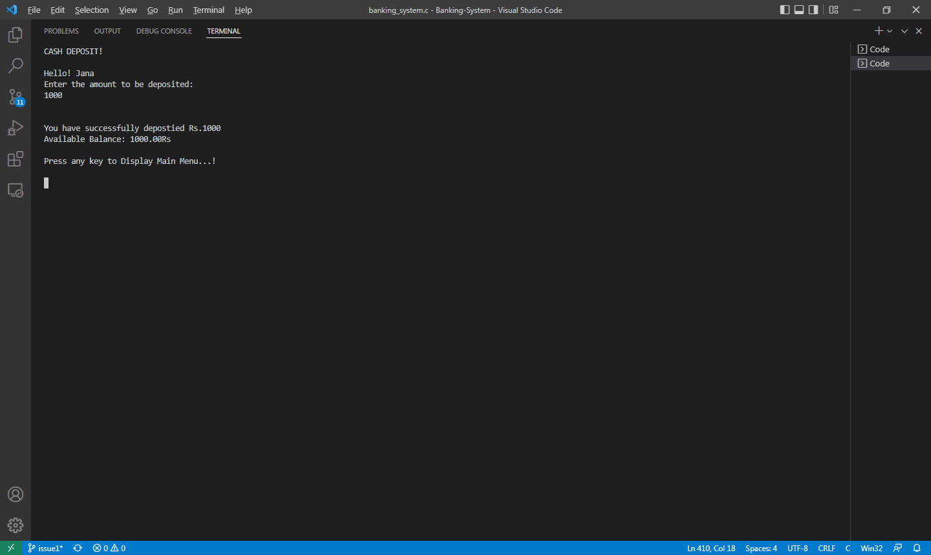

In deposit function, the new balance is added and stored in data member but after writing it to file, the changes are not reflected in file. Sometimes, changes are reflected in new balance but it truncates the other necessary data.

Same is happening in withdraw function as well.

**Issue Log File:**

* deposit_issue1_log1_20220413a
* deposit_issue1_log2_20220413a

**Link Referred:**

[How to overwrite only part of a file in c++ - Stack Overflow](https://stackoverflow.com/questions/2530274/how-to-overwrite-only-part-of-a-file-in-c)

[Why does fwrite print garbage to the end of the file (C++, C, and development)? - Quora](https://www.quora.com/Why-does-fwrite-print-garbage-to-the-end-of-the-file-C-C-and-development)

**Issue Fix:**

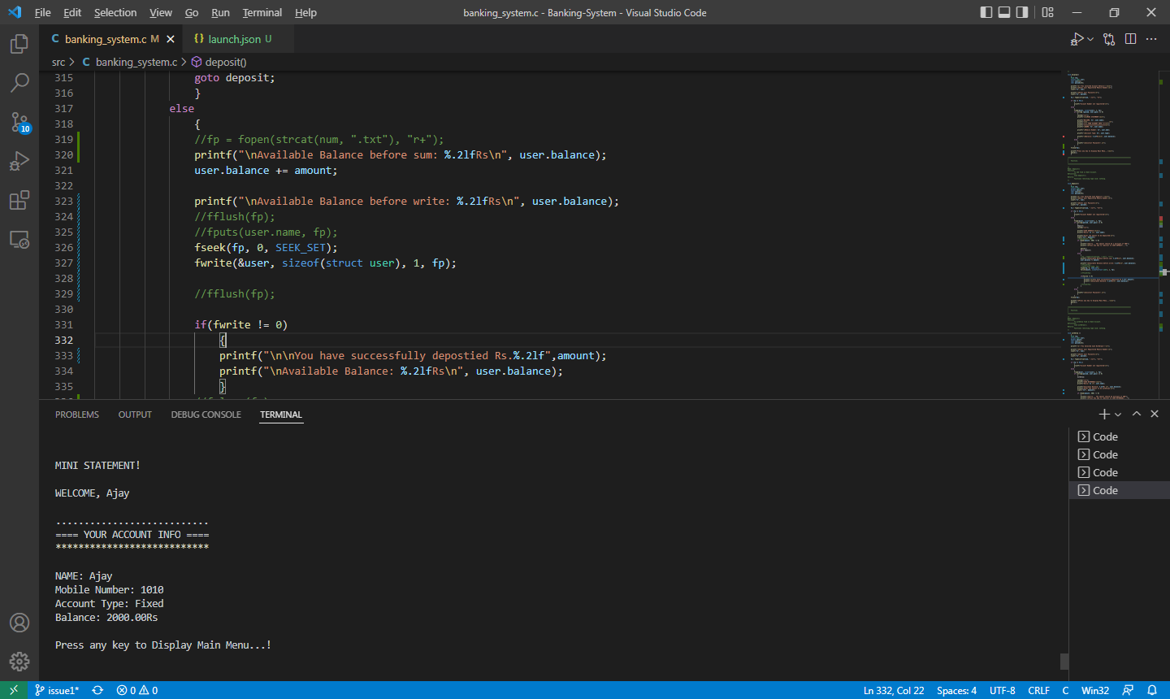

Whenever we try to read and write a file at the same time like we did in deposit and withdraw function, it is necessary to add a file positioning function between the two functions (fread, fwrite). Here we used fseek() function. By using this function, we moved our position to starting of the file. So, now it is possible to read or write/overwrite the file once again from beginning.

**Issue Log File:**

deposit_issue1__fix_log1_20220418a.txt

**Link Referred:**

* [file io - fwrite() does not override text in Windows (C) - Stack Overflow](https://stackoverflow.com/questions/6255833/fwrite-does-not-override-text-in-windows-c)
* [c - Why is fseek or fflush always required between reading and writing in the update modes? - Stack Overflow](https://stackoverflow.com/questions/1713819/why-is-fseek-or-fflush-always-required-between-reading-and-writing-in-the-update)