**Work/Task/Title:** Plantuml flowchart

**Expected Result:** To complete the loop statement without breaking the flow and to obtain the backward flow.

**Issue (Screenshot):**

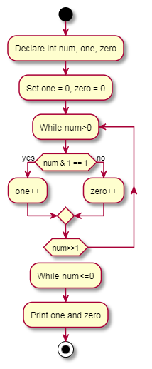

**Issue-Log-File:** flowchart_issue1_20220301.txt

**References:**

<https://plantuml.com/activity-diagram-beta>

**Fix (if issue solved):**

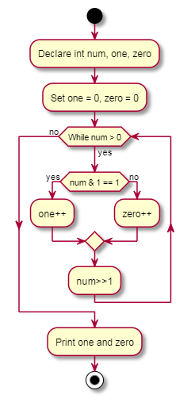

Instead of using repeat while loop, we used while loop to fix this issue.

**Reference:**

<https://stackoverflow.com/questions/58637166/how-to-represent-a-loop-with-a-continue-statement-from-c-in-a-plantuml-activit>