**Plantuml Diagram with Source Code:**

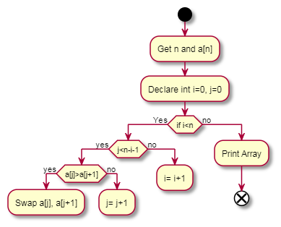

@startuml

!pragma useVerticalIf on

start

:Get n and a[n];

:Declare int i=0, j=0;

if (if i<n) then (Yes)

    if (j<n-i-1) then (yes)

        if (a[j]>a[j+1]) then (yes)

        :Swap a[j], a[j+1];

        else (no)

        :j= j+1;

        endif

        kill

    else (no)

    :i= i+1;

    Endif

kill

else (no)

:Print Array;

End

**Flowchart:**

Start

Get n and a[n]

Declare i=0, j=0

if I<n Print Array

i= i+1 End

if j<n-i-1

a[i]>a[j+1] j= j+1

swap a[j], a[j+1]

Here we cannot able to create a proper activity diagram/ flowchart using Plantuml. We tried to create some loop statements but we cannot able to complete it properly.

**Reference Link:**

* <https://plantuml.com/activity-diagram-legacy#:~:text=You%20can%20use%20%2D%3E%20for%20horizontal,%2Dright%2D%3E%20or%20%2D%3E>
* <https://plantuml.com/activity-diagram-beta>