**Work/Task/Title:** Single Linked List

**Expected Result:** To create a Menu for addition, deletion and display of user Entries

**Issue (Screenshots):**

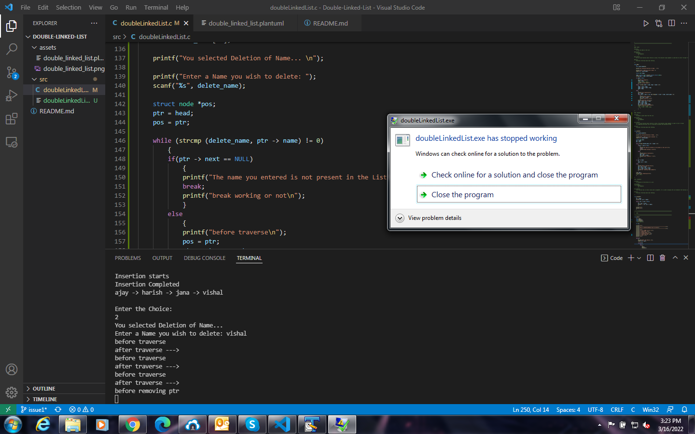

Whenever we try to delete the last data from the list, Instead of data deletion, the program gets crashed.

**Issue Log File:** delete_issue1_log_20220316