**Work/Task/Title:** Single Linked List

**Expected Result:** To create a Menu for addition, deletion and display of user Entries

**Issue (Screenshots):**

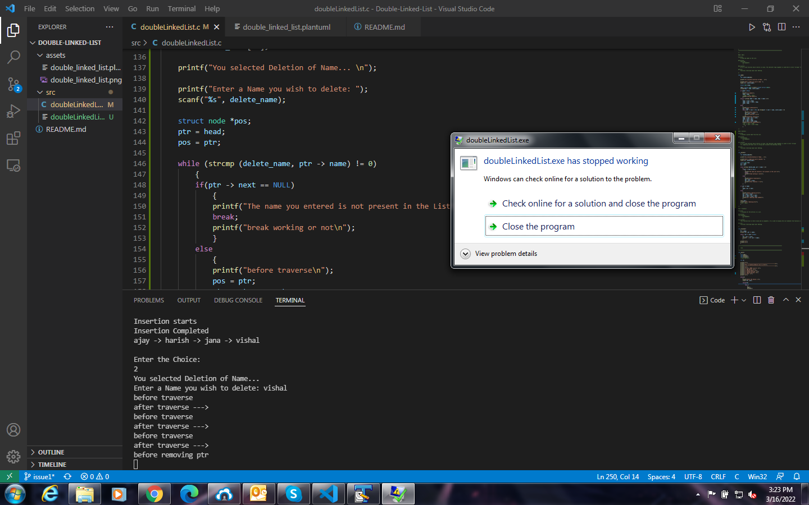

Whenever we try to delete the last data from the list, Instead of data deletion, the program gets crashed.

**Issue Log File:** delete_issue1_log_20220316

**Issue Fix:**

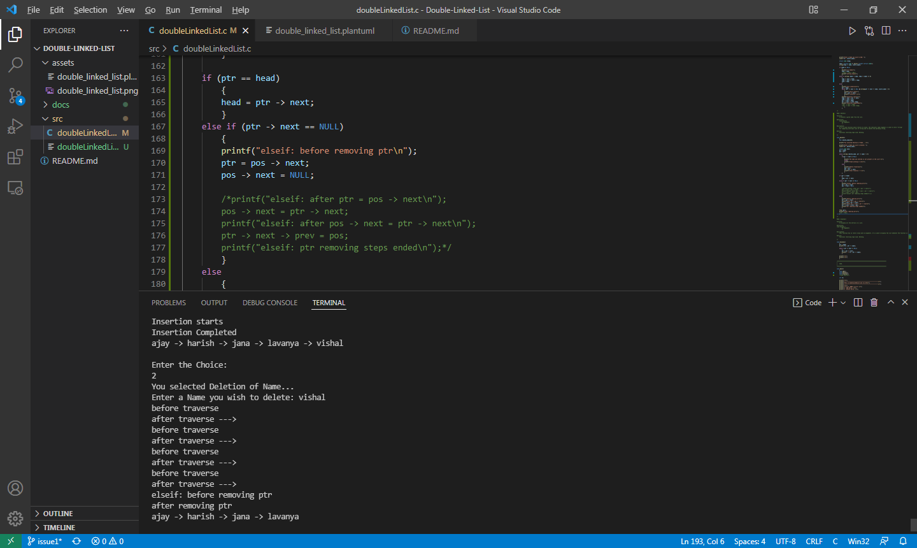

Since the next node after the last data node is NULL, we cannot access NULL using next -> prev or prev -> next. So instead of using these pointers, we created a new else if condition for this last node case.

That is, if the next memory of last node is containing NULL, make the next memory address of previous node from last node NULL.

**Referred Link:**

<https://stackoverflow.com/questions/55380505/freeing-the-previous-node-in-a-linked-list#:~:text=When%20that%20variable%20is%20NULL,node%20preceding%20the%20current%20minimum>.