**Work/Task/Title:** Extern Calculator

**Expected Result:** To create a simple arithmetic operational calculator using Extern Keyword.

**Issue (Screenshots):**

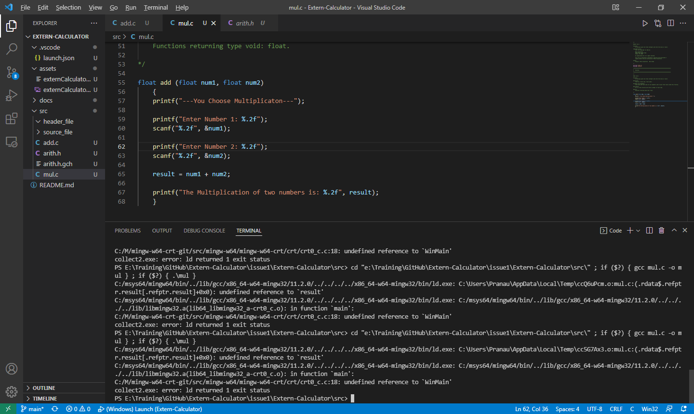

We need to link “arith.h” header file with operational source files such as “add.c”, “mul.c”, “sub.c”, “div.c”. Instead of linking, we are facing compile time error. The linking is not happening properly. “arith.h” cannot be found of linked here.

**Issue Log File:** compile_issue_log1_20220317a

**Referred Link:**

* <https://stackoverflow.com/questions/1433204/how-do-i-use-extern-to-share-variables-between-source-files>
* <https://iq.opengenus.org/extern-in-c/#:~:text=Extern%20is%20a%20keyword%20in,access%20variables%20across%20C%20files>.