**Work/Task/Title:** Simple Calculator

**Expected Result:** To create a simple arithmetic operational calculator using Extern Keyword.

**Issue (Screenshots):**

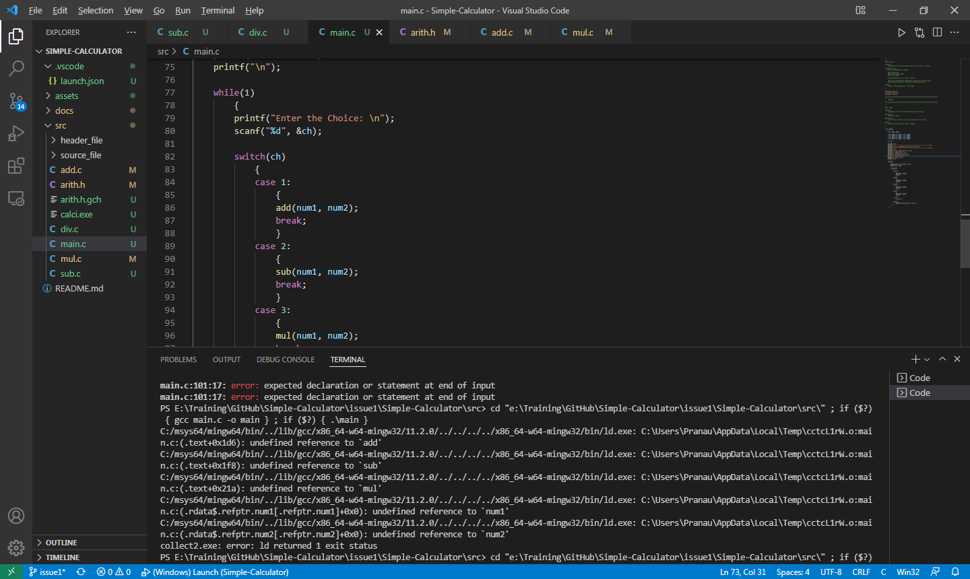

We are facing a compile time error even after creating a proper main() function.

Files are not getting compiled and not producing an application as we expected.

**Issue Log File:** compile_issue2_log_20220318a