**Work/Task/Title:** Simple Calculator

**Expected Result:** To create a simple arithmetic operational calculator using Extern Keyword.

**Issue (Screenshots):**

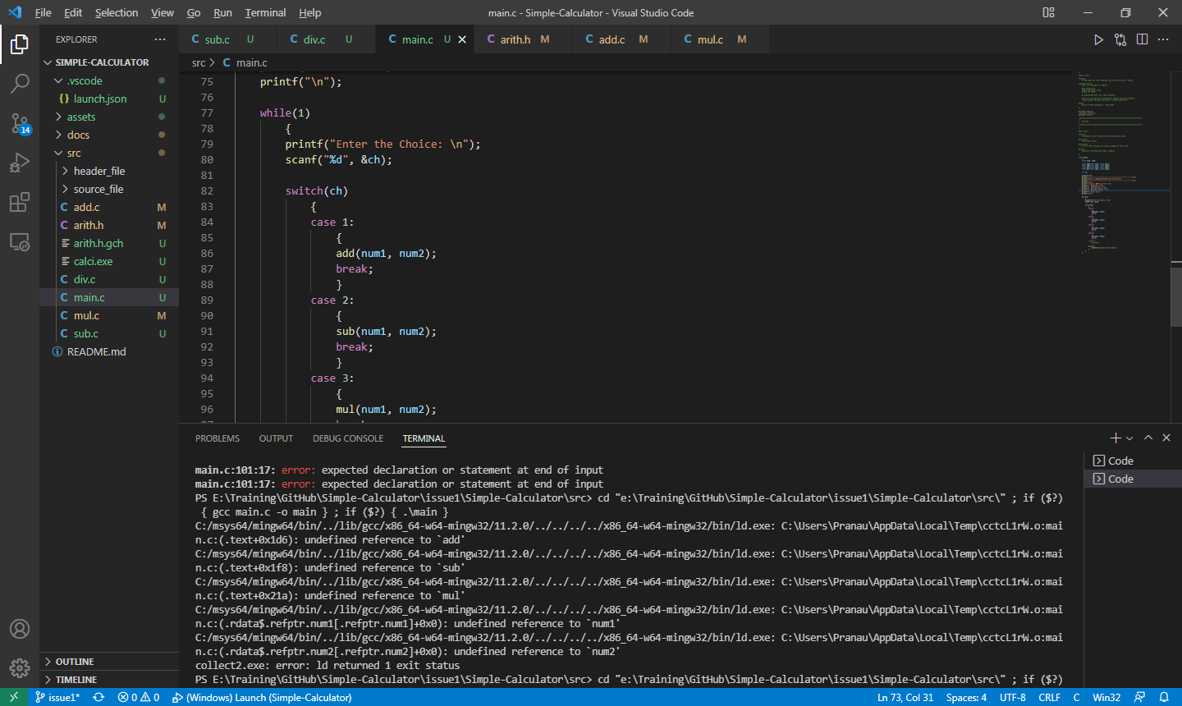

We are facing a compile time error even after creating a proper main() function.

Files are not getting compiled and not producing an application as we expected.

**Issue Log File:** compile_issue2_log_20220318a

**Issue Fix:**

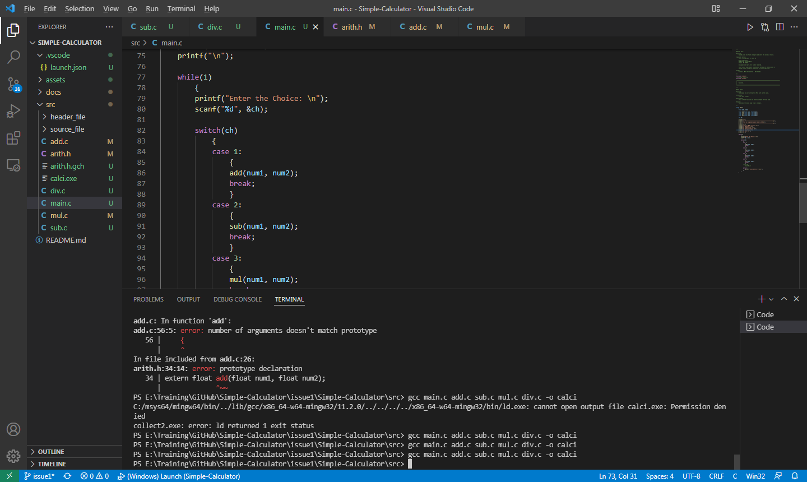

Instead of trying to run the main.c program, we created an object application by compiling all source files properly using compiling cmd in terminal.

i.e.: gcc main.c add.c sub.c mul.c div.c -o calci

Here, -o represents object file. We compiled all our source files together and created an application file called calci. Now we can run our newly created application and get our required output.

**Log File:** compile_issue2_log_fix_20220318a.txt

**Referred Link:**

<https://youtu.be/IUylyTdX_8A>