**Work/Task/Title:** Simple Calculator

**Expected Result:** To create a simple arithmetic operational calculator using Extern Keyword.

**Issue (Screenshots):**

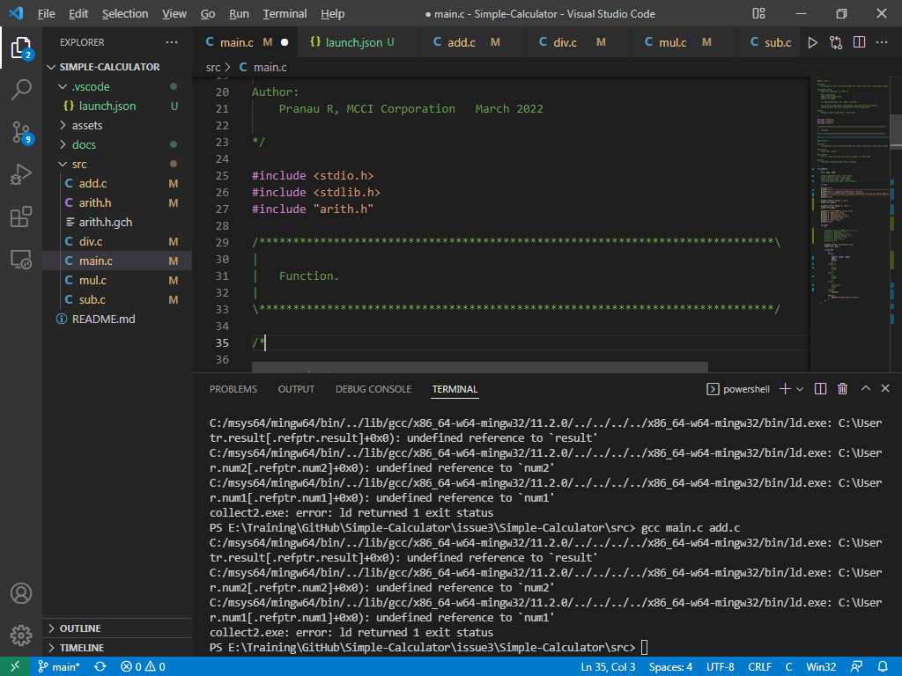

Instead of linking, we are facing compile time error. The linking is not happening properly. We are getting an “undefined reference” error. The extern variable which we declare in header file is not used properly in source as well as main file.

**Issue Log File:** compile_issue3_log1_20220321a

**Referred Link:**

* <https://stackoverflow.com/questions/1433204/how-do-i-use-extern-to-share-variables-between-source-files>
* <https://iq.opengenus.org/extern-in-c/#:~:text=Extern%20is%20a%20keyword%20in,access%20variables%20across%20C%20files>.
* <https://www.softwaretestinghelp.com/cpp-errors/#:~:text=An%20%E2%80%9CUndefined%20Reference%E2%80%9D%20error%20occurs,linked%20object%20files%20and%20libraries>.