**Work/Task/Title:** Simple Calculator

**Expected Result:** To create a simple arithmetic operational calculator using Extern Keyword.

**Issue (Screenshots):**

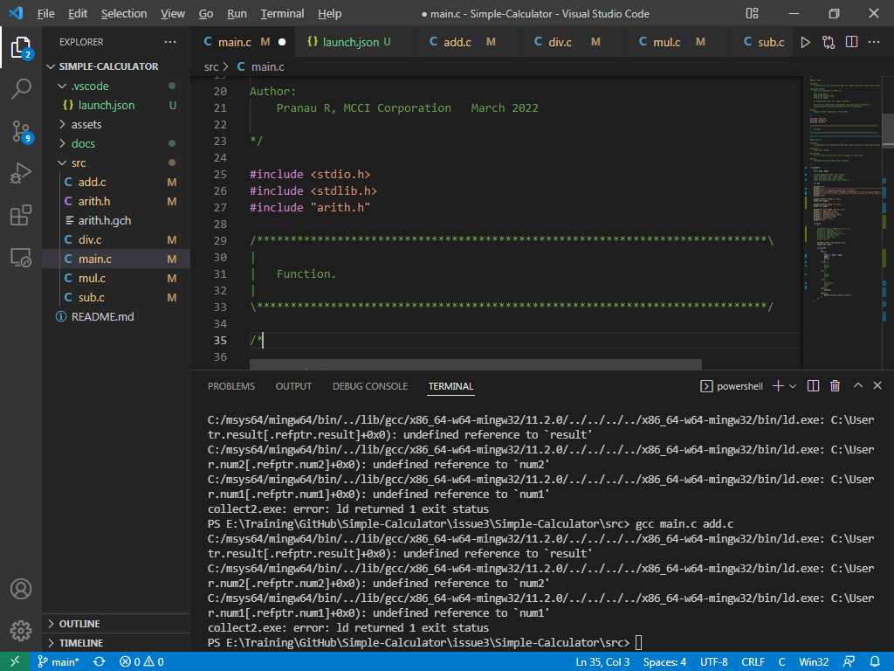

Instead of linking, we are facing compile time error. The linking is not happening properly. We are getting an “undefined reference” error. The extern variable which we declare in header file is not used properly in source as well as main file.

**Issue Log File:** compile_issue3_log1_20220321a

**Referred Link:**

* <https://stackoverflow.com/questions/1433204/how-do-i-use-extern-to-share-variables-between-source-files>
* <https://iq.opengenus.org/extern-in-c/#:~:text=Extern%20is%20a%20keyword%20in,access%20variables%20across%20C%20files>.
* <https://www.softwaretestinghelp.com/cpp-errors/#:~:text=An%20%E2%80%9CUndefined%20Reference%E2%80%9D%20error%20occurs,linked%20object%20files%20and%20libraries>.

**Issue Fix:**

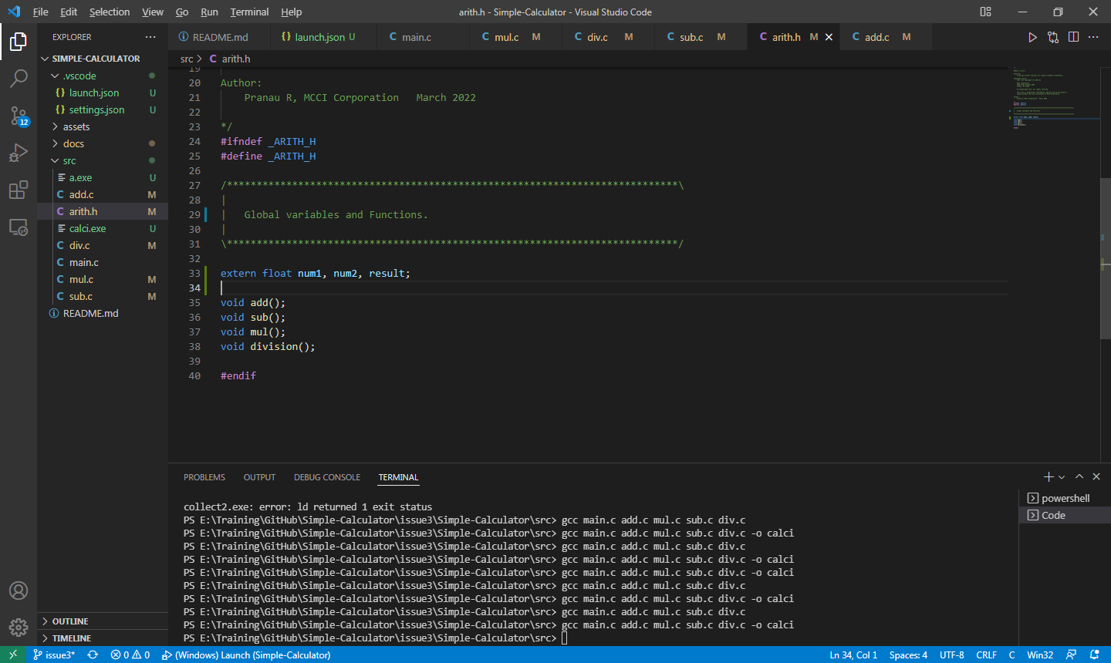

We were facing “undefined reference” and “first defined here” errors because we used extern keyword for a global variable in wrong way. Previously, we declared our extern variables and used extern keyword in header file and source files as well. But in actual usage, a global variable must be declared where it is defined, or it must be declared once in a program globally without definition and then can be extended several times using ‘extern’ keyword for definition purpose. A variable can be declared various times but it can be defined only once in a program.

**For ex:** In our task, we are getting input numbers (variable definition) from user in main() function, i.e. The input variables are defined only once inside main() function.

It is necessary to declare a global variable outside function so that whole program gets access to it.

Now, to use the values entered by user on other source files (or other function) we use “extern” keyword. Therefore, by using “extern” keyword in other file, a variable from one file (where it gets defined) can be accessed/used in other file.

To avoid multiple times declaring a variable in a multi-source files, we can use ‘extern’ keyword in header file. Therefore, we have extended our global variable in header file using ‘extern’ keyword, thus the values of a global variable from main.c file is extended to header file. Now by including the header file (#include “filename.h”) inside the required source file, we can able extend the global variable in that required source file as well.

**Issue Fix Log File:** compile_issue3_fix_log1_20220323a

**Link Referred:** [Understanding the extern Keyword in C - JournalDev](https://www.journaldev.com/38985/extern-keyword-in-c)