**Work/Task/Title:** Recursive Function – Fib, Fact and Prime numbers

**Expected Result:** To create a Menu which can perform Fibonacci series, Factorial of a number and Prime numbers using recursive function.

**Issue (Screenshot 1):**

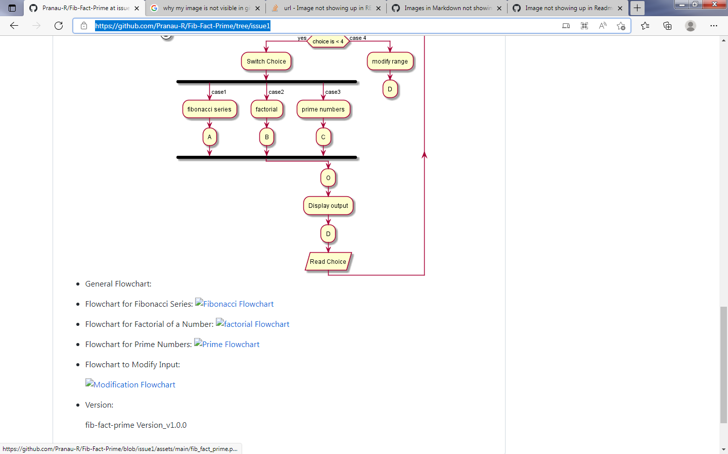

Only general Flow chart is visible in README.md file after uploading, other flowcharts are not not visible in README.md. Flowchart is visible while using VSCode but it is not visible once it is pushed to remote repository.

**Issue (Screenshots):**

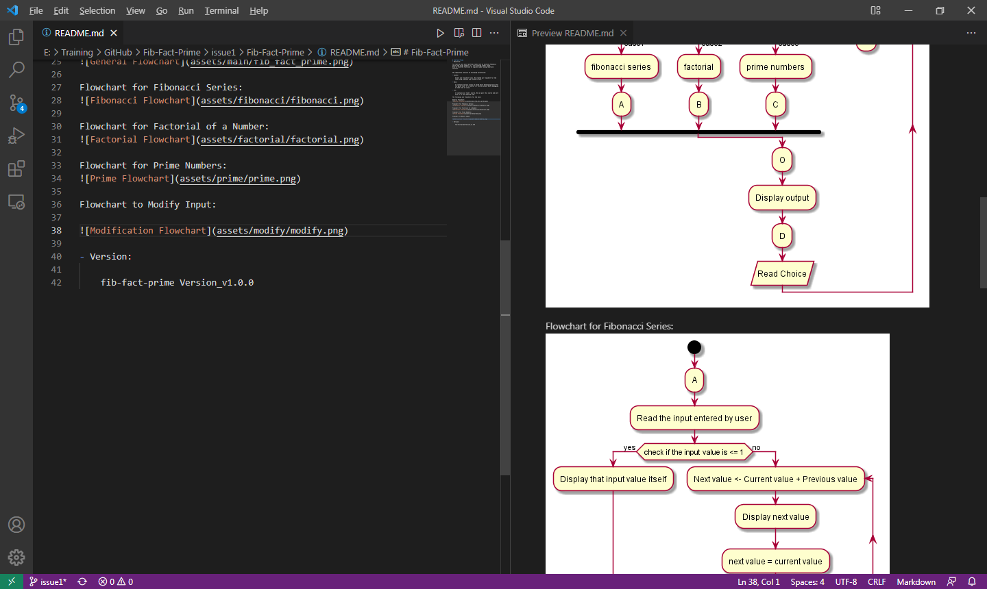

VSCode screenshot.