**Work/Task/Title:** Recursive Function – Fib, Fact and Prime numbers

**Expected Result:** To create a Menu which can perform Fibonacci series, Factorial of a number and Prime numbers using recursive function.

**Issue (Screenshots):**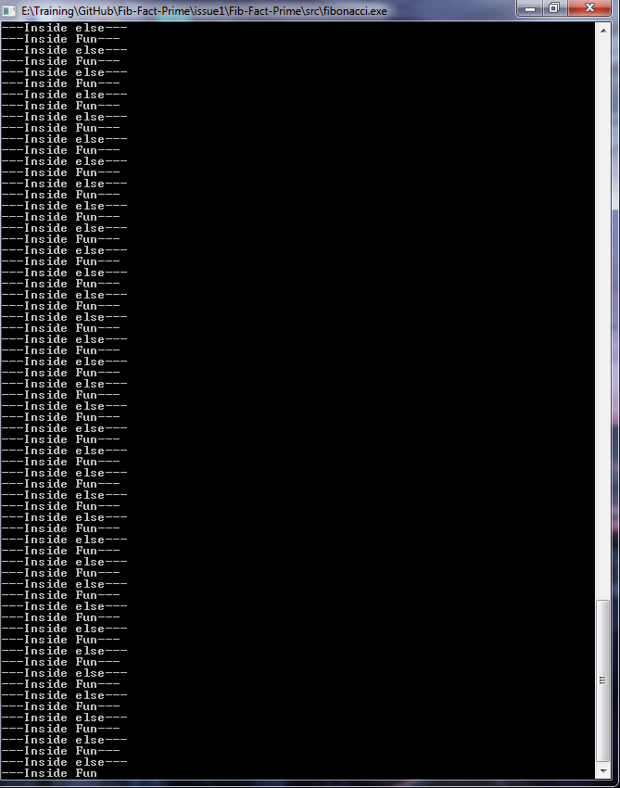

Instead of printing fibonacci series, the output is getting inside an infinity loop.