**Work/Task/Title:** Recursive Function – Fib, Fact and Prime numbers

**Expected Result:** To create a Menu which can perform Fibonacci series, Factorial of a number and Prime numbers using recursive function.

**Issue (Screenshot 1):**

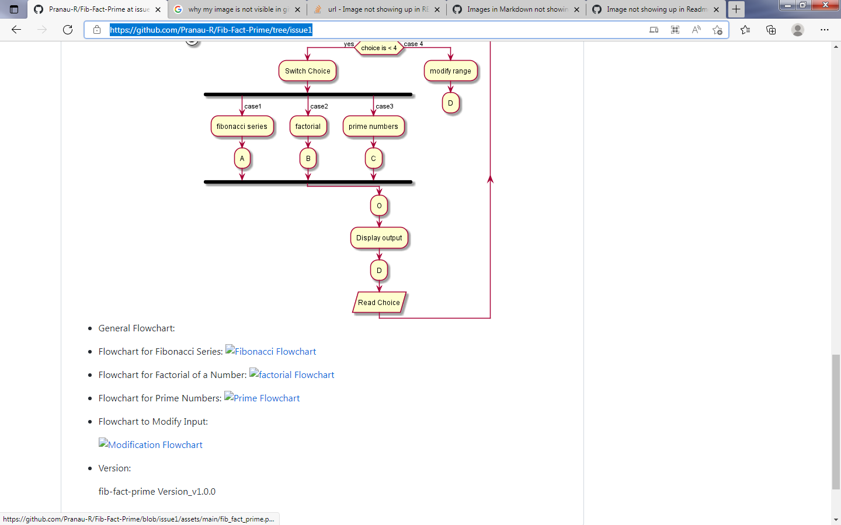

Only general Flow chart is visible in README.md file after uploading, other flowcharts are not not visible in README.md. Flowchart is visible while using VSCode but it is not visible once it is pushed to remote repository.

**Issue (Screenshots):**

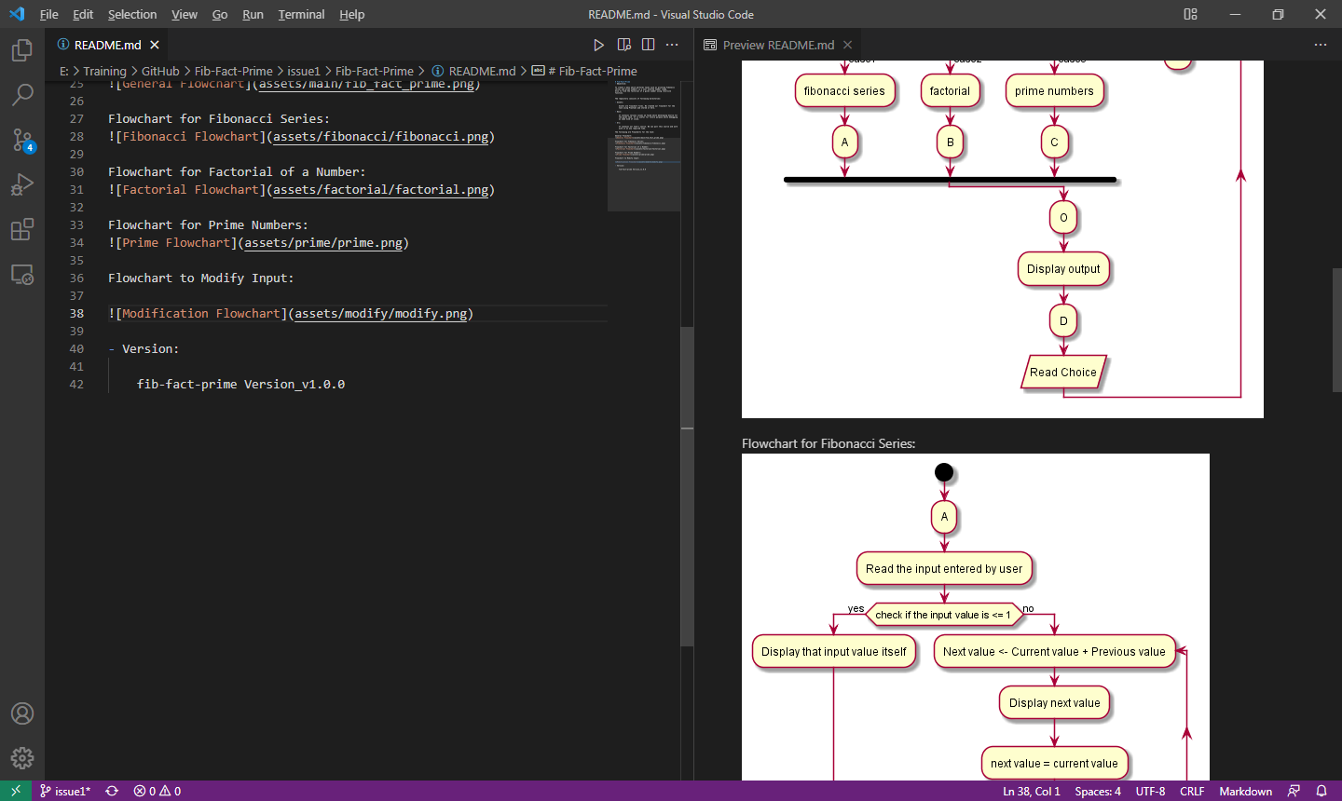

VSCode screenshot.

**Issue fix:**

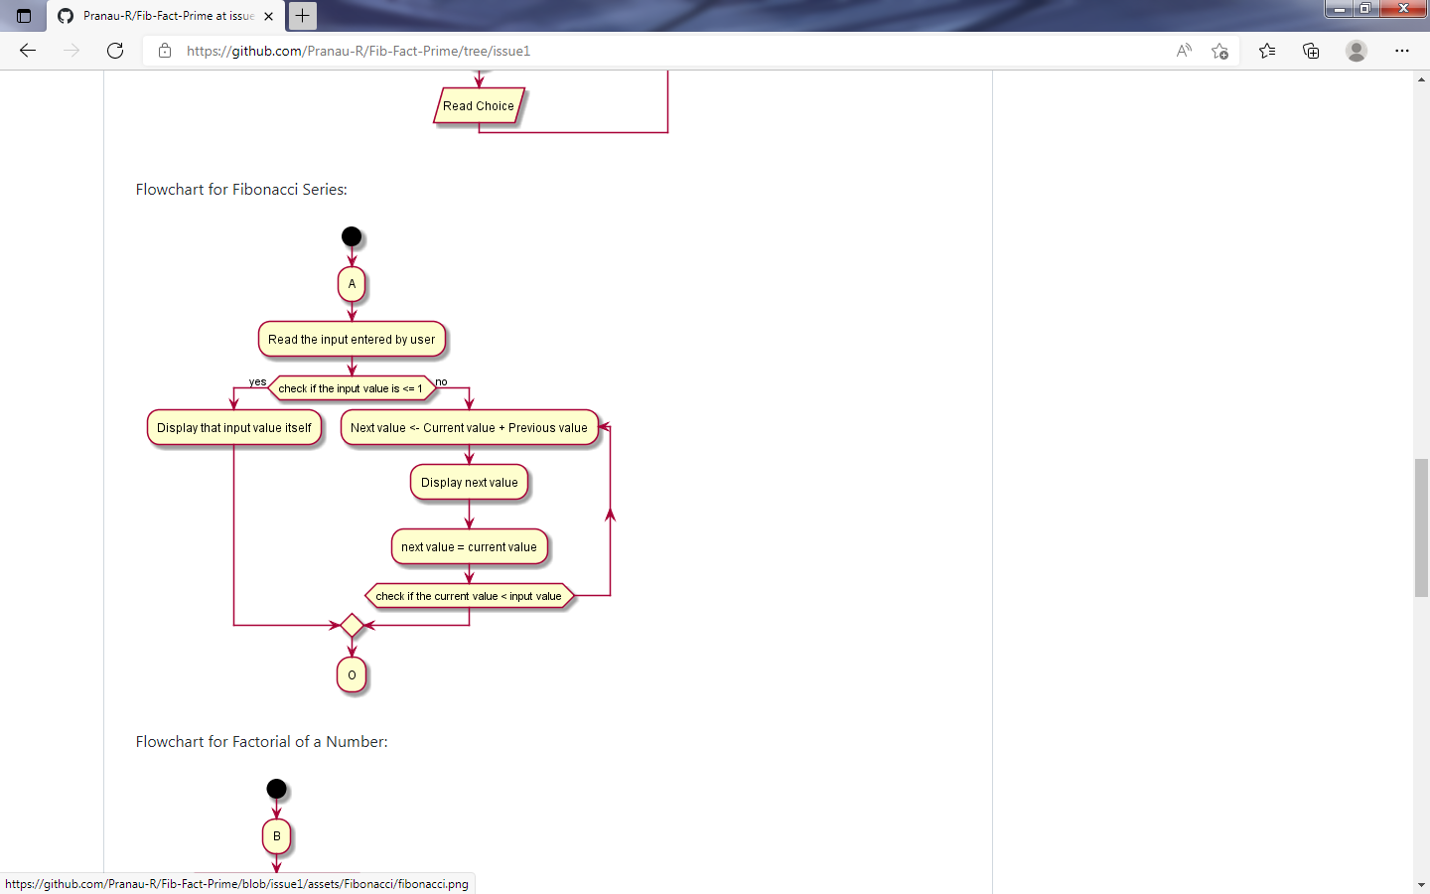

In README.md file, the path we set for these images are incorrect. Only the main function (general flowchart) path was correct. The issue was due to case sensitivity. Instead of using capital letter on first letter of the directory path, I used small letter.

**For ex:** instead of “Factorial”, I used “factorial”.

**Example path:** from this “![Prime Flowchart](assets/prime/**p**rime.png)” to this “![Prime Flowchart](assets/**P**rime/prime.png)”.

It is because, while creating those directories, I created them with the first letter capital. So even in path, we have to mention those capital letters properly.

Since case sensitivity plays an important role in Github, the README file was looking perfect in local repo but the flowchart was not visible unexpectedly in remote repo.

Now I changed it from “factorial”, ”fibonacci”, ”prime”, ”modify” to “Factorial”, “Fibanocci”, “Prime”, “Modify” respectively.