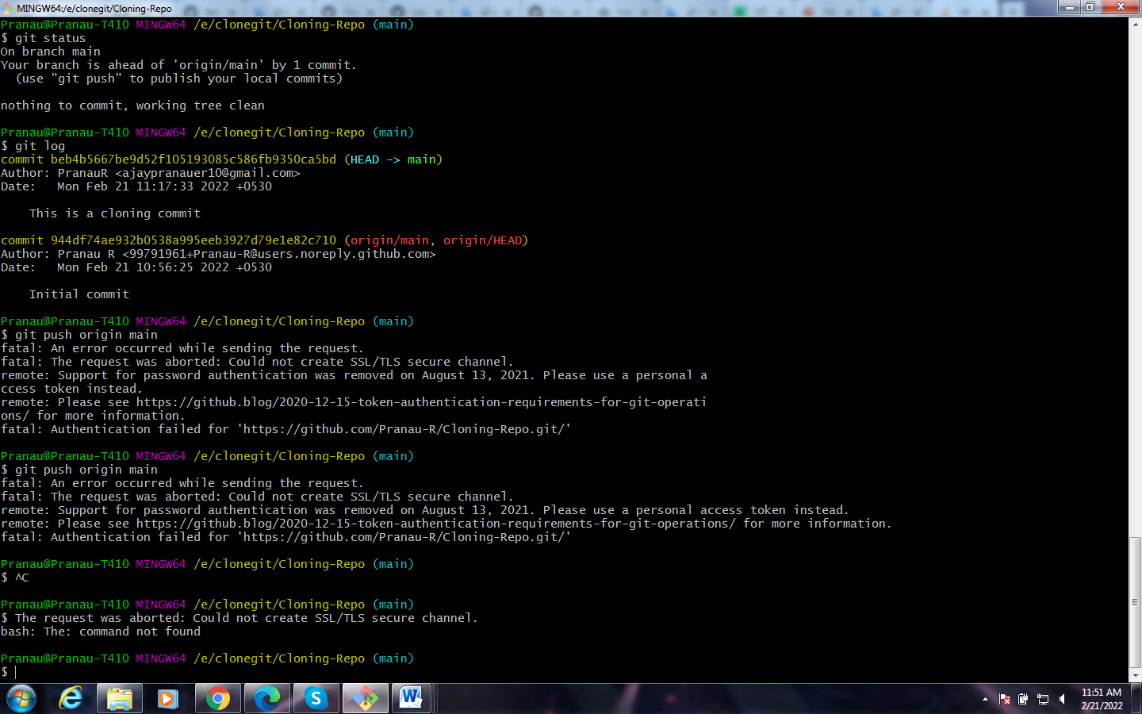

I can’t able to push my file to remote repository. Its’s showing something like above image.

**Attachment:**

Pushing-Issue1.txt

**Fix for Push-Issue1:**

Instead of pushing the files using user login, we pushed used github personal access token.