Catena New Board Software Support
  - Engineering Report 95000xxxx95000xxxx
  - Draft 195000xxxx Draft 1Draft 1
  - Date: 2021-02-01
Copyright © 2021
All Rights Reserved

PROPRIETARY NOTICE AND DISCLAIMER
Unless noted otherwise, this document and the information herein disclosed are proprietary to MCCI Corporation, 3520 Krums Corners Road, Ithaca, New York 14850 (“MCCI”). Any person or entity to whom this document is furnished or having possession thereof, by acceptance, assumes custody thereof and agrees that the document is given in confidence and will not be copied or reproduced in whole or in part, nor used or revealed to any person in any manner except to meet the purposes for which it was delivered. Additional rights and obligations regarding this document and its contents may be defined by a separate written agreement with MCCI, and if so, such separate written agreement shall be controlling.
The information in this document is subject to change without notice, and should not be construed as a commitment by MCCI. Although MCCI will make every effort to inform users of substantive errors, MCCI disclaims all liability for any loss or damage resulting from the use of this manual or any software described herein, including without limitation contingent, special, or incidental liability.
MCCI, TrueCard, TrueTask, MCCI Catena, and MCCI USB DataPump are registered trademarks of MCCI Corporation.
MCCI Instant RS-232, MCCI Wombat, NerveCircuit, and InstallRight Pro are trademarks of MCCI Corporation.
All other trademarks and registered trademarks are owned by the respective holders of the trademarks or registered trademarks.
Copyright © 2021 by MCCI Corporation.

Document Release History
Draft 1 | 2021-MM-DD | First draft

Table of Contents
1 Introduction 5
2 Documents Required 5
2.1 Documents to Modify 5
2.2 New Documents 5
2.2.1 For Board Support 5
2.2.2 For Platform Support 5
2.3 Working of Modified Documents 5
2.3.1 Catena.h 6
2.3.2 Catena_base.h 7
2.3.3 Catena_guid.h 8
2.3.4 Catena_platforms.h 12
2.4 Relevant Documents 12

List of Tables
Table 1. References, IP Blocks 12

List of Figures
Figure 1 Include board header file in Catena.h 6
Figure 2 Create required platform flags 7
Figure 3 Generate a GUID and use it 8
Figure 4 Install Insert GUID extension 8
Figure 5 Open Command Palette 9
Figure 6 Search Insert GUID in Command Palette 10
Figure 7 Select the appropriate GUID format 10
Figure 8 Comment the GUID 11
Figure 9 Use the GUID as GUID init Function Argument 11
Figure 10 Declare a Global Platform 12

List of SeQUENCE Diagrams
No table of figures entries found.

Introduction
This document outlines the procedure to build a proper software support for any new Catena Board.

Documents Required
There are few libraries that have to be modified to provide software support for a Catena Board.
The Libraries are:
- Arduino LMIC
- Catena Arduino Platform
- Catena BSP
There are two types of documents that have to be modified or to be developed.

Documents to Modify
- Catena.h
- Catena_base.h
- Catena_guid.h
- Catena_platforms.h

New Documents

For Board Support
- Catena_xxxx.h
- ReadVoltage.cpp
- getPlatform.cpp
- Catenaxxxx_begin.cpp
- Catenaxxxx_LoRaWAN_begin.cpp

For Platform Support
- Override_usbd_ll_connectionstate.c
- PeripheralPins.c
- stm32l0xx_hal_conf.h
- variant.h
- variant.cpp

Working of Modified Documents
To understand the working of software support files, let’s consider MCCI Catena 5120 Board as an example new board which requires the software support.

Catena.h
Figure 1 Include board header file in Catena.h
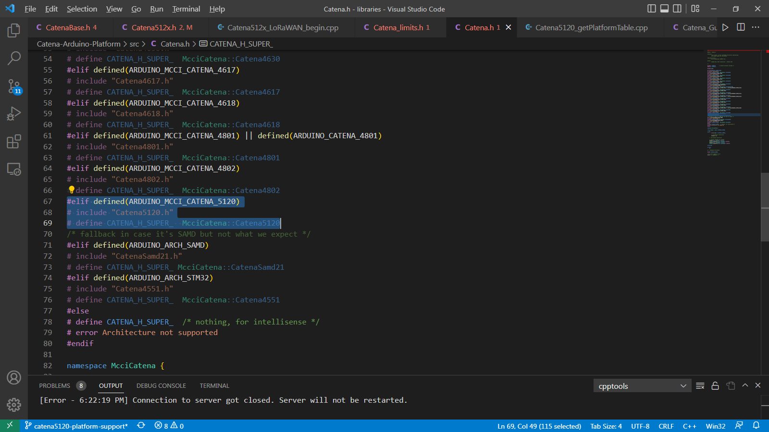
Initially in Catena.h header file, the Catena 5120 board’s header is included so that whenever it is targeted to build, the sketch will be built for Catena 5120 board.

Catena_base.h
Figure 2 Create required platform flags
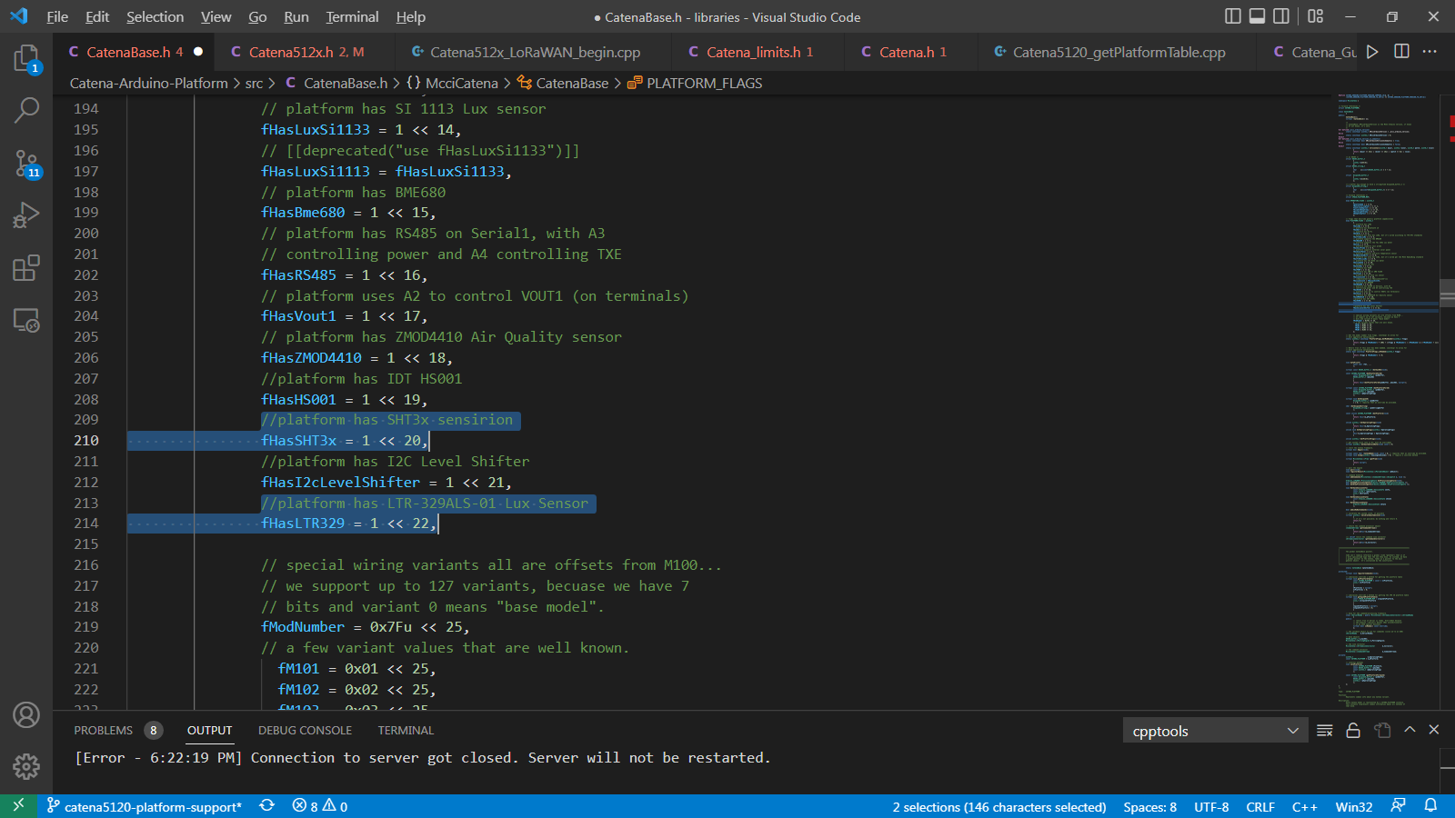
In Catena_base.h, the required platform flag should be added so that it can be used while setting up the Catena 5120 board platform. For example: In Catena 5120, the on board sensors are SHT3x Sensirion and LTR-329ALS-01 Lux sensor. Therefore it is necessary to create a platform flag for SHT3x Sensirion and LTR-329ALS-01 Lux sensor.

Catena_guid.h
Figure 3 Generate a GUID and use it
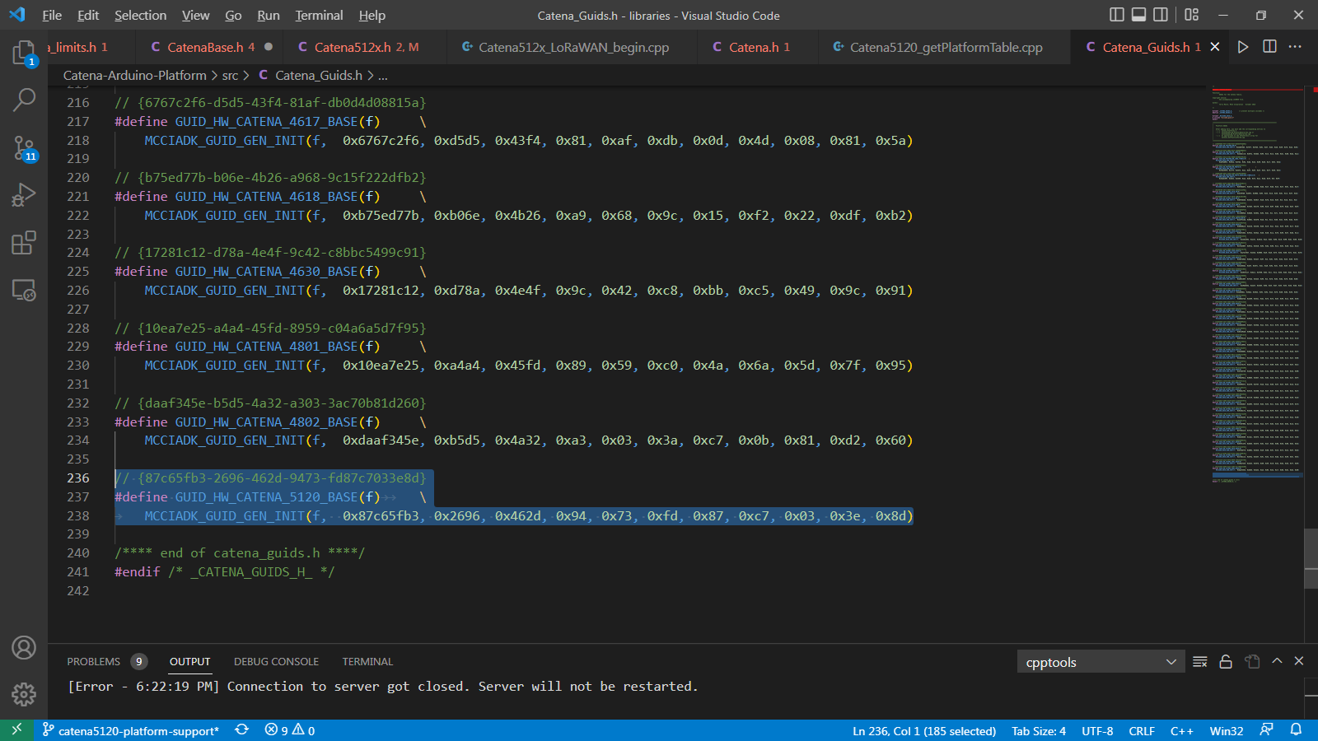
Generate a Global Unique ID (GUID) for new Catena Board to make the Board unique. Follow the below steps to generate and setup a new GUID for new Catena Board.
Figure 4 Install Insert GUID extension
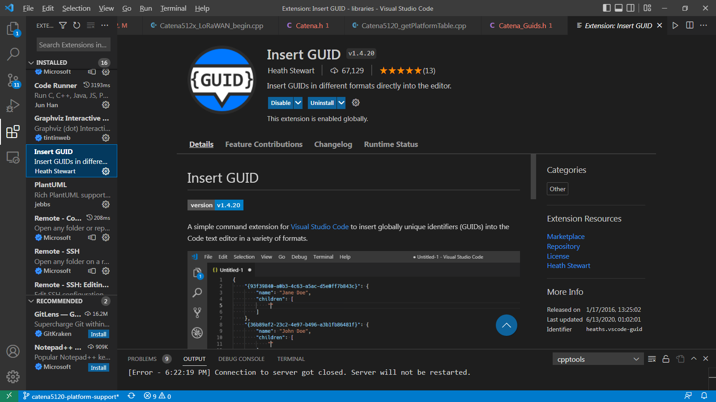
Install the “Insert GUID” extension to generate a new GUID for the Board.

Figure 5 Open Command Palette
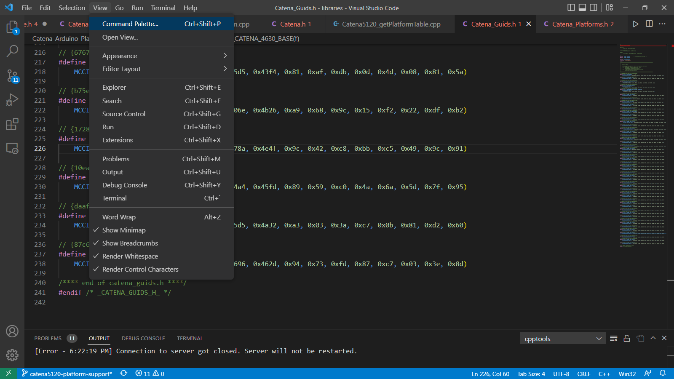
Open “command palette” by clicking “view” then “Command Palette” on top left corner. (Or simply use Ctrl + Shift + P)
Figure 6 Search Insert GUID in Command Palette
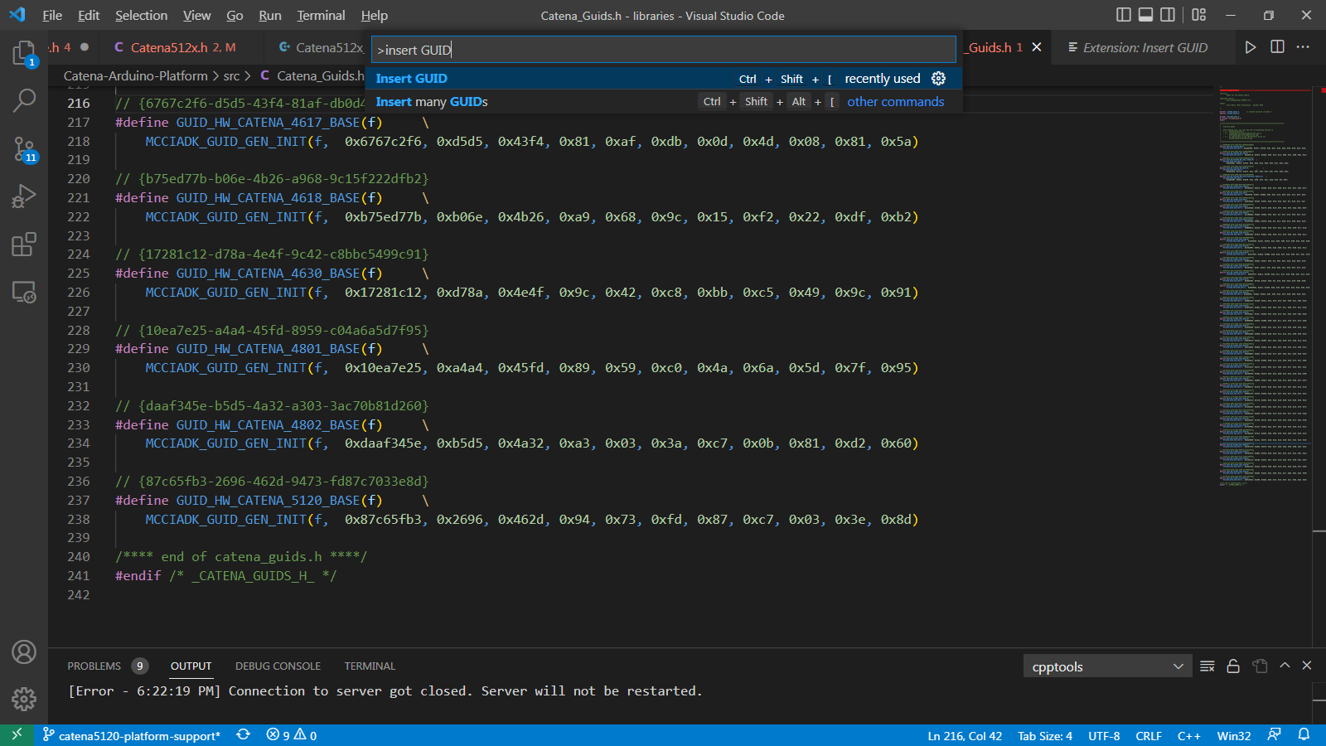
In command palette, type “Insert GUID” and choose “Insert GUID” from scroll down bar.
Figure 7 Select the appropriate GUID format
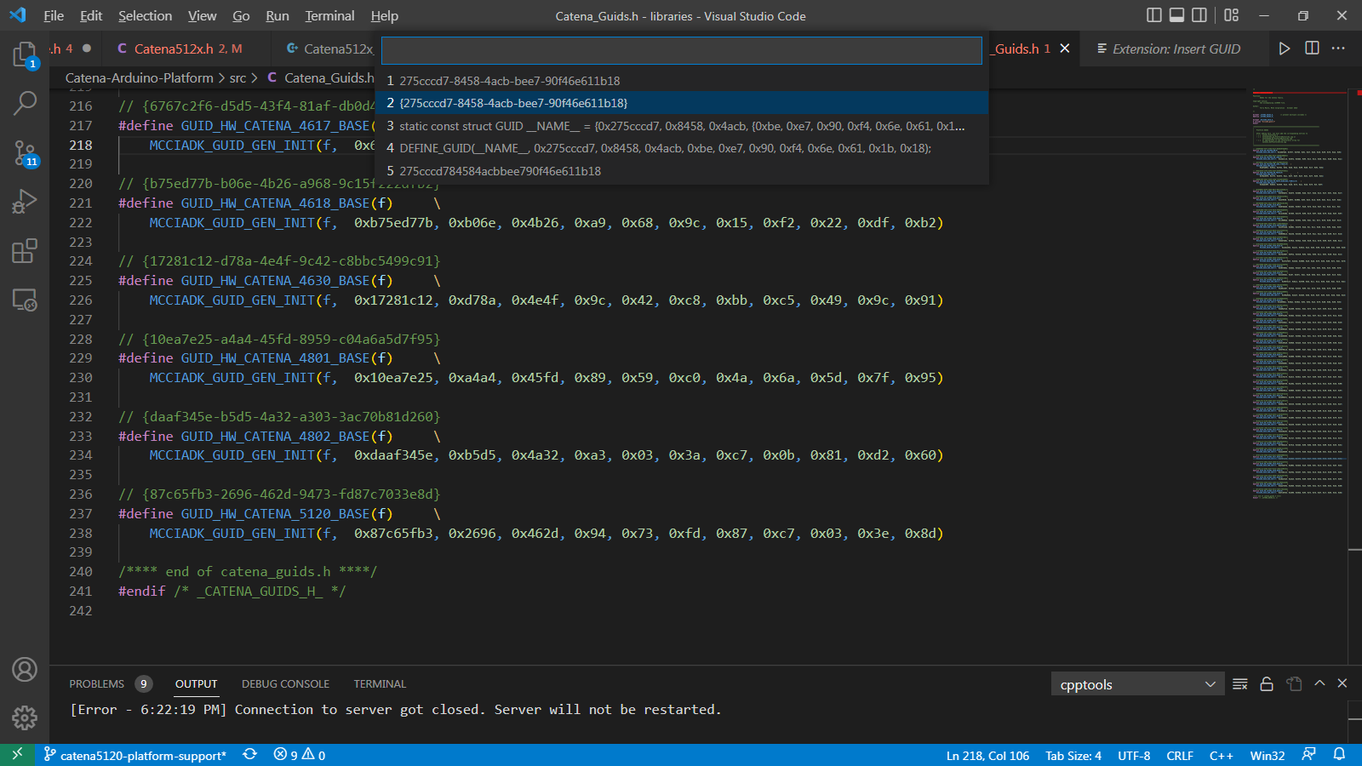
From the scroll down bar, once again select the suitable GUID format. (We use the second format from above figure)
Figure 8 Comment the GUID
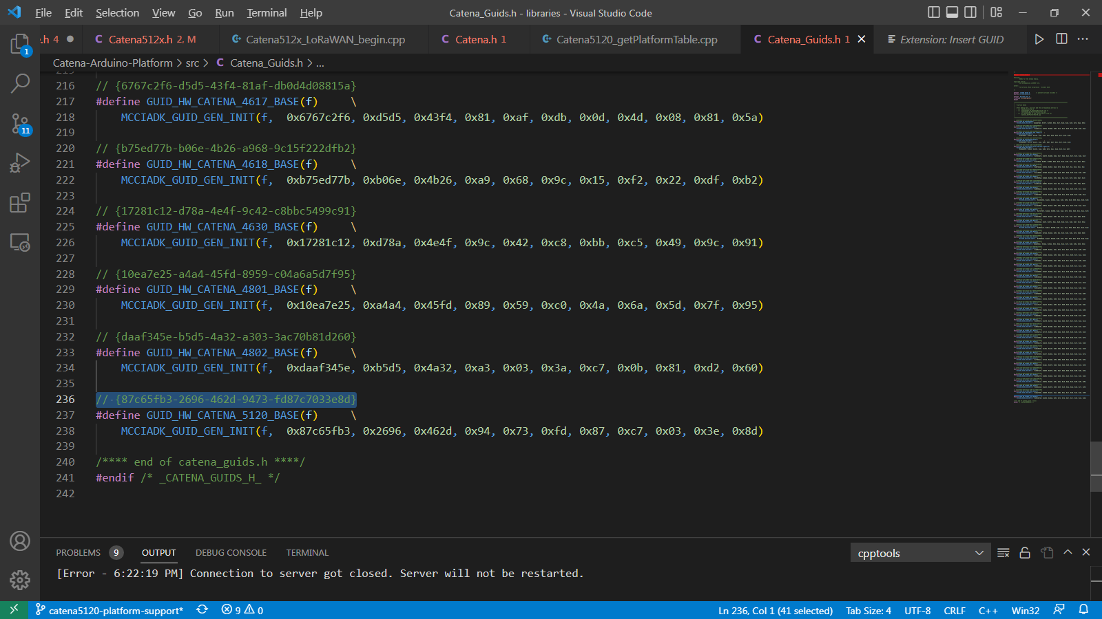
After choosing the suitable GUID format, the GUID will be placed in source. Now comment the GUID by using “//” operator.
Figure 9 Use the GUID as GUID init Function Argument
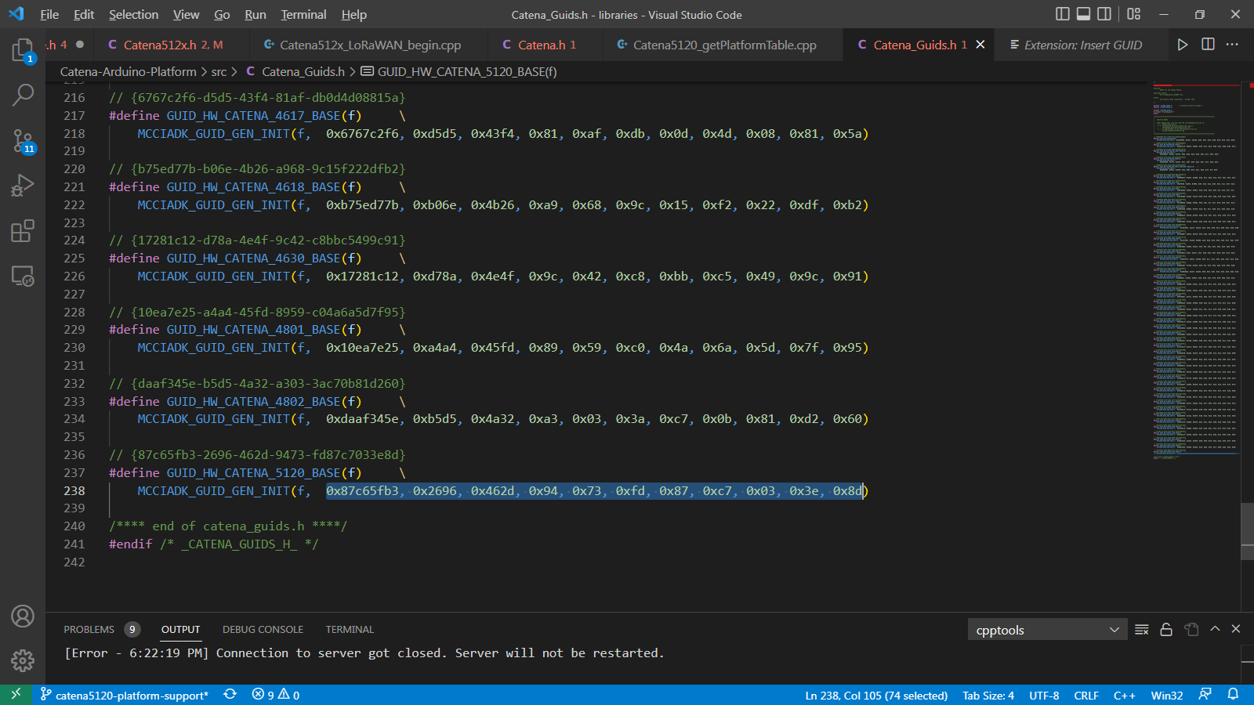
Now pass the newly generated GUID in MCCIADK_GUID_GEN_INIT() function as an argument so the GUID will be registered for the Catena Board.

Catena_platforms.h
Figure 10 Declare a Global Platform
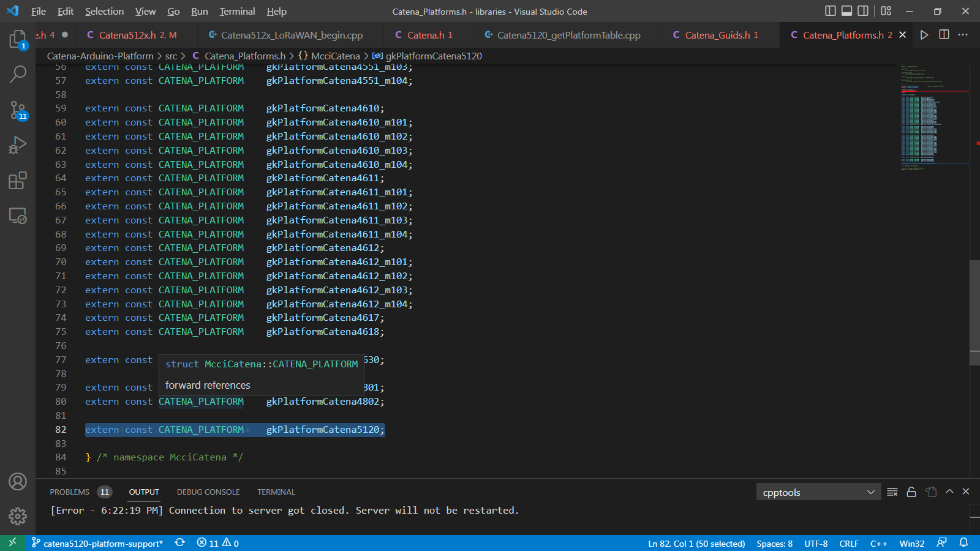
Declare an extern global platform in Catena_platforms.h so that the Catena_platforms.h header file can be re-used in all Catena Boards to avoid confusion and to avoid more coding.The global platform variable is defined in Catena5120_getPlatformTable.cpp which is extern in Catena_platforms.h

Relevant Documents

Table 1. References, IP Blocks
Reference | File | Comments

