Catena New Board Software Support
  - Engineering Report 95000xxxx95000xxxx
  - Draft 195000xxxx Draft 1Draft 1
  - Date: 2021-02-01
Copyright © 2021
All Rights Reserved

PROPRIETARY NOTICE AND DISCLAIMER
Unless noted otherwise, this document and the information herein disclosed are proprietary to MCCI Corporation, 3520 Krums Corners Road, Ithaca, New York 14850 (“MCCI”). Any person or entity to whom this document is furnished or having possession thereof, by acceptance, assumes custody thereof and agrees that the document is given in confidence and will not be copied or reproduced in whole or in part, nor used or revealed to any person in any manner except to meet the purposes for which it was delivered. Additional rights and obligations regarding this document and its contents may be defined by a separate written agreement with MCCI, and if so, such separate written agreement shall be controlling.
The information in this document is subject to change without notice, and should not be construed as a commitment by MCCI. Although MCCI will make every effort to inform users of substantive errors, MCCI disclaims all liability for any loss or damage resulting from the use of this manual or any software described herein, including without limitation contingent, special, or incidental liability.
MCCI, TrueCard, TrueTask, MCCI Catena, and MCCI USB DataPump are registered trademarks of MCCI Corporation.
MCCI Instant RS-232, MCCI Wombat, NerveCircuit, and InstallRight Pro are trademarks of MCCI Corporation.
All other trademarks and registered trademarks are owned by the respective holders of the trademarks or registered trademarks.
Copyright © 2021 by MCCI Corporation.

Document Release History
Draft 1 | 2021-MM-DD | First draft

Table of Contents
1 Introduction 5
2 Documents Required 5
2.1 Documents to Modify 5
2.2 New Documents 5
2.2.1 For Board Support 5
2.2.2 For Platform Support 5
2.3 Purpose of Modified Documents 6
2.3.1 Catena.h 6
2.3.2 Catena_base.h 7
2.3.3 Catena_guid.h 8
2.3.4 Catena_platforms.h 12
2.4 Purpose of New Documents 13
2.4.1 For Board Support 13
2.4.1.1 Catena_xxxx.h (for board specific platform support) 13
2.4.1.2 Catena_xxxx.h (for CatenaBase family platform support) 14
2.4.1.3 ReadVoltage.cpp 15
2.4.1.4 getPlatformTable.cpp 16
2.4.1.5 Catenaxxxx_begin.cpp 17
2.4.1.6 Catenaxxxx_LoRaWAN_begin.cpp 18
2.4.2 For Platform Support 19
2.4.2.1 Override_usbd_ll_connectionstate.c 19
2.4.2.2 PeripheralPins.c 19
2.4.2.3 stm32l0xx_hal_conf.h 20
2.4.2.4 variant.h 20
2.4.2.5 variant.cpp 21
2.5 Relevant Documents 21

List of Tables
Table 1. References, IP Blocks 21

List of Figures
Figure 1 Include board header file in Catena.h 6
Figure 2 Create required platform flags 7
Figure 3 Generate a GUID and use it 8
Figure 4 Install Insert GUID extension 8
Figure 5 Open Command Palette 9
Figure 6 Search Insert GUID in Command Palette 10
Figure 7 Select the appropriate GUID format 10
Figure 8 Comment the GUID 11
Figure 9 Use the GUID as GUID init Function Argument 11
Figure 10 Declare a Global Platform 12
Figure 11 Board Specification Support 13
Figure 12 CatenaBase family platform support 14
Figure 13 ReadVoltage.cpp for Catena 5120 15
Figure 14 getPlatformTable.cpp for Catena 5120 16
Figure 15 Catena_begin.cpp for Catena 5120 17
Figure 16 Catena_LoRaWAN_Begin.cpp for Catena 5120 18

List of SeQUENCE Diagrams
No table of figures entries found.

Introduction
This document outlines the procedure to build a proper software support for any new Catena Board.

Documents Required
There are few libraries that have to be modified to provide software support for a Catena Board.
The Libraries are:
- Arduino LMIC
- Catena Arduino Platform
- Catena BSP
There are two types of documents that have to be modified or to be developed.

Documents to Modify
- Catena.h
- Catena_base.h
- Catena_guid.h
- Catena_platforms.h

New Documents

For Board Support
- Catena_xxxx.h (for platform support)
- Catena_xxxx.h (for CatenaBase platform support)
- ReadVoltage.cpp
- getPlatformTable.cpp
- Catenaxxxx_begin.cpp
- Catenaxxxx_LoRaWAN_begin.cpp

For Platform Support
- Override_usbd_ll_connectionstate.c
- PeripheralPins.c
- stm32l0xx_hal_conf.h
- variant.h
- variant.cpp

Purpose of Modified Documents
To understand the working of software support files, let’s consider MCCI Catena 5120 Board as an example new board which requires the software support.

Catena.h
Figure 1 Include board header file in Catena.h
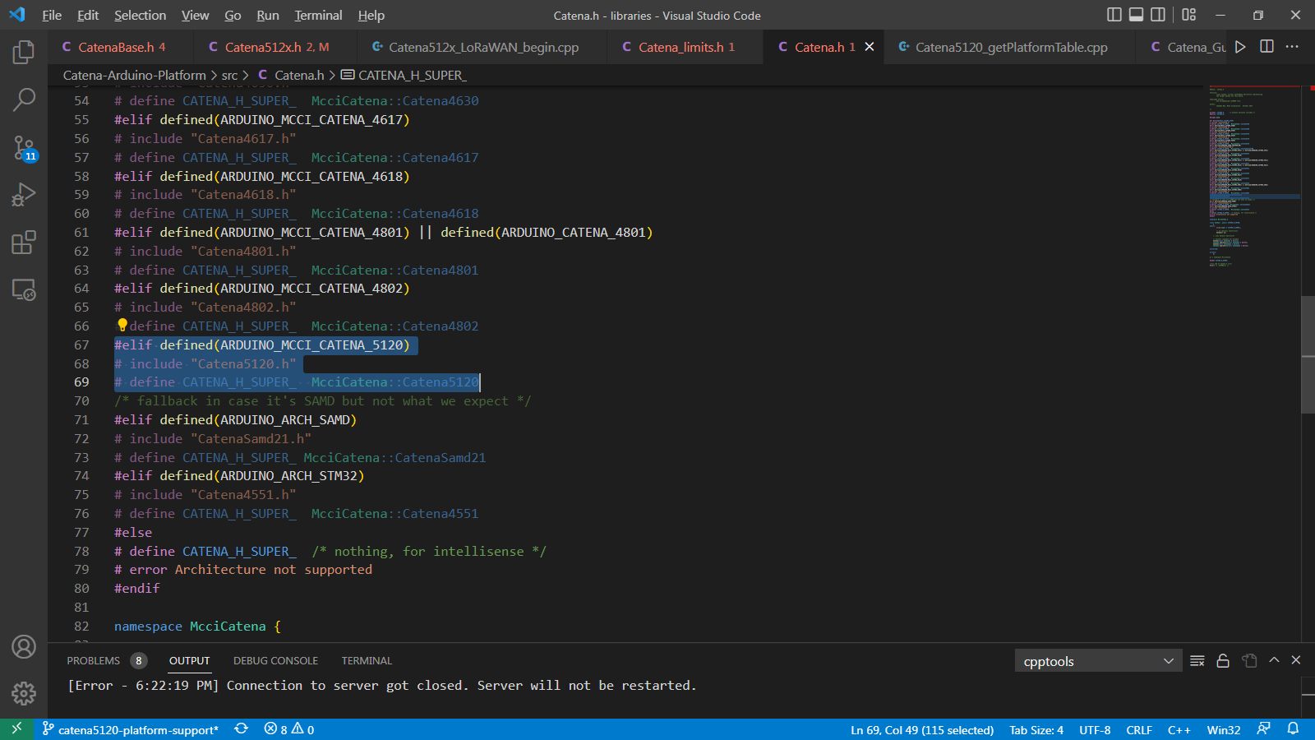
Initially in Catena.h header file, the Catena 5120 board’s header is included so that whenever it is targeted to build, the sketch will be built for Catena 5120 board.

Catena_base.h
Figure 2 Create required platform flags
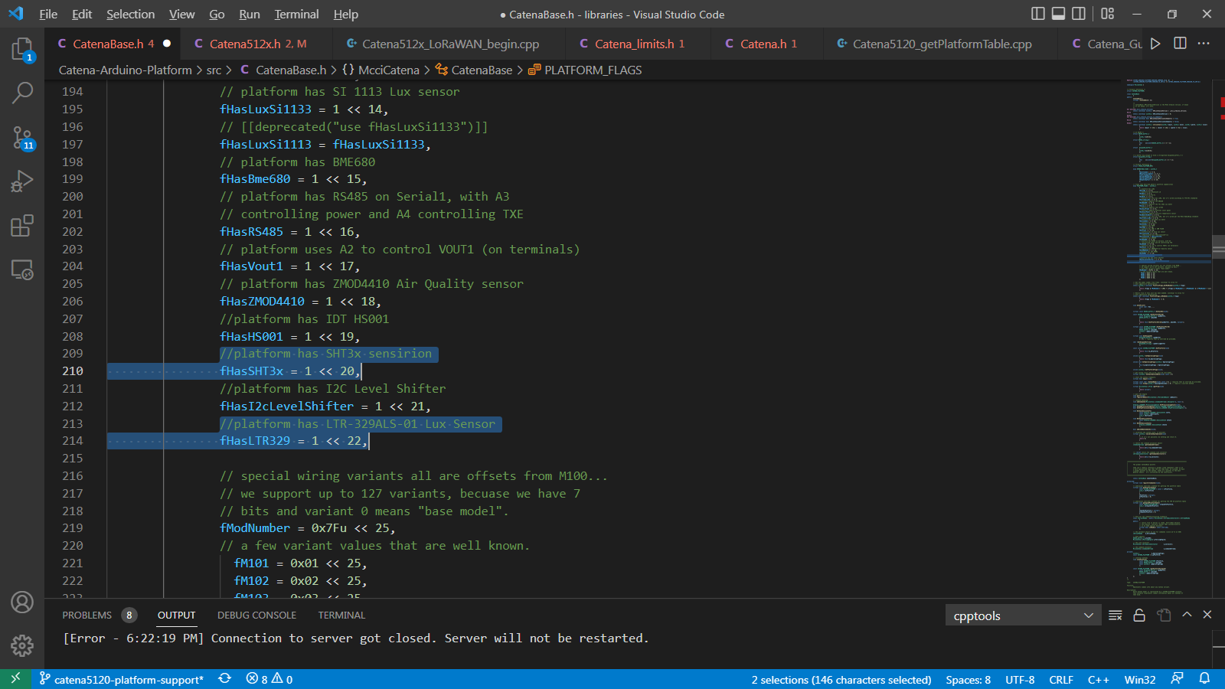
In Catena_base.h, the required platform flag should be added so that it can be used while setting up the Catena 5120 board platform. For example: In Catena 5120, the on board sensors are SHT3x Sensirion and LTR-329ALS-01 Lux sensor. Therefore it is necessary to create a platform flag for SHT3x Sensirion and LTR-329ALS-01 Lux sensor.

Catena_guid.h
Figure 3 Generate a GUID and use it
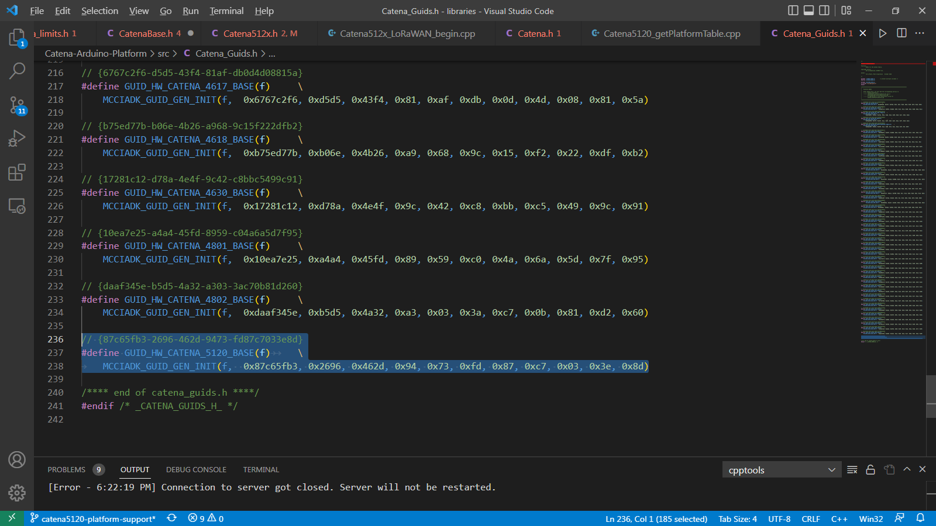
Generate a Global Unique ID (GUID) for new Catena Board to make the Board unique. Follow the below steps to generate and setup a new GUID for new Catena Board.
Figure 4 Install Insert GUID extension
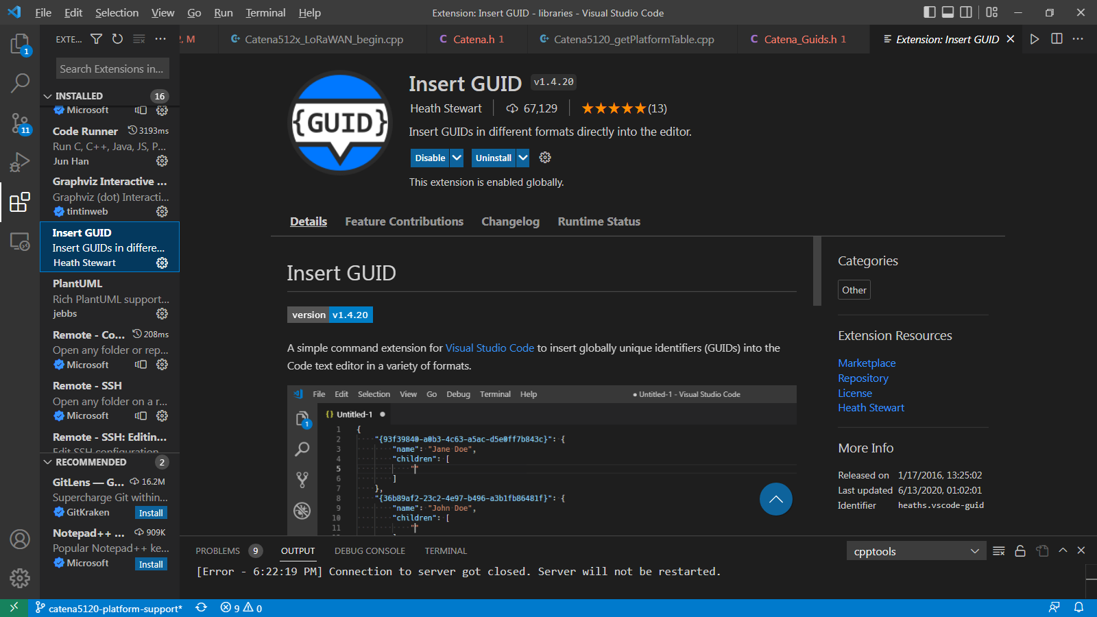
Install the “Insert GUID” extension to generate a new GUID for the Board.

Figure 5 Open Command Palette
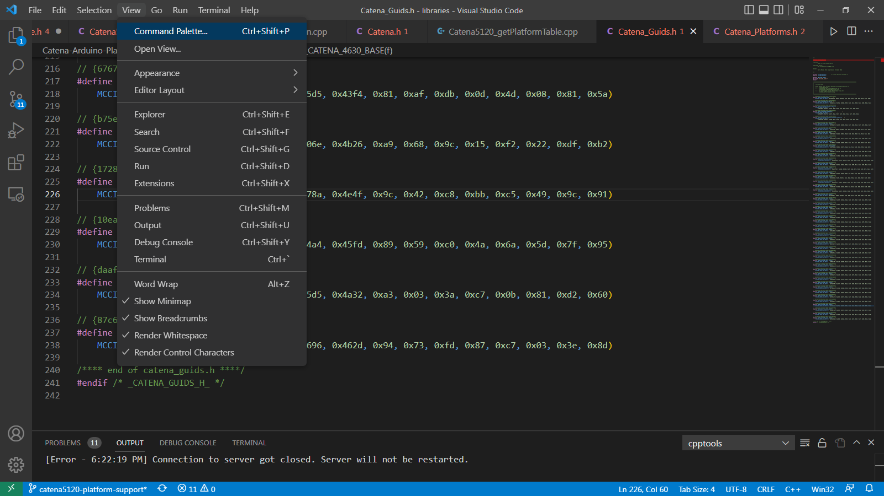
Open “command palette” by clicking “view” then “Command Palette” on top left corner. (Or simply use Ctrl + Shift + P)
Figure 6 Search Insert GUID in Command Palette
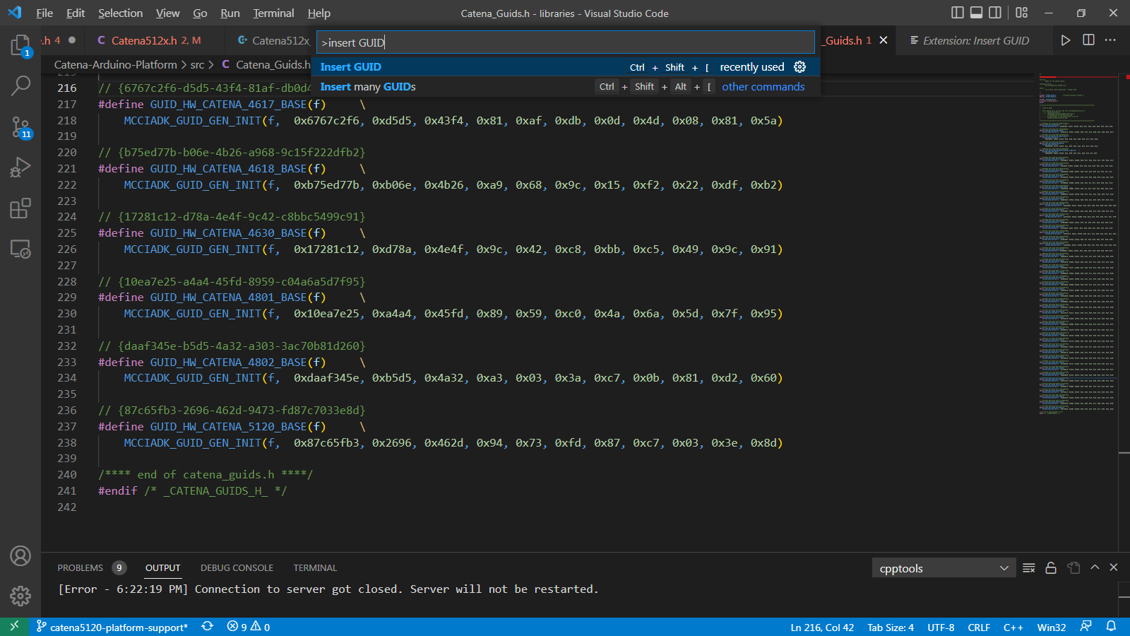
In command palette, type “Insert GUID” and choose “Insert GUID” from scroll down bar.
Figure 7 Select the appropriate GUID format
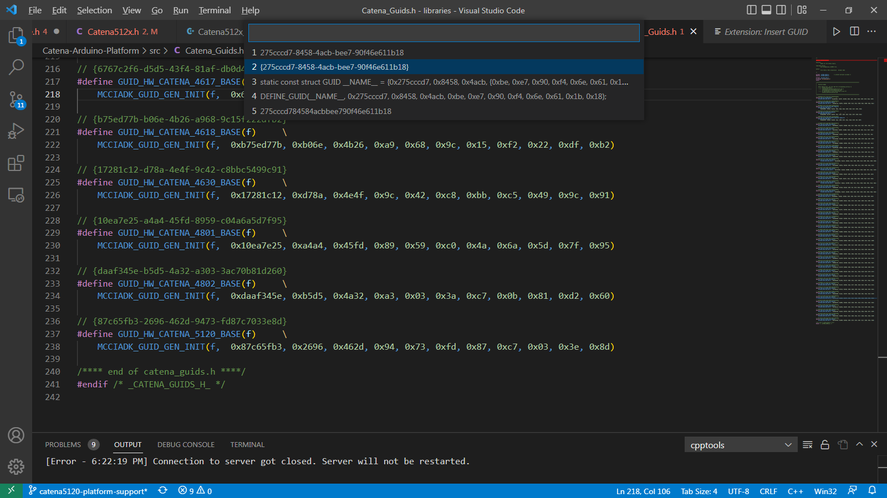
From the scroll down bar, once again select the suitable GUID format. (We use the second format from above figure)
Figure 8 Comment the GUID
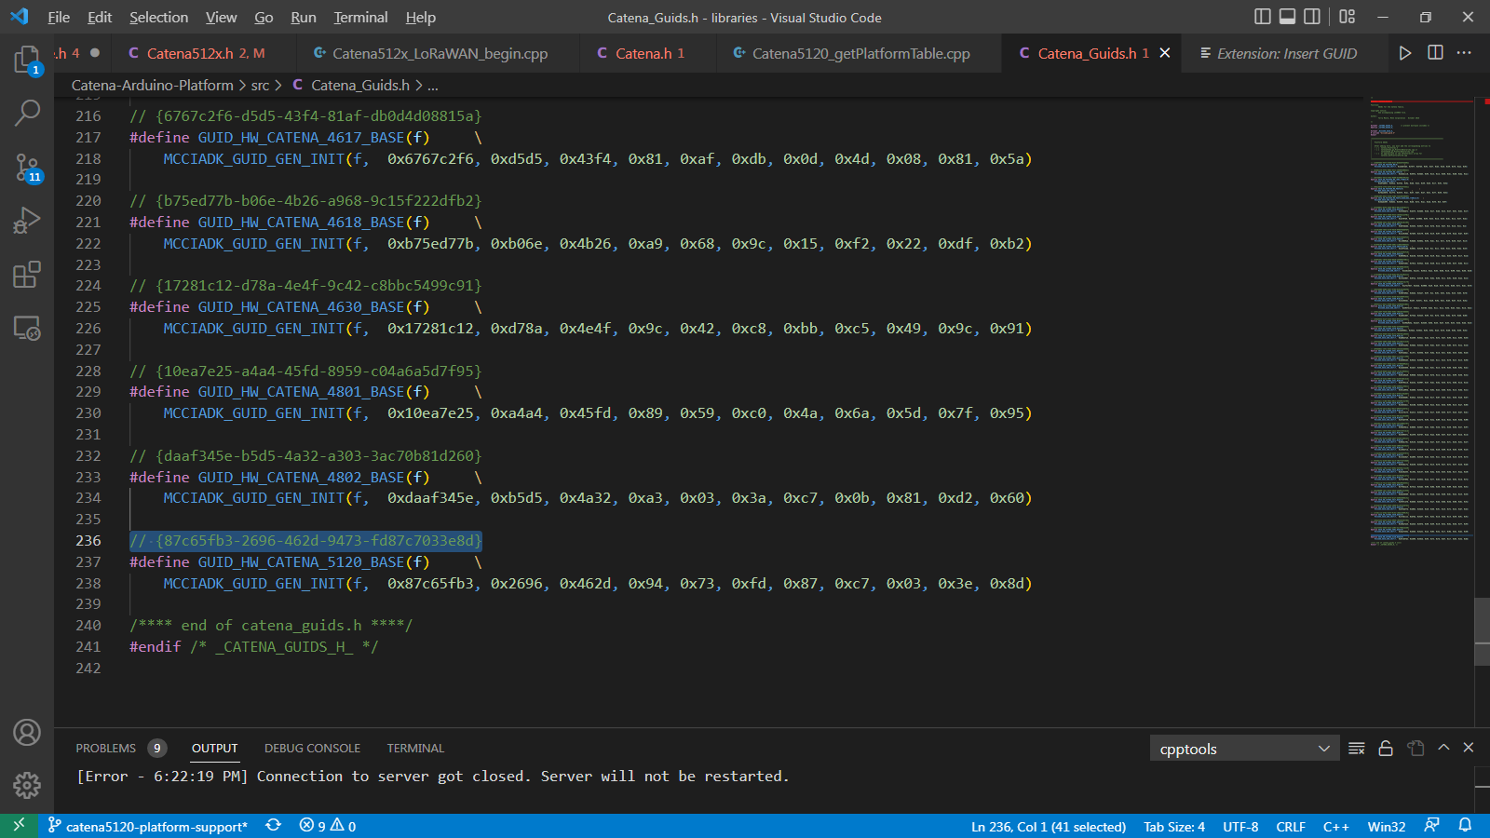
After choosing the suitable GUID format, the GUID will be placed in source. Now comment the GUID by using “//” operator.
Figure 9 Use the GUID as GUID init Function Argument
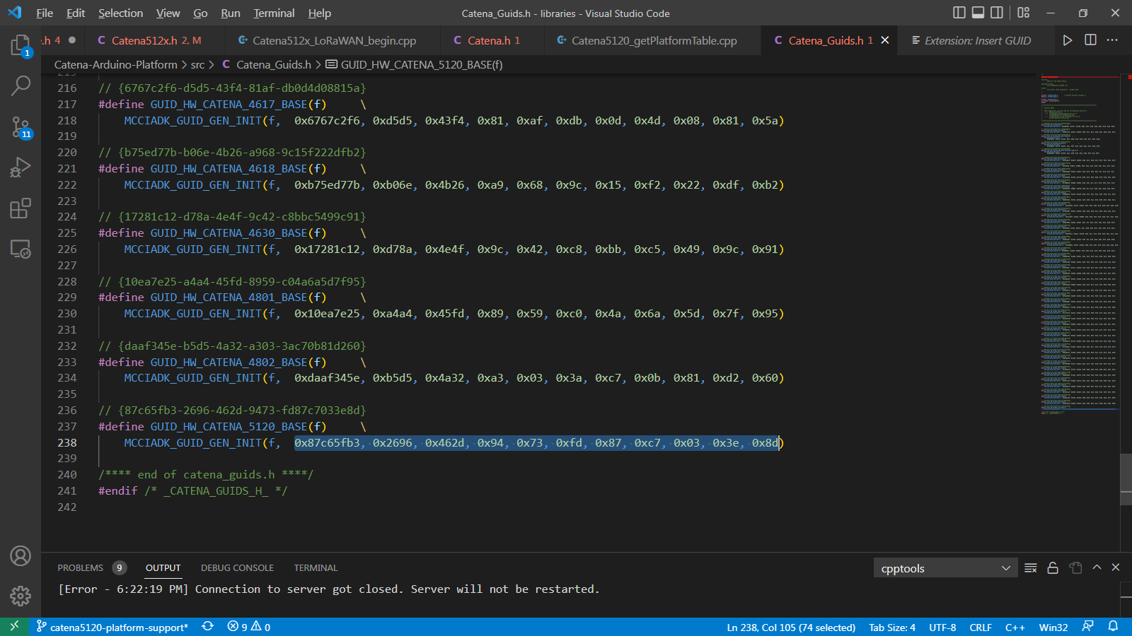
Now pass the newly generated GUID in MCCIADK_GUID_GEN_INIT() function as an argument so the GUID will be registered for the Catena Board.

Catena_platforms.h
Figure 10 Declare a Global Platform
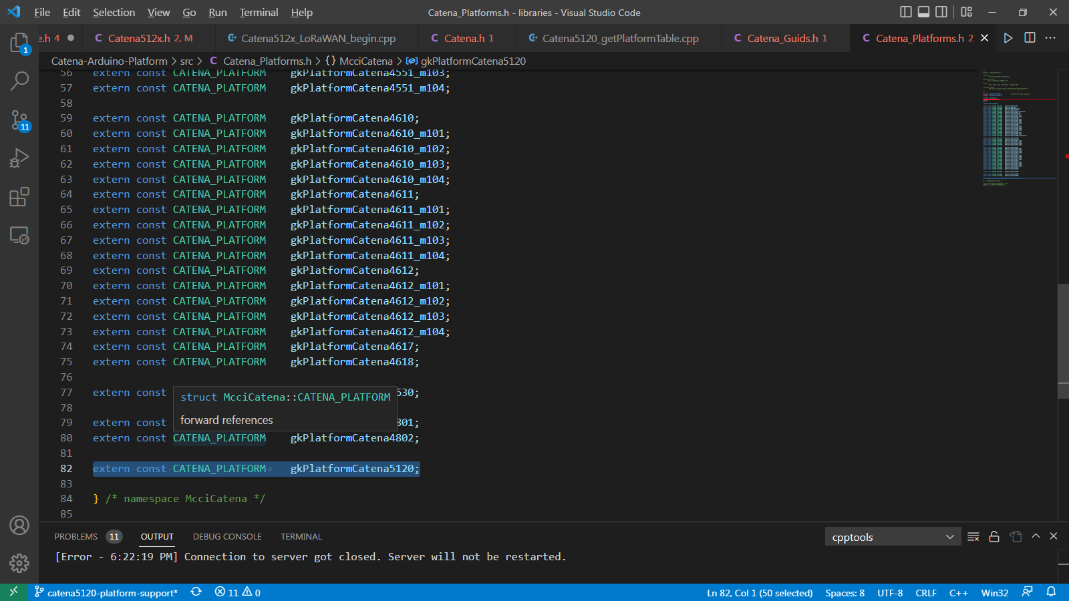
Declare an extern global platform in Catena_platforms.h so that the Catena_platforms.h header file can be re-used in all Catena Boards to avoid confusion and to avoid more coding.The global platform variable is defined in Catena5120_getPlatformTable.cpp which is extern in Catena_platforms.h

Purpose of New Documents

For Board Support

Catena_xxxx.h (for board specific platform support)
Figure 11 Board Specification Support
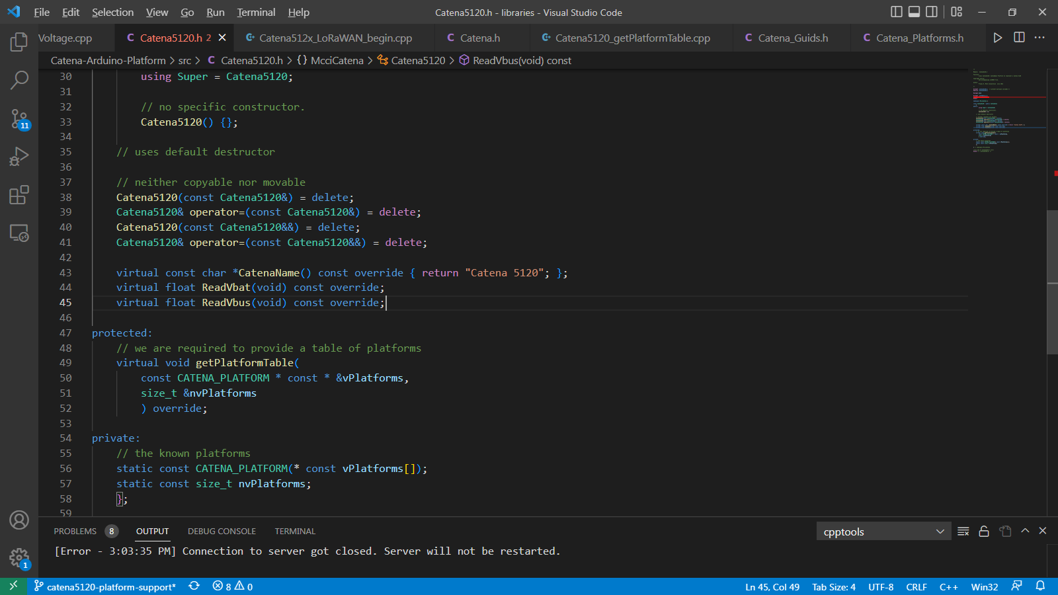
Since we are considering Catena 5120 board as an example, we can name this file as Catena_5120.h. This file is used as CatenaBase platform file to represent Catena 5120 board alone.
It contains some of the required function prototypes such as getPlatformTable (which will be used in Catena5120_getPlatformTable.cpp) and ReadVbat and ReadVbus (which will be used in Catena5120_ ReadVoltage.cpp).

Catena_xxxx.h (for CatenaBase family platform support)
Figure 12 CatenaBase family platform support
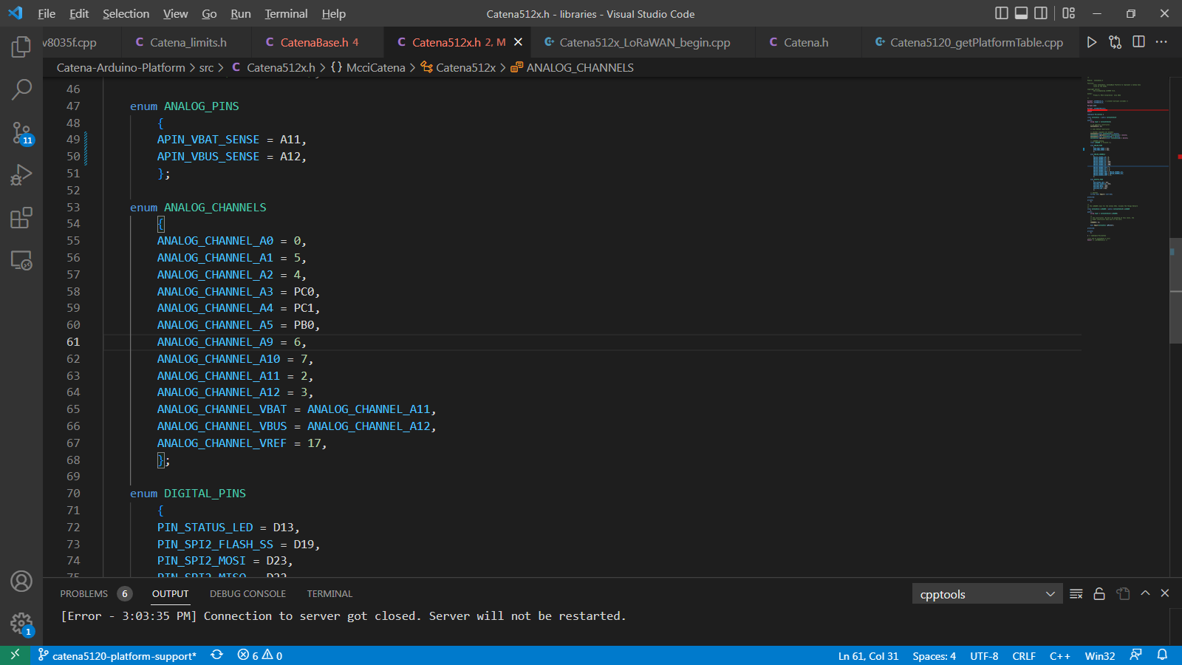
Since we are considering Catena 5120 board as an example, we can name this file as Catena_512x.h. This file is used as CatenaBase platform file to represent all the Catena 512x boards (such as 5120).
It is used for PIN mapping of a board family. For reference, check figure _.
This file is not needed to be created every time for a new board. Once we created a CatenaBase platform support file for a board (for example: Catena_461x.h), many boards such as 4610, 4612 and 4618 comes under the same family. Thus all these boards can share the same CatenaBase platform support file.
Therefore, check for an existing CatenaBase platform support file. If there is no file existing for the new board family, create a new CatenaBase platform support file.

Note:
Along with this file, some other files which represent a board’s family can also be re-used instead of creating a new file every time. For example: as Catena512x_LoRaWAN_begin.cpp, as Catena512x_begin.cpp are some examples of re-use support files for Catena 512x family.

ReadVoltage.cpp
Figure 13 ReadVoltage.cpp for Catena 5120
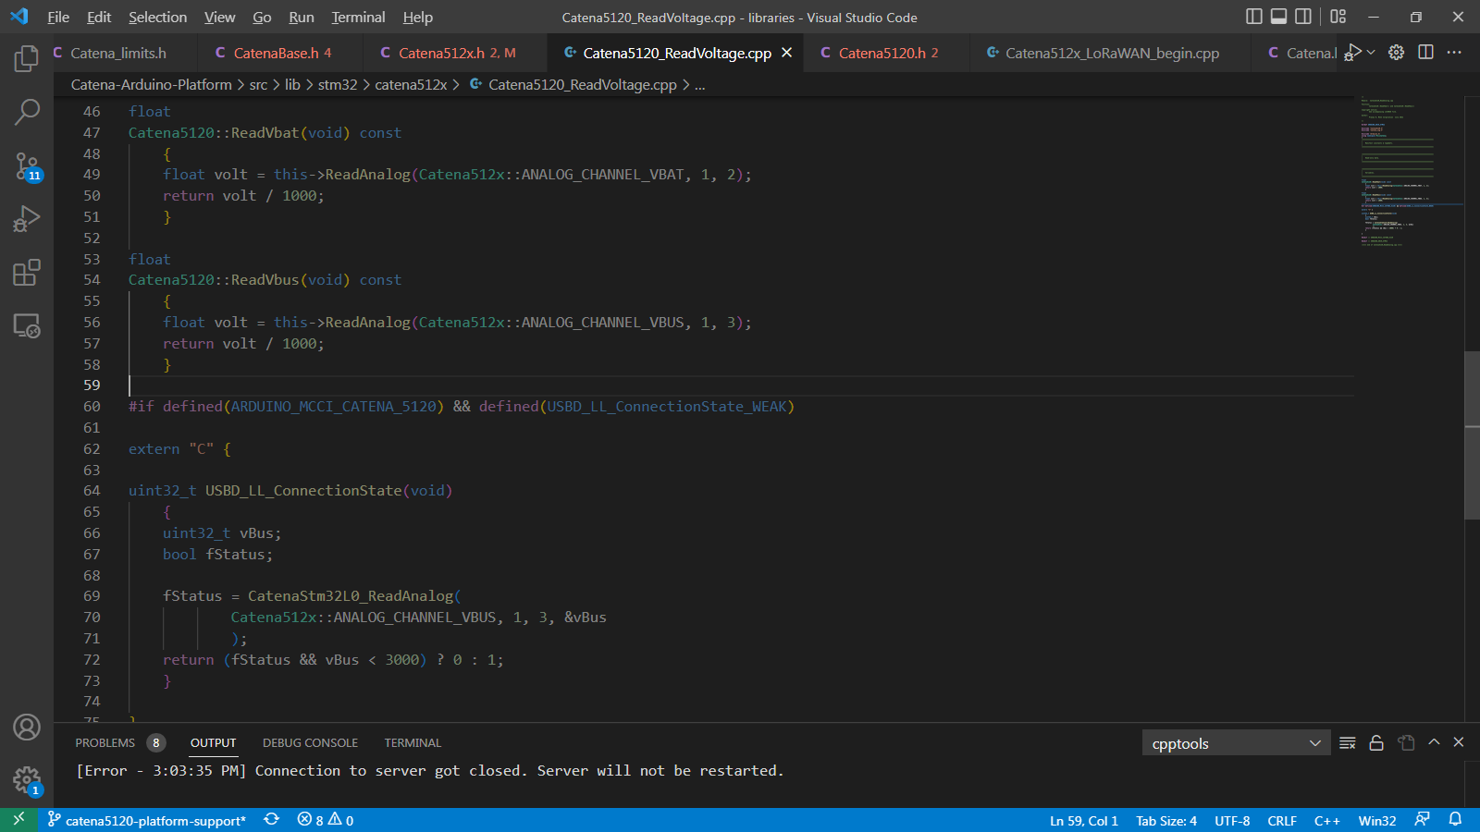
Since we are considering Catena 5120 board as an example, we can name this file as Catena5120_ReadVoltage.cpp. This source file is used to Read Vbat and Vbus. The prototype of ReadVbat() and ReadVbus is declared in Catena5120.h source file under Catena5120 class.

getPlatformTable.cpp
Figure 14 getPlatformTable.cpp for Catena 5120
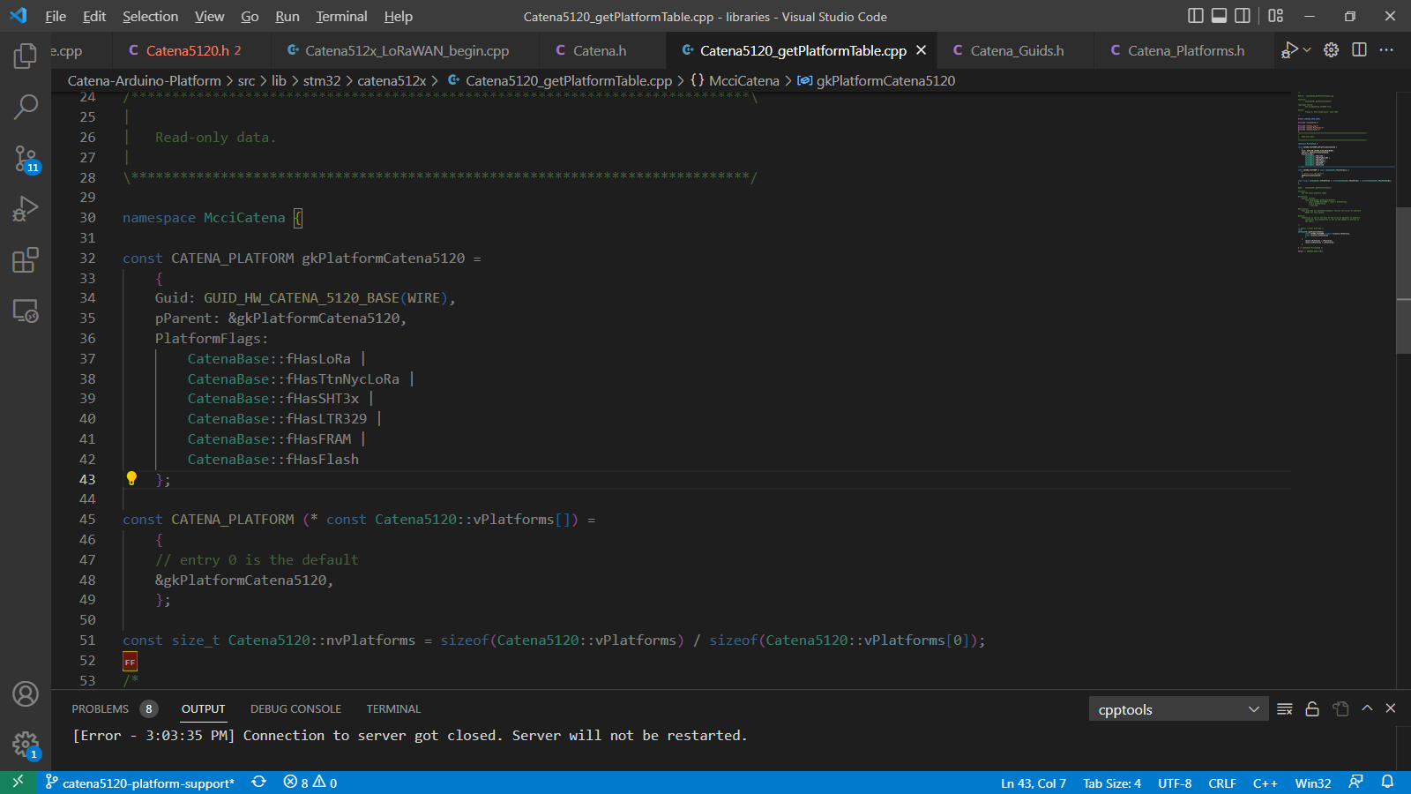
Since we are considering Catena 5120 board as an example, we can name this file as Catena5120_getPlatformTable.cpp. This file is used to set platform flags for all the available on-board sensors and to return the GUID for Catena 5120 board.

Catenaxxxx_begin.cpp
Figure 15 Catena_begin.cpp for Catena 5120
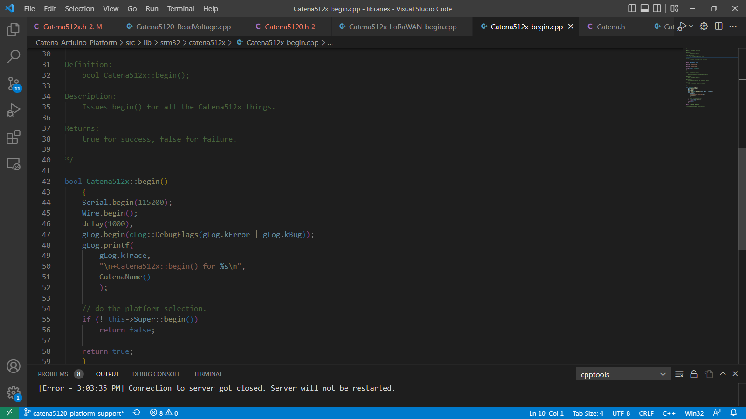
For Catena 5120 board, we can name this file as Catena512x_begin.cpp. It is used to setup the on-board peripherals by using begin () function from Catena512x class.

Catenaxxxx_LoRaWAN_begin.cpp
Figure 16 Catena_LoRaWAN_Begin.cpp for Catena 5120
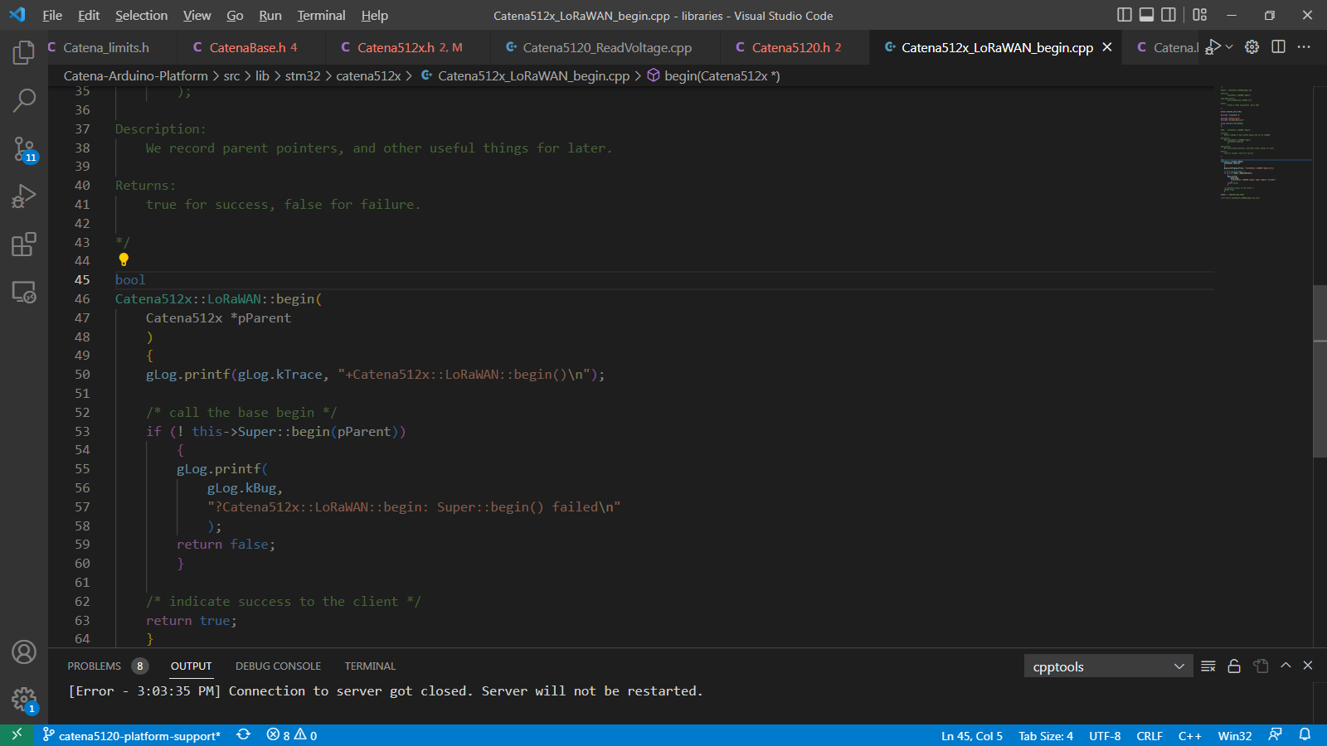
For Catena 5120 board, we can name this file as Catena512x_LoRaWAN_begin.cpp. It is used to setup the LoRaWAN for data transmission and reception.

For Platform Support

Override_usbd_ll_connectionstate.c
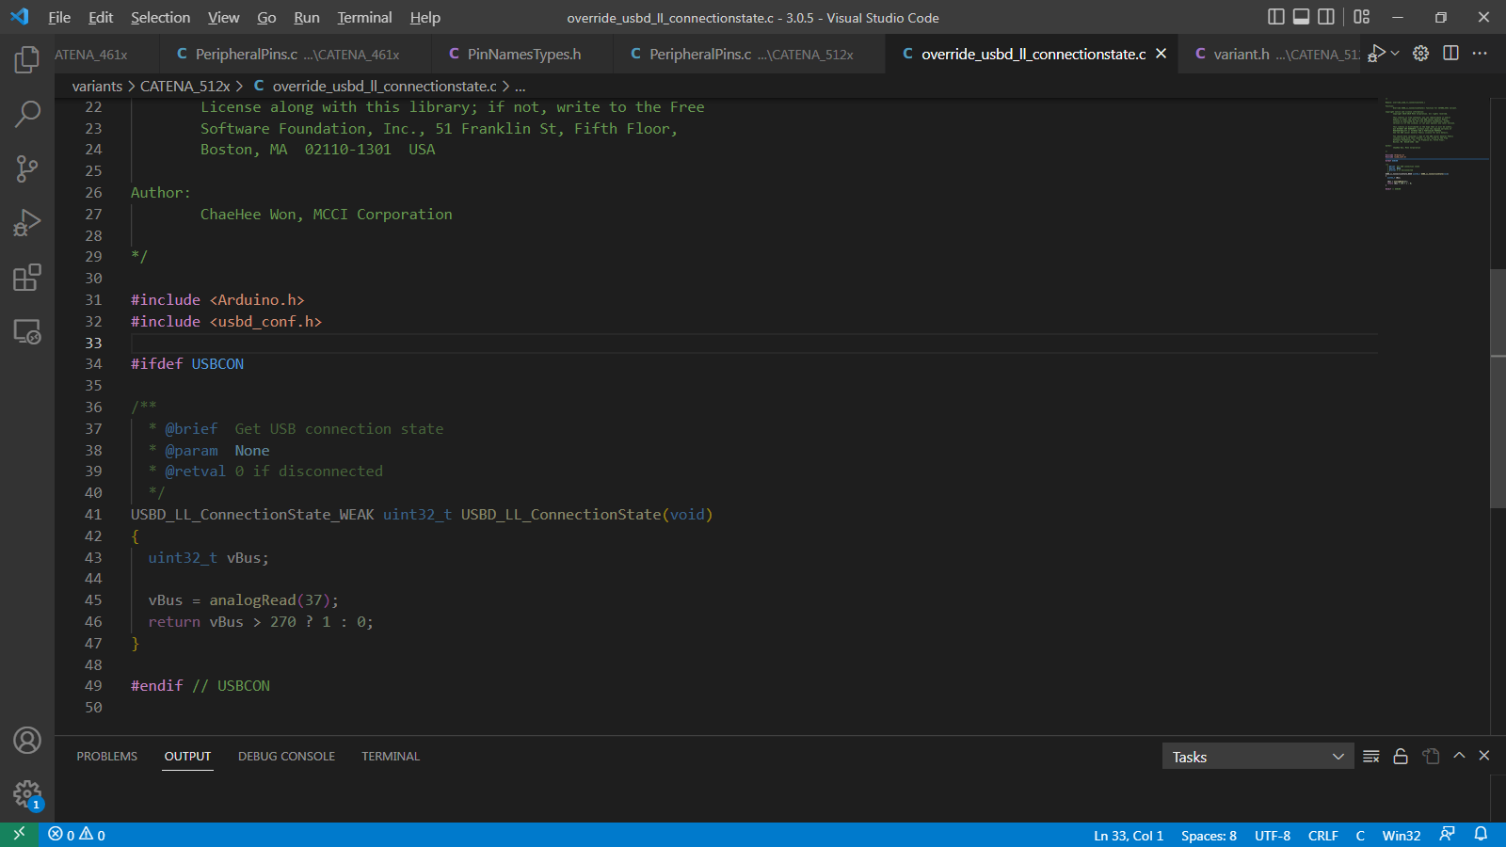

PeripheralPins.c
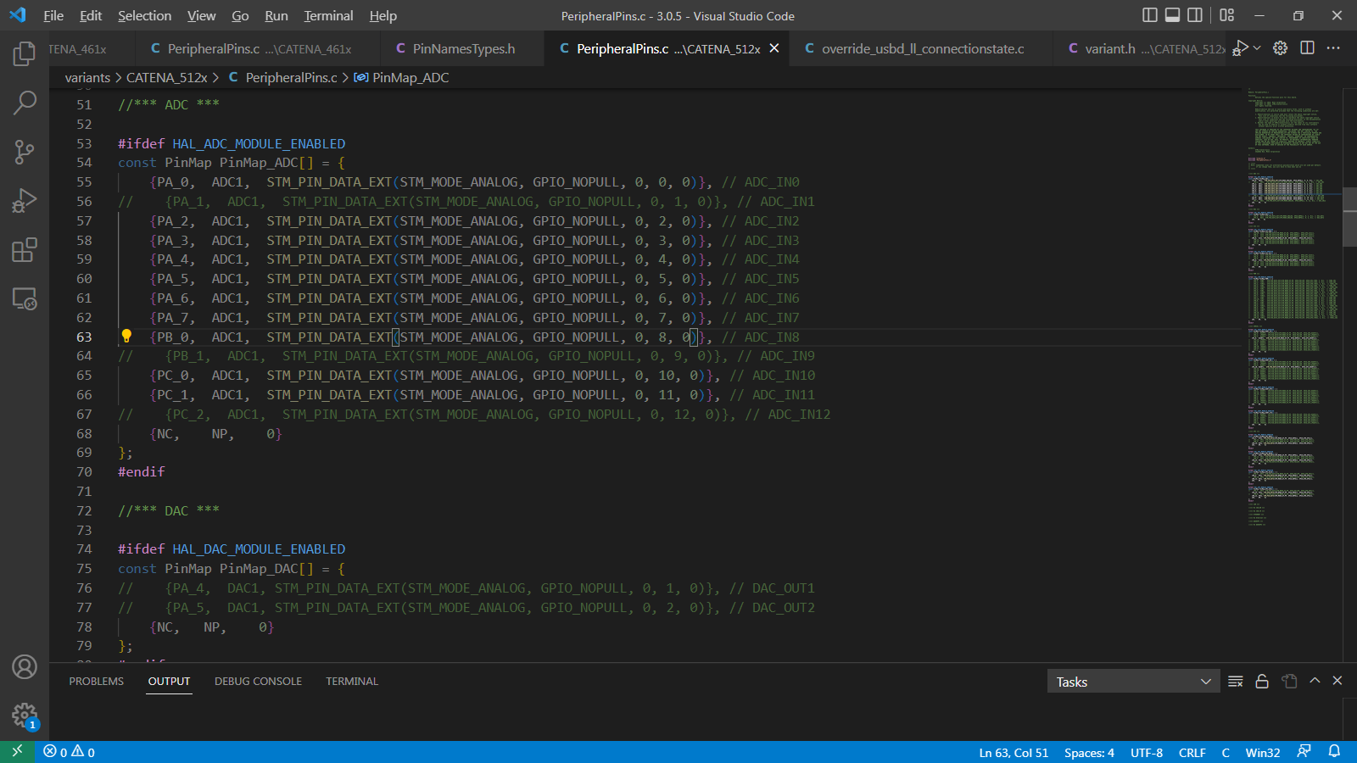

stm32l0xx_hal_conf.h
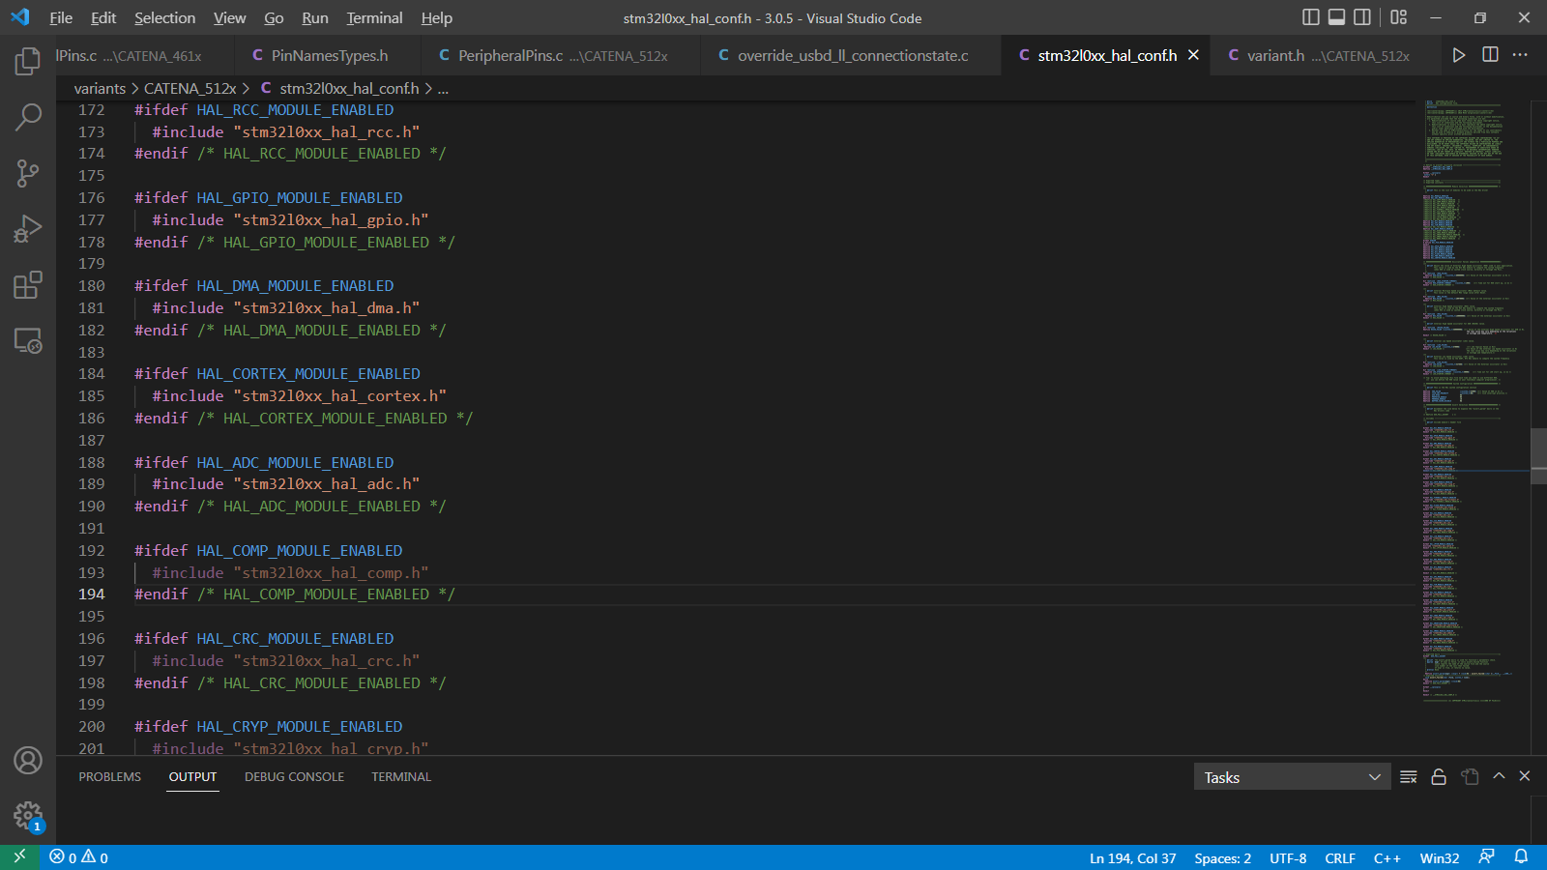

variant.h
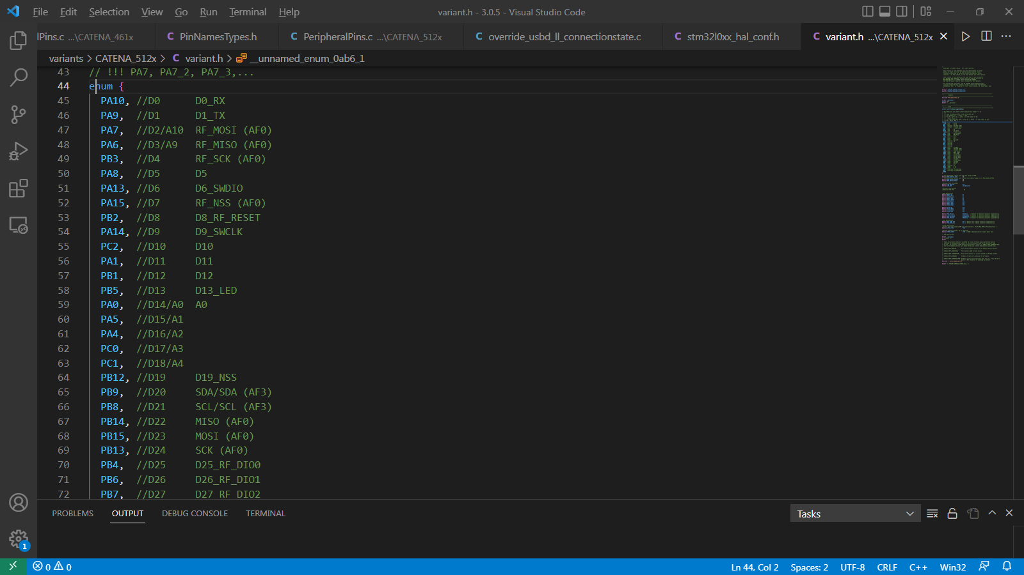

variant.cpp
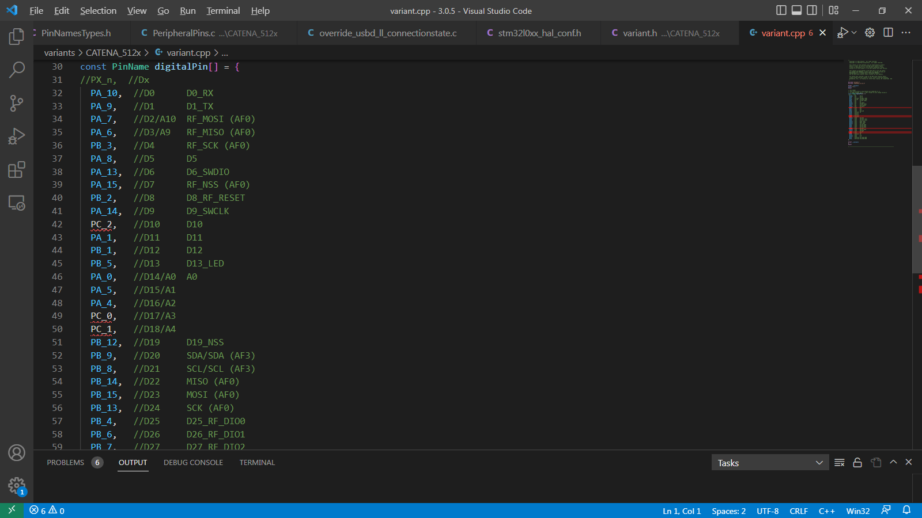

Relevant Documents

Table 1. References, IP Blocks
Reference | File | Comments

