Catena 4612 with Pressure Transducer Sensor Setup & Assembly
  - Engineering Report 234001416234001416
  - Rev B234001416 Rev BRev B
  - Date: 2021-12-27
Copyright © 2021
All Rights Reserved

PROPRIETARY NOTICE AND DISCLAIMER
Unless noted otherwise, this document and the information herein disclosed are proprietary to MCCI Corporation, 3520 Krums Corners Road, Ithaca, New York 14850 (“MCCI”). Any person or entity to whom this document is furnished or having possession thereof, by acceptance, assumes custody thereof and agrees that the document is given in confidence and will not be copied or reproduced in whole or in part, nor used or revealed to any person in any manner except to meet the purposes for which it was delivered. Additional rights and obligations regarding this document and its contents may be defined by a separate written agreement with MCCI, and if so, such separate written agreement shall be controlling.
The information in this document is subject to change without notice, and should not be construed as a commitment by MCCI. Although MCCI will make every effort to inform users of substantive errors, MCCI disclaims all liability for any loss or damage resulting from the use of this manual or any software described herein, including without limitation contingent, special, or incidental liability.
MCCI, TrueCard, TrueTask, MCCI Catena, and MCCI USB DataPump are registered trademarks of MCCI Corporation.
MCCI Instant RS-232, MCCI Wombat, NerveCircuit, and InstallRight Pro are trademarks of MCCI Corporation.
All other trademarks and registered trademarks are owned by the respective holders of the trademarks or registered trademarks.
Copyright © 2021 by MCCI Corporation.

Document Release History
Rev A | 2021-10-05 | Initial Release
Rev B | 2021-12-27 | Update Document

Table of Contents
1 Introduction 7
2 Requirements 7
2.1 Catena – 4612 7
2.2 Pin Headers 7
2.2.1 Male Pin Header (1x36) 7
2.2.2 Female Pin header (2x12, 2x16) 7
2.3 Adafruit Perma-Proto Half-sized Breadboard 8
2.4 Base plate 8
2.5 Vacuum Pressure Transducer Sensor 8
2.6 Adafruit 2030 9
2.7 Adafruit ADS1015 (Adafruit_1083) 9
2.8 Assembly Enclosure 10
2.9 D-Cell Battery Holder 10
2.10 Thread-cutting screw 10
2.11 Spacer (Breadboard) 11
2.12 Screw (Breadboard) 11
2.13 Screws (Batteryholder) 11
2.14 Washers (Batteryholder) 11
2.15 D Type Lithium Manganese Dioxide 12
2.16 u.FL Whip Antenna 12
2.17 Terminal Butt Splice Connector 12
2.18 3-conductor cable 12
3 Hardware Setup 13
4 Assembly Instructions 13
4.1 Catena 4612 Board Assembly 13
4.2 Adafruit 2030 Assembly 14
4.3 Adafruit ADS1015 15
4.4 Model 4612 Assembly 15
4.4.1 Bread Board Assembly 15
4.4.2 Enclosure Assembly 17
5 Final Assembly 19

List of Tables
Table 1 Bread board Connection 17
Table 2 Battery connected with catena 4612 18
Table 3 Vacuum Pressure Transducer 19

List of Figures
Figure 1 Catena 4612 Assembled Unit 7
Figure 2 1x36 Screw Terminal 7
Figure 3 1x12, 1x16 Pin Header 7
Figure 4 Adafruit Perma-Proto Breadboard (Half-sized) 8
Figure 5 Vacuum Pressure Transducer Sensor 8
Figure 6 Adafruit Boost Converter 9
Figure 7 Adafruit ADC Converter 9
Figure 8 Enclosure 10
Figure 9 D-Cell Battery Holder 10
Figure 10 Thread-cutting screw 10
Figure 11 Spacer 11
Figure 12 Screw 11
Figure 13 Pan head screw 11
Figure 14 Washer 11
Figure 15 D type Lithium Manganese Dioxide 12
Figure 16 u.FL Antenna 12
Figure 17 Terminal Butt Splice Connector 12
Figure 18 3-Conductor Cable 12
Figure 19 4612 Hardware Test-Setup- Schematic 13
Figure 20 Hardware Test Setup 13
Figure 21 Catena 4612 with u.FL Antenna 14
Figure 22 Soldered to Adafruit 2030 14
Figure 23 Soldered to Adafruit ADS1015 15
Figure 24 Adaruit Perma-Proto Breadboard (Half-sized) 15
Figure 25 Breadboard soldered with Connectors 15
Figure 26 Catena 4612 assembled with breadboard 16
Figure 27 Adafruit 2030 assembled with breadboard 16
Figure 28 Adafruit ADS1015 assembled with breadboard 16
Figure 29 Soldered 1X03 JST connector 17
Figure 30 Breadboard screw hole location 17
Figure 31 Adafruit soldered with Breadboard 18
Figure 32 Battery connected with catena 4612 18
Figure 33 Battery connected with catena 4612 18
Figure 34 Assembled Unit - Inner View 19

List of SeQUENCE Diagrams
No table of figures entries found.

Introduction
This document outlines the procedure to assemble Catena 4612 with the low cost vacuum pressure transducer sensor.

Requirements

Catena – 4612
Catena 4612 assembled board (123001405)
Figure 1 Catena 4612 Assembled Unit
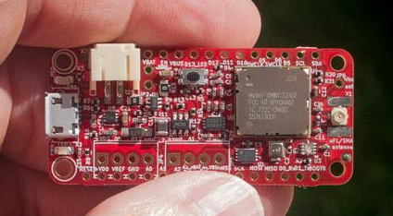

Pin Headers

Male Pin Header (1x36)
Male Pin headers (123001999) are broken into 1x12, 1x16, and 1x06
Figure 2 1x36 Screw Terminal
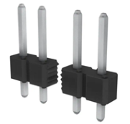

Female Pin header (2x12, 2x16)
Break female Pin header (123001013) into 1x12, 1x16, 1x10, 1x06 and 1x04
Figure 3 1x12, 1x16 Pin Header
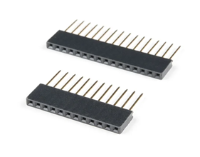

Adafruit Perma-Proto Half-sized Breadboard
Adafruit Perma-Proto Half-sized Breadboard (123001058) is used to make robust connection between Catena board and Adafruit Power booster.
Figure 4 Adafruit Perma-Proto Breadboard (Half-sized)
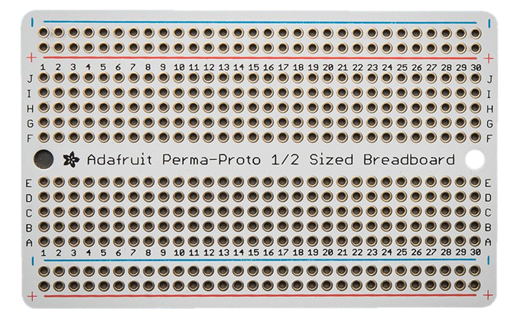

Base plate
Base plate for enclosure (123002299) is used to fit the Adafruit Perma-Proto Breadboard (Half-sized) and D-Cell Battery Holder.

Vacuum Pressure Transducer Sensor
Stainless Steel Vacuum Pressure Transducer (123002154) for Oil Fuel Air Water
Figure 5 Vacuum Pressure Transducer Sensor
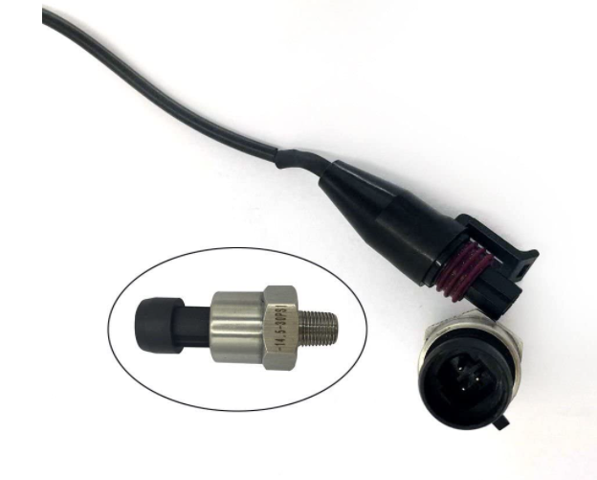

Adafruit 2030
Power Boost (123002155) is the perfect power supply for your power-hungry portable project. This little DC/DC boost converter module can run from 1.8V batteries or higher, and convert that voltage to 5.2V DC for running your 5V projects. With a beefy 4A DC/DC converter, it can give you 1A+ from as low as 2V.
Figure 6 Adafruit Boost Converter
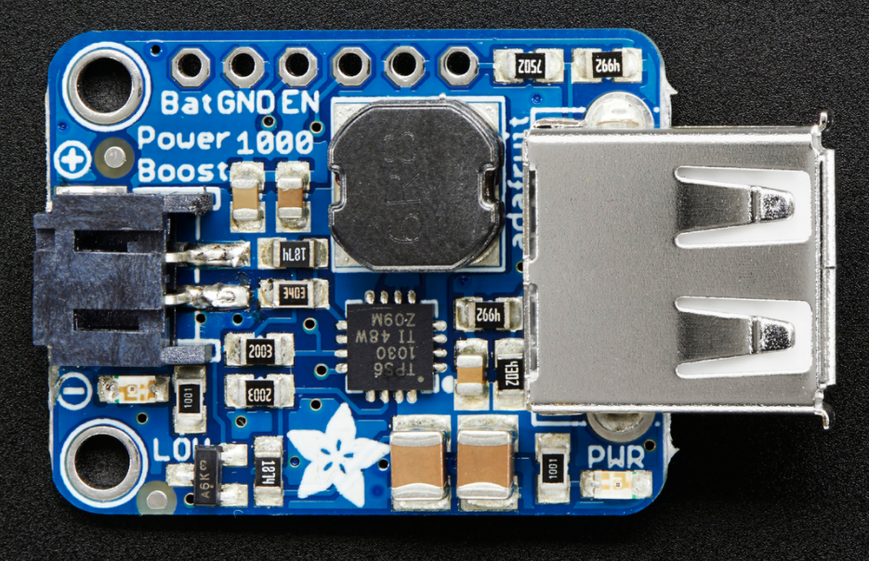

Adafruit ADS1015 (Adafruit_1083)
(123002210) For microcontrollers without an analog-to-digital converter or when you want a higher-precision ADC, the ADS1015 provides 12-bit precision at 3300 samples/second over I2C. The chip can be configured as 4 single-ended input channels, or two differential channels. As a nice bonus, it even includes a programmable gain amplifier, up to x16, to help boost up smaller single/differential signals to the full range. We like this ADC because it can run from 2V to 5V power/logic, can measure a large range of signals and its super easy to use. It is a great general purpose 12 bit converter.
Figure 7 Adafruit ADC Converter
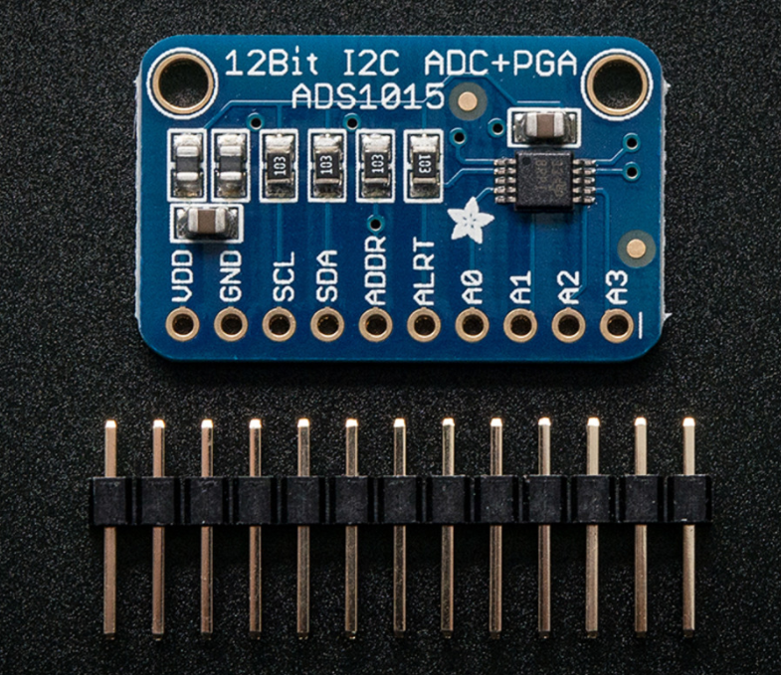

Assembly Enclosure
The IP67 Enclosure (123001965) is used for assembling the setup with the Baseplate, battery holder, Screws and spacers.
Figure 8 Enclosure
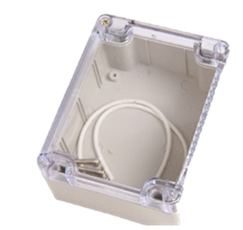

D-Cell Battery Holder
D-Cell Battery Holder (123002009) is used to hold the battery.
Figure 9 D-Cell Battery Holder
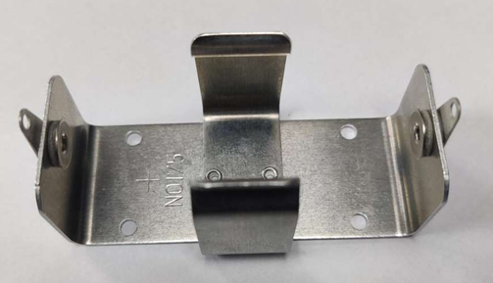

Thread-cutting screw
Thread-cutting screw (123001642) of 4 numbers is mounted between D-Cell Battery Holder Figure 9 D-Cell Battery Holder and the holes in the Bottom Base plate Enclosure.
Figure 10 Thread-cutting screw
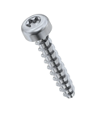

Spacer (Breadboard)
Spacer (123002301) of 2 numbers used to mount between the Adafruit Perma-Proto Breadboard (Half-sized) and Baseplate. It was Split, M2.5, Stainless Steel.

Figure 11 Spacer
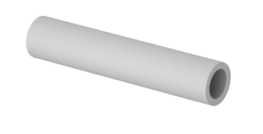

Screw (Breadboard)
Pan head Screw (123002300) of 2 numbers are used for tighten the Adafruit Perma-Proto Breadboard (Half-sized) with the Base plate for enclosure.
Figure 12 Screw
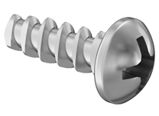

Screws (Batteryholder)
Screw (123002311) of 4 numbers are used for tighten the Base plate for enclosure with D-Cell Battery Holder. Pan head Torx, M2.5X6, Stainless steel.
Figure 13 Pan head screw

Washers (Batteryholder)
(123002312) of 4 numbers are used to mount between D-Cell Battery Holder and head of the screws.
Figure 14 Washer
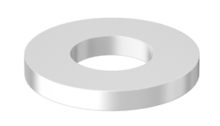

D Type Lithium Manganese Dioxide
D type Lithium Manganese Dioxide, 3.0V, 12 Ah, CR34615 Battery (123002011)
Figure 15 D type Lithium Manganese Dioxide
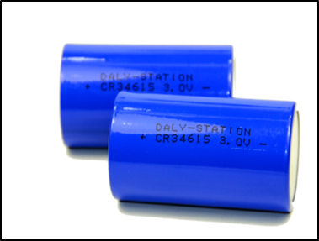

u.FL Whip Antenna
u.FL Antenna (123001414) of 915MHz has to be connected on the u.FL connector.
Figure 16 u.FL Antenna
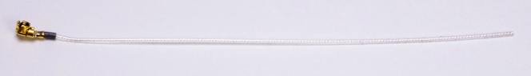

Terminal Butt Splice Connector
Terminal Butt Splice connector (123002105) are used for the gauge size of 22-24AWG.
Figure 17 Terminal Butt Splice Connector
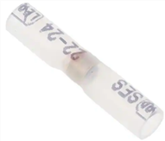

3-conductor cable
3-Conductor Cable (123001123) of 22-AWG are used for connecting the Sensor with the 4-Terminal connector.
Figure 18 3-Conductor Cable
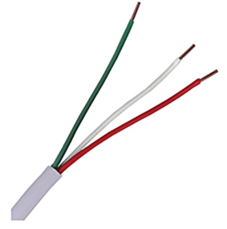

Hardware Setup
Figure 19 4612 Hardware Test-Setup- Schematic
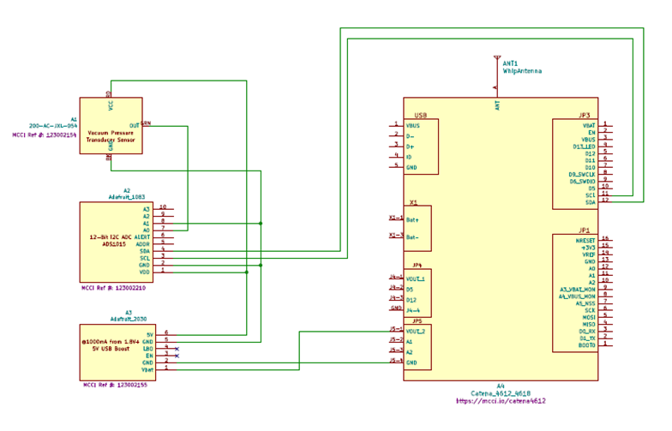
Figure 20 Hardware Test Setup
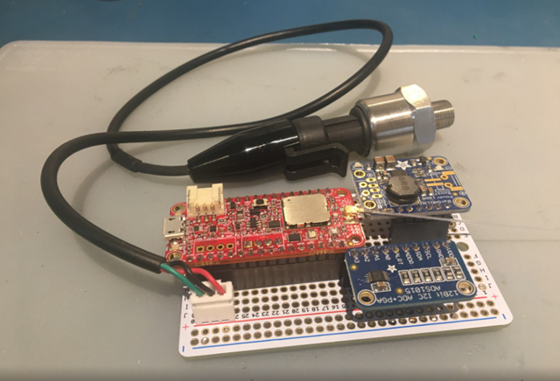

Assembly Instructions

Catena 4612 Board Assembly
Catena 4612 board assembling procedures are listed below:

1. Attach the 1x12 Screw Terminals on JP3
I. Solder one post
II. Adjust for proper alignments and good cosmetics
III. Solder the remaining posts
2. Attach the 1x16 Screw Terminals on JP1
I. Solder one post
II. Adjust for proper alignments and good cosmetics.
III. Solder the remaining posts
3. Attach the 1x04 Screw Terminals on JP5
I. Solder one post
II. Adjust for proper alignments and good cosmetics.
III. Solder the remaining posts

Connect the U.FL Antenna on the X1 (u.FL connector) of the Catena 4612 board as shown in

Figure 21 Catena 4612 with u.FL Antenna
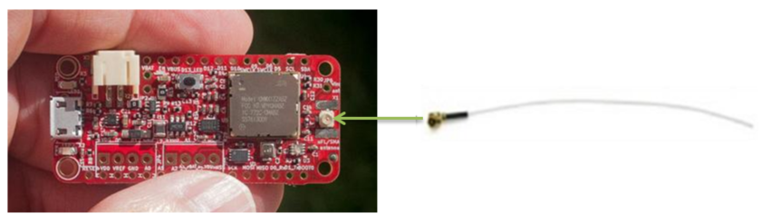

Adafruit 2030 Assembly
The Broken pieces of male headers have to be placed with Adafruit 2030 board assembly (1x06) as shown in Figure 22
Figure 22 Soldered to Adafruit 2030
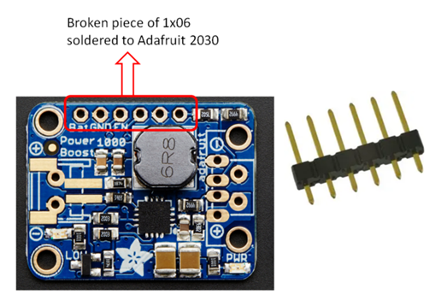

Adafruit ADS1015
The Broken pieces of male headers have to be placed with Adafruit ADS1015 board assembly (1x10) as shown in Figure 23
Figure 23 Soldered to Adafruit ADS1015
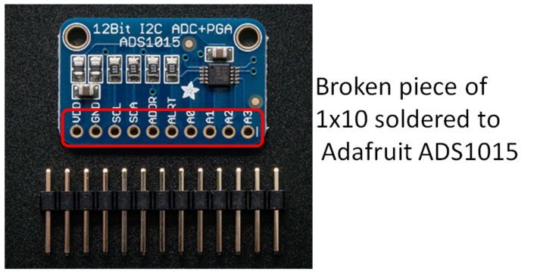

Model 4612 Assembly

Bread Board Assembly
- Take Half-sized Breadboard (123001058)
Figure 24 Adaruit Perma-Proto Breadboard (Half-sized)
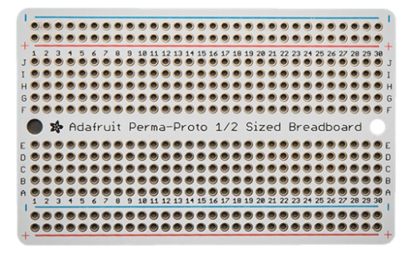
- Place the Female connector on to the Adafruit Perma-Proto Breadboard (Half-sized) as shown in Figure 25
Figure 25 Breadboard soldered with Connectors
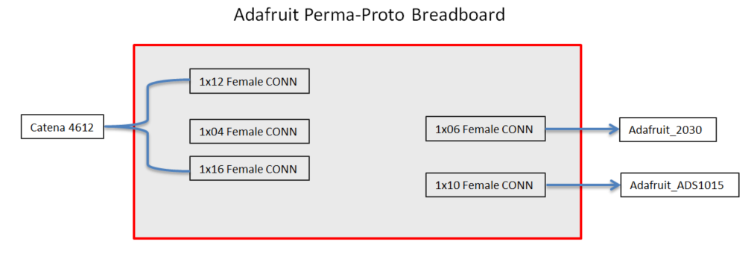
- Place the Soldered Catena 4612 and Adafruit Boost Converter board have to be placed on to the respective female headers as shown in the Figure 26 , Figure 27 and Figure 28
Figure 26 Catena 4612 assembled with breadboard
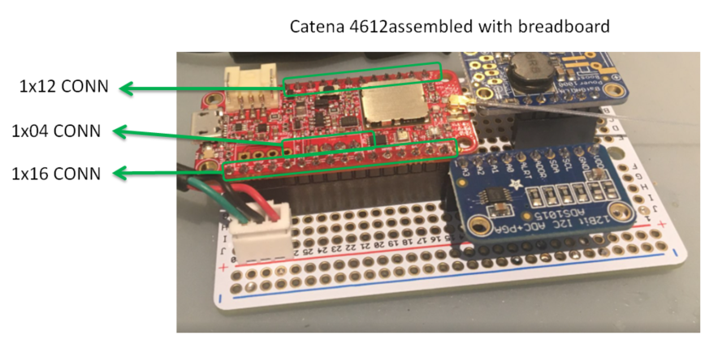
Figure 27 Adafruit 2030 assembled with breadboard
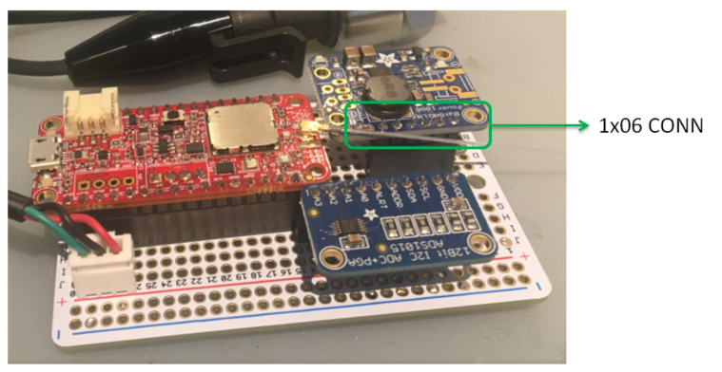
Figure 28 Adafruit ADS1015 assembled with breadboard
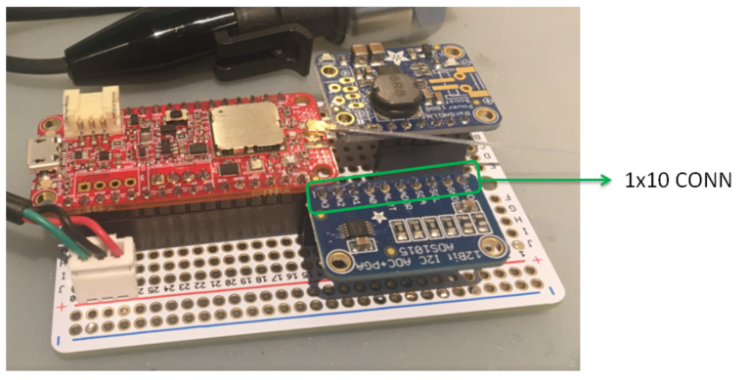
NOTE: Please make sure that female headers are mated properly with their corresponding male headers.

- Solder the Female 1X03 JST connector as shown Figure 29
Figure 29 Soldered 1X03 JST connector
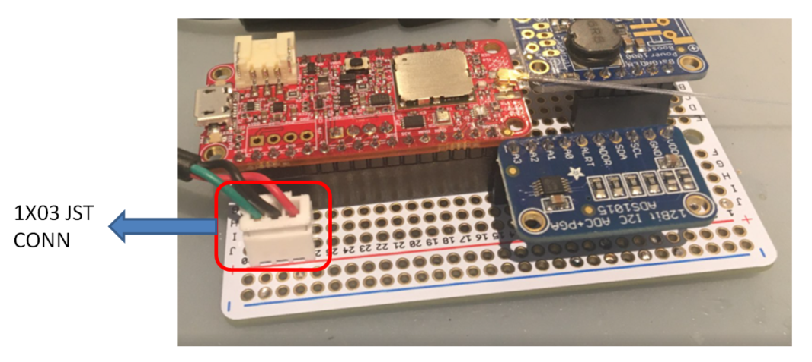
- Solder the wires on Breadboard between Catena 4612, Adafruit_1083 and Adafruit_2030 as shown in Table 1
Table 1 Bread board Connection
 | Catena 4612 | Adafruit_2030 | Adafruit_1083  ADC to I2C | Pressure Transducer | Description
I2C | JP3-11 |  | 3 |  | SCL
I2C | JP3-12 |  | 4 |  | SDA
3.3V | JP5-VOUT2(1) | VBAT (1) |  |  | Provide input Power to Adafruit_2030 from Catena 4612
3.3V | JP5-GND(4) | GND(2) |  |  | Provide input Power to Adafruit_2030 from Catena 4612
5V |  | 5V (6) | VDD (1) | VDD (RED) | Provide 5V to Adafruit_1083 and Pressure Transducer from Adafruit_2030
5V |  | GND (5) | GND (2) | GND (BLACK)
ADC |  |  | A0 (7) | OUT (GREEN)

Enclosure Assembly
- Place the assembled breadboard onto the enclosure and tightened with the corresponding screw(123002300) and Spacer(123002301)
Figure 30 Breadboard screw hole location
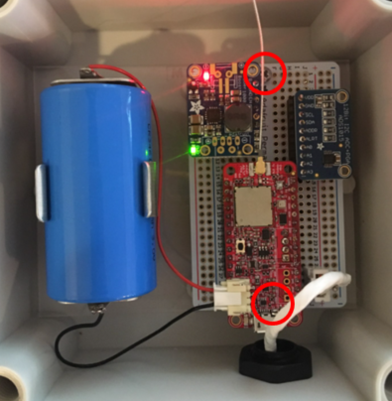
- Place the D-Cell Battery Holder and tighten with the 4 screws (123002311), washer(123002312) and Thread-cutting screw (123001642) on Enclosure
Figure 31 Adafruit soldered with Breadboard
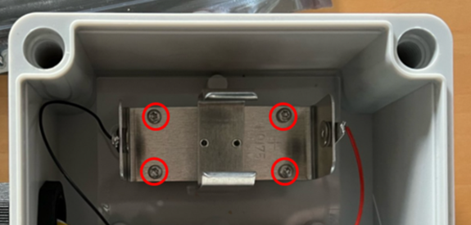
- Place the battery on D-Cell Battery Holder and connect the wire to JP6 of Catena 4612 as shown Figure 32
Figure 32 Battery connected with catena 4612
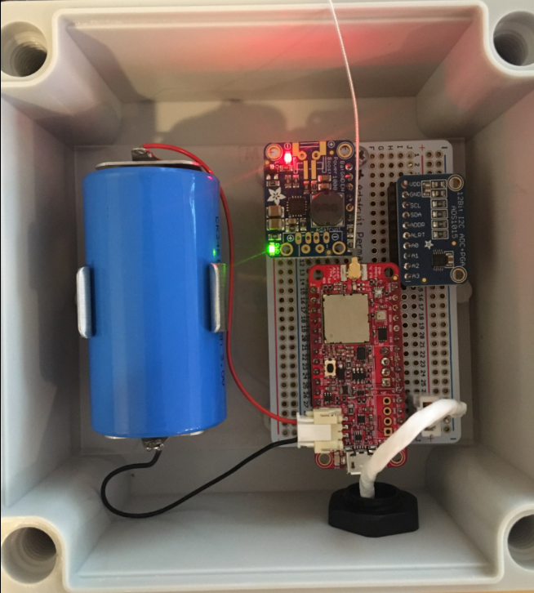
Table 2 Battery connected with catena 4612
JP6 CONN | Color | Battery Holder
VBAT | Red | + Ve
GND | Black | - Ve

- Vacuum Pressure Transducer sensor has to be connected to the respected units are mentioned in the Figure 33
Figure 33 Battery connected with catena 4612
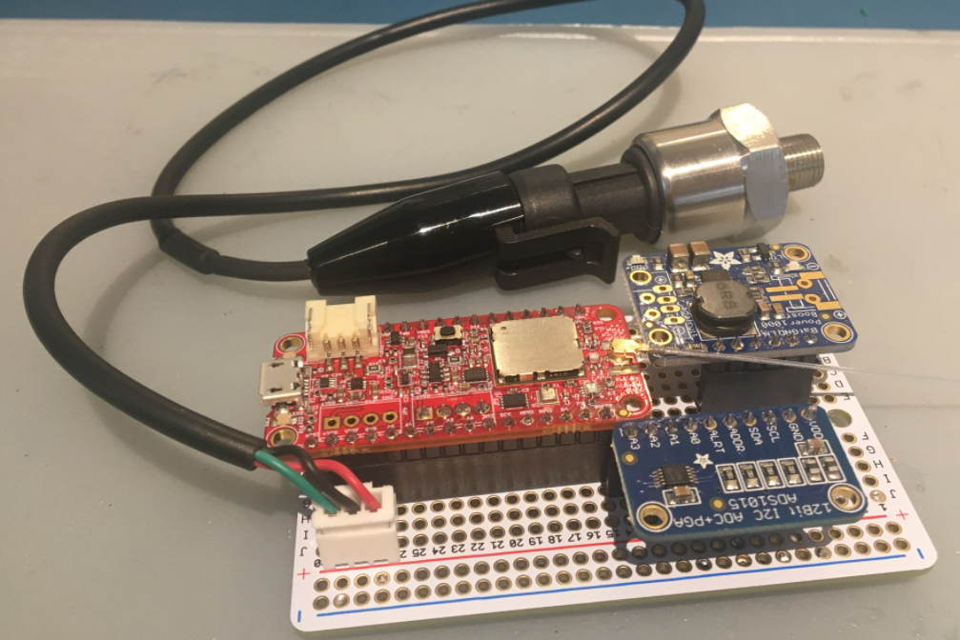
Table 3 Vacuum Pressure Transducer
Pin No | Color | Designator
1 | GREEN | Analog
2 | BLACK | GND
3 | RED | +5V

Final Assembly
The Final Assembled unit is shown in the below.
Figure 34 Assembled Unit - Inner View
