**Memory Management:**

**(Diagram):**

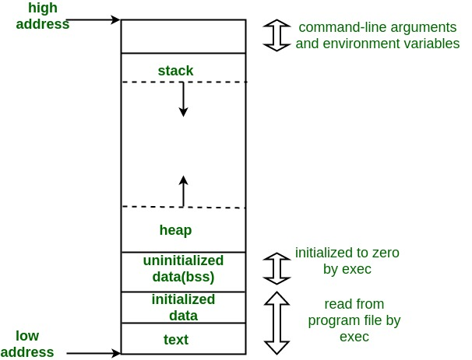

**Links referred:**

[Memory Layout of C Programs - GeeksforGeeks](https://www.geeksforgeeks.org/memory-layout-of-c-program/)

[Stack vs Heap. What’s the difference and why should I care? | by Nickolas Teixeira Lanza | Medium](https://nickolasteixeira.medium.com/stack-vs-heap-whats-the-difference-and-why-should-i-care-5abc78da1a88)

[Stack Vs Heap Memory - C# (c-sharpcorner.com)](https://www.c-sharpcorner.com/article/stack-vs-heap-memory-c-sharp/)