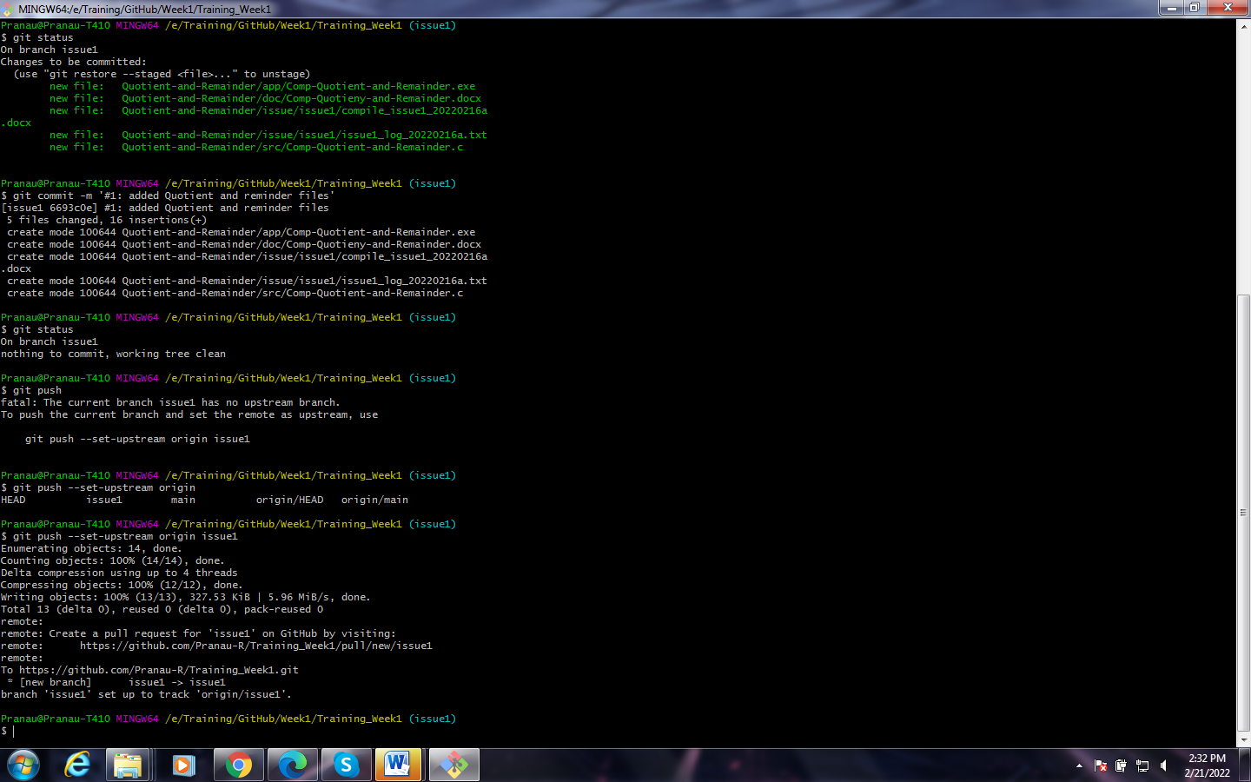

We learned how to created our Week1 repository and how to push it’s file to Training_Week1 remote repository.

