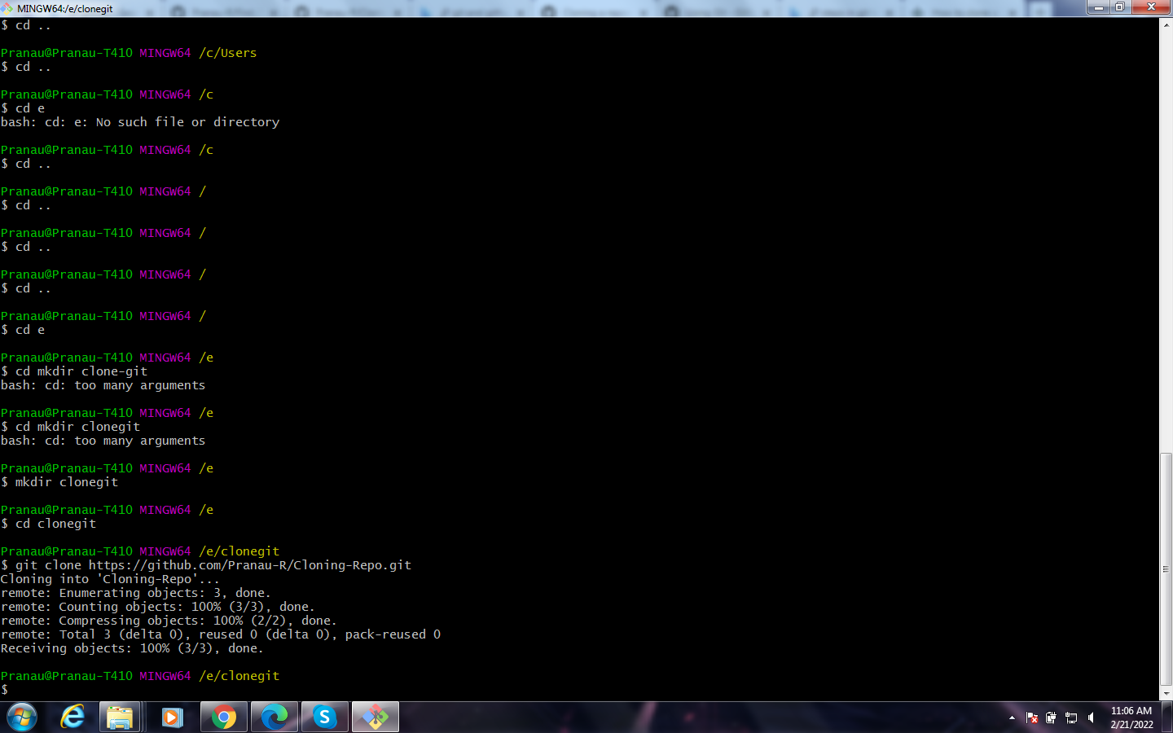

Link Referred:

[How to clone a GitHub repository? (tutorialspoint.com)](https://www.tutorialspoint.com/how-to-clone-a-github-repository)

[Cloning a repository - GitHub Docs](https://docs.github.com/en/repositories/creating-and-managing-repositories/cloning-a-repository)