**Exporting a Plantuml to png:**

1. Select all codes using mouse + right click (or ctrl + A).
2. Now open command palette (ctrl + shift + P).
3. In that palette, type plantuml: export current diagram.
4. Then select png extension from the drop down bar.
5. Now an “out” folder will be created on the main folder an inside the “out” folder, there is our required png image for the plantuml code.
6. Now cut that png image and plaste it on our assets folder. Now we are good to delete “out” folder which consists of no files.

**Palette (Screenshot):**

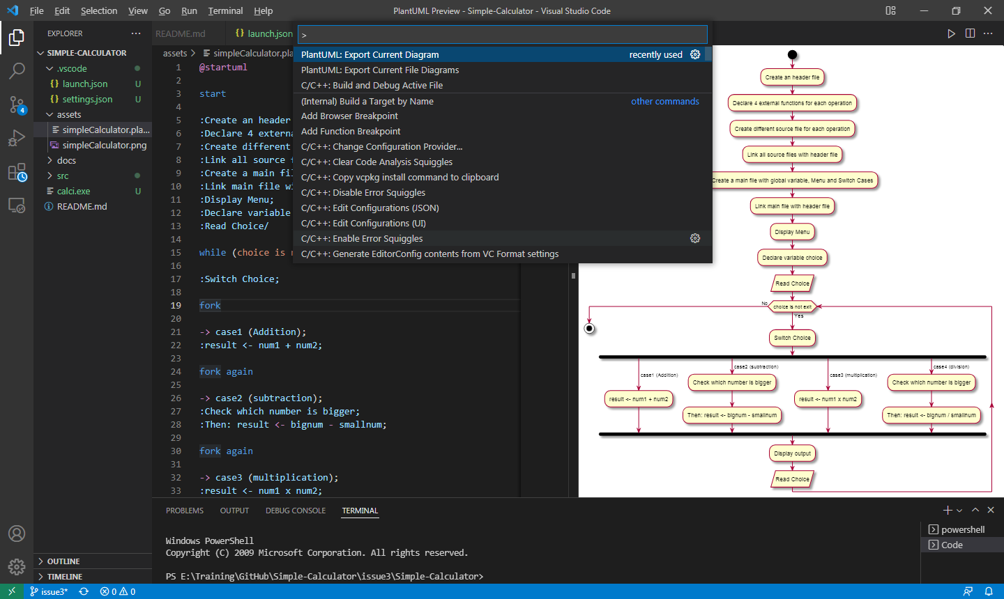

**Drop down bar (Screenshot):**

