**Work/Task/Title:** To create a simple sketch to read Lux from light for optical sensor LTR329 MCCI Library.

**Expected Result:** To read the Lux and to display the output.

**Issue (Screenshot):**

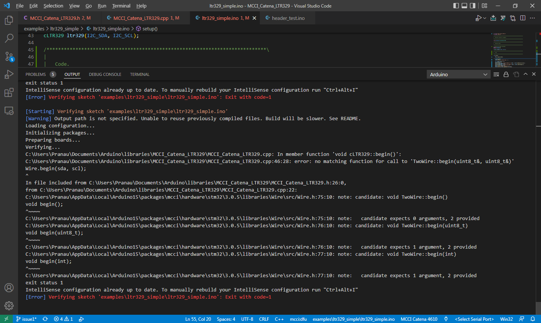

Above screen shot is from VS Code and here, we are facing a compile issue regarding Wire library.

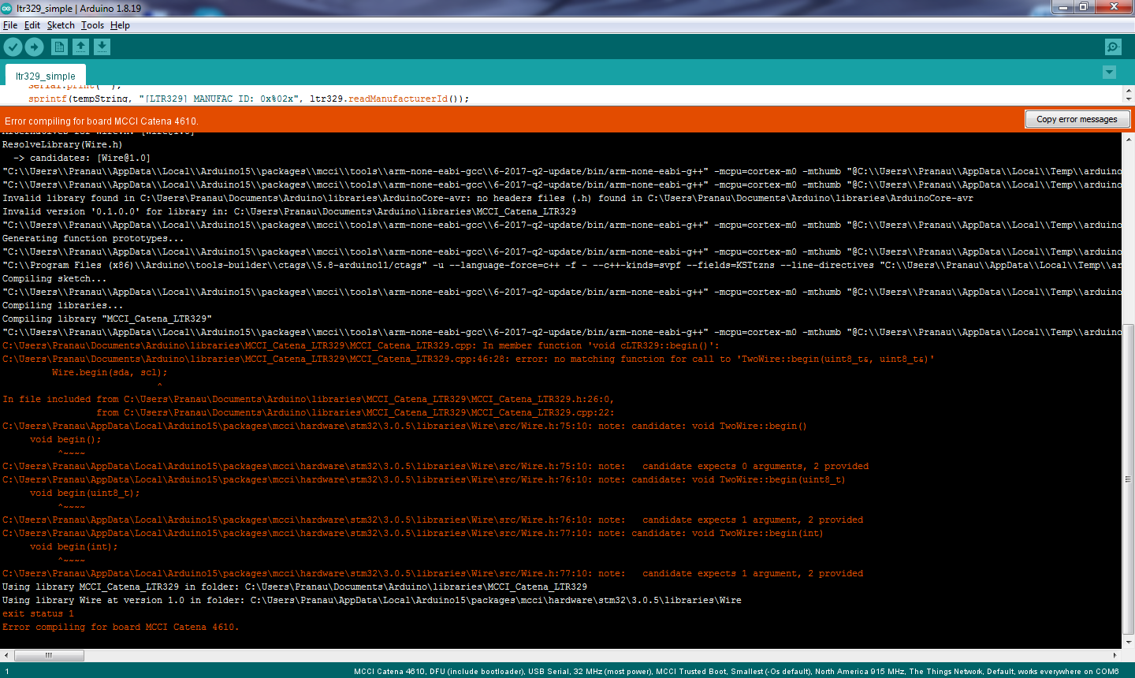

Above screen shot is from Arduino IDE and here, we are facing the same compile issue regarding Wire library.

**Issue Log Files:**

* compile_issue_log_20220525a
* compile_issue_log_20220525b