**Work/Task/Title:** Single Linked List

**Expected Result:** To create a Menu for addition, deletion and display of user Entries

**Issue (Screenshot):**

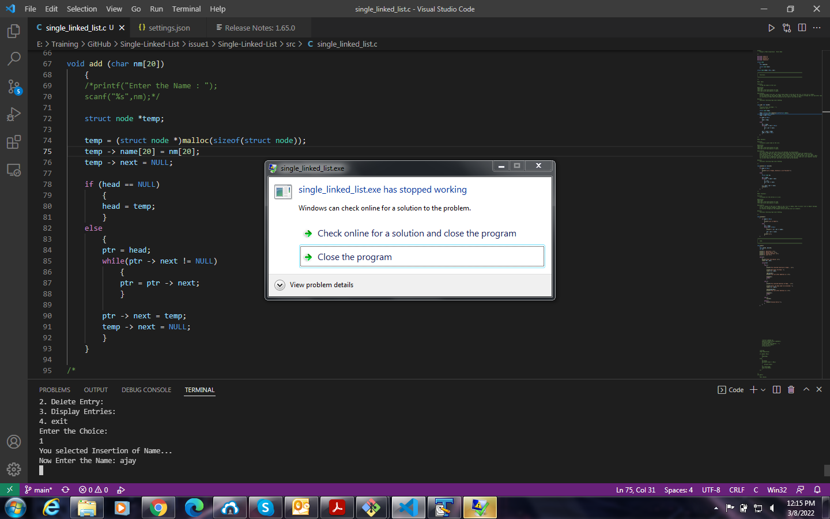

When I run a program and enter/delete an entry, The program application stops working.

**Issue-Log-File:** program_stop_issue_terminal_20220308a.txt