**Work/Task/Title:** Single Linked List

**Expected Result:** To create a Menu for addition, deletion and display of user Entries

**Issue (Screenshots):**

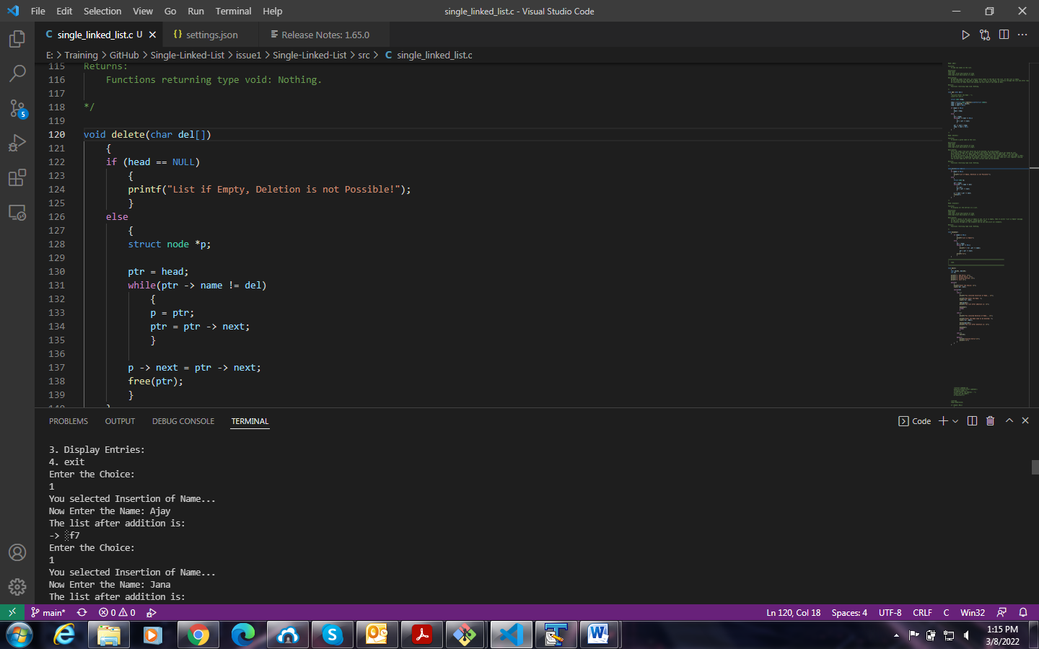

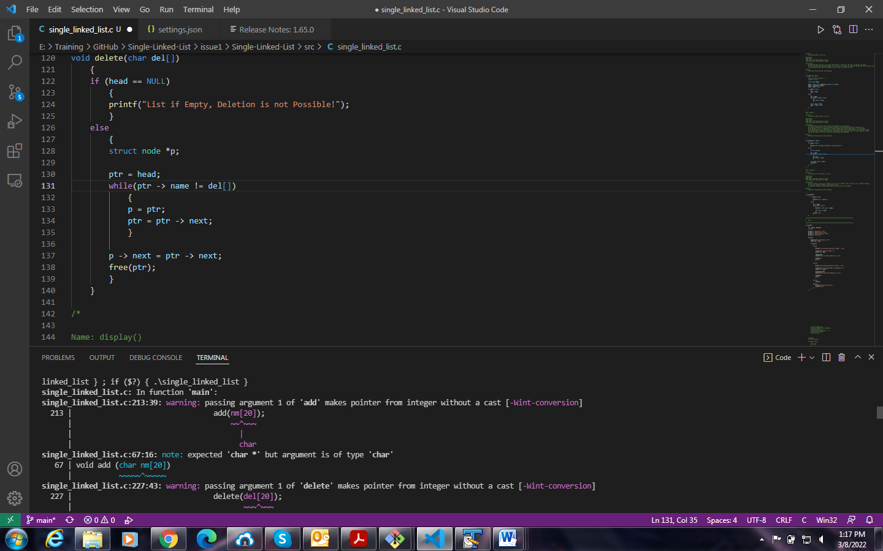

In screenshot 1, Instead of getting our required output, We are getting some random values.

In Screenshot 2, We are getting an error message.

**Issue-Log-File:** output_issue2_20220308a.txt

**Link Referred:**

* <https://www.daniweb.com/programming/software-development/threads/25193/makes-pointer-from-integer-without-a-cast>
* <https://stackoverflow.com/questions/37225244/error-assignment-to-expression-with-array-type-error-when-i-assign-a-struct-f>
* <https://stackoverflow.com/questions/15162665/passing-argument-makes-pointer-from-integer>
* <https://www.reddit.com/r/C_Programming/comments/jyxdnu/passing_argument_1_of_printf_makes_pointer_from/>
* <https://dev-qa.com/2035279/passing-argument-fwrite-makes-pointer-integer-without-cast>