**Work/Task/Title:** Single Linked List

**Expected Result:** To create a Menu for addition, deletion and display of user Entries

**Issue (Screenshot):**

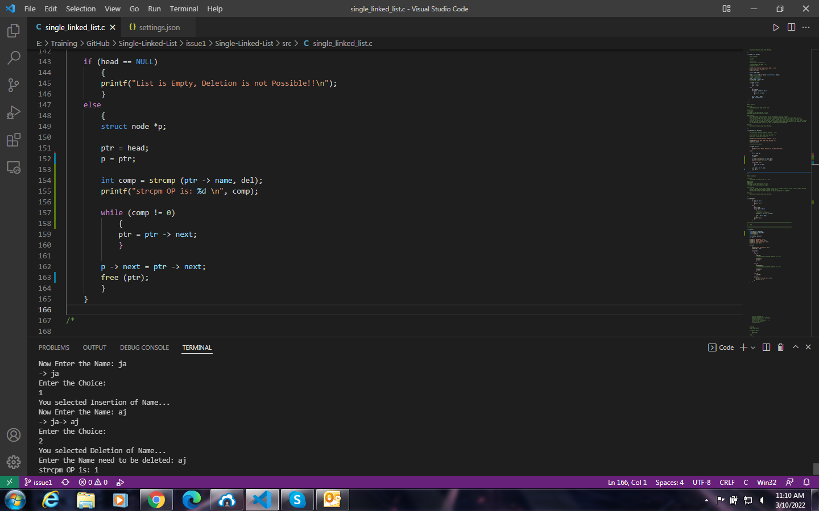

Deletion function is not working as per the requirement. The name entered for deletion should be searched and then deleted, but here the user entered name is not deleting.

**Issue Log File:** deleteOP_issue3_20220310a

**Link Referred:**

<https://stackoverflow.com/questions/47722411/comparing-two-strings-in-c-in-a-loop>

**Issue (Screenshot):**

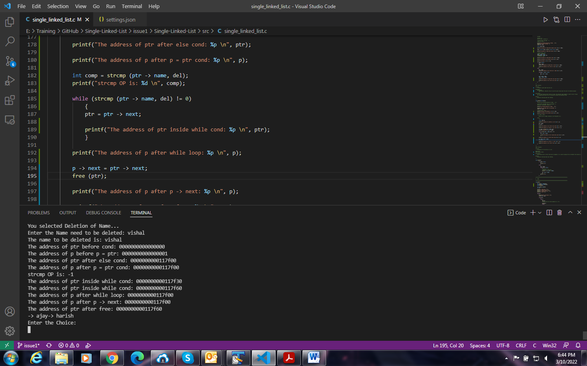

Here we are trying to delete a particular node in the list which contains the user entered data but along with the required node deletion, the nodes which are preceding that particular deletion node also getting deleted till the HEAD node.

Also when we are trying to delete the HEAD node, the data inside the current HEAD node is replaced with some garbage value.

**Issue Log File:** deleteOP_issue3_20220310b.txt

**Issue fix:**

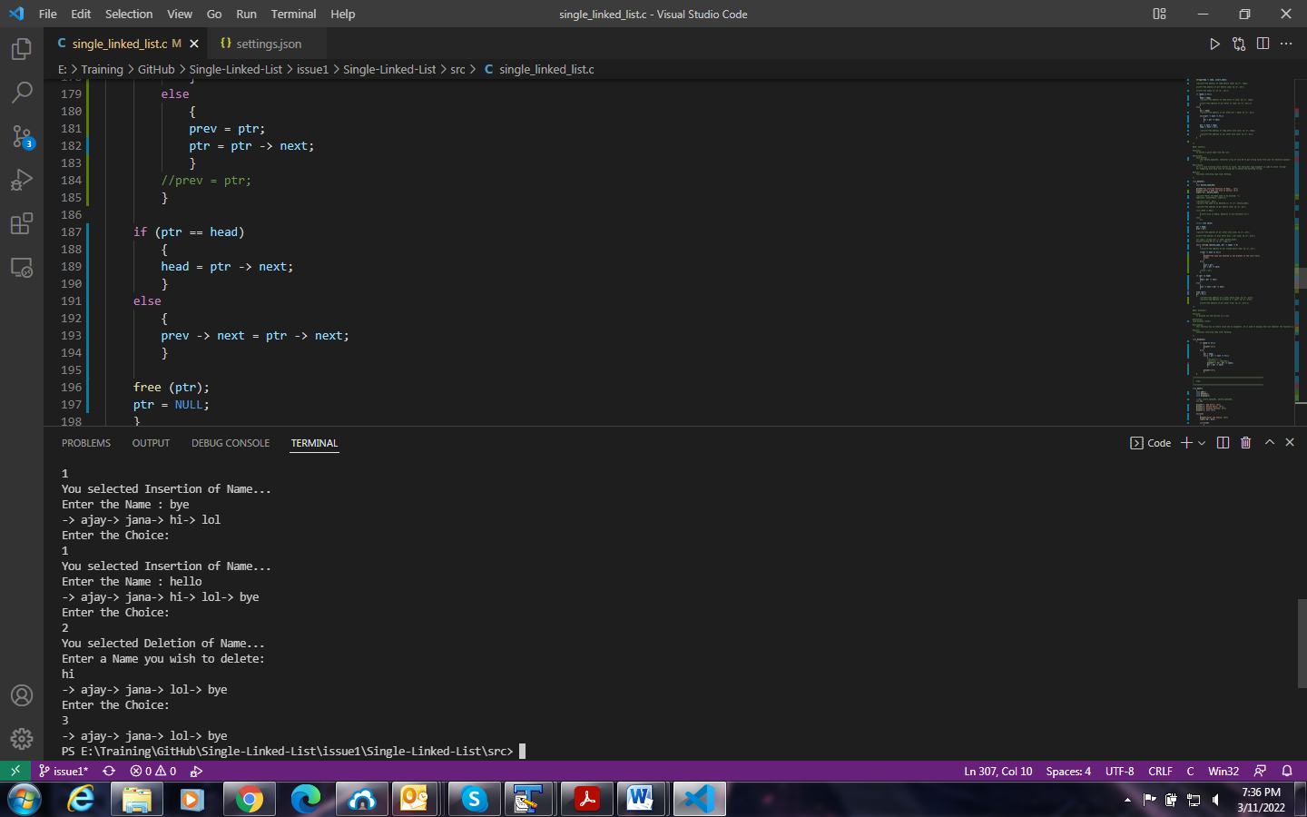

Previously, we did not join the previous node and next node properly. Now we joined the previous node as well as the next node properly, so that the display function is performing as per our requirement.

**Issue Log File:** deleteOP_issue3_fix_20220311a