**Work/Task/Title:** Single Linked List

**Expected Result:** To create a Menu for addition, deletion and display of user Entries

**Issue (Screenshot):**

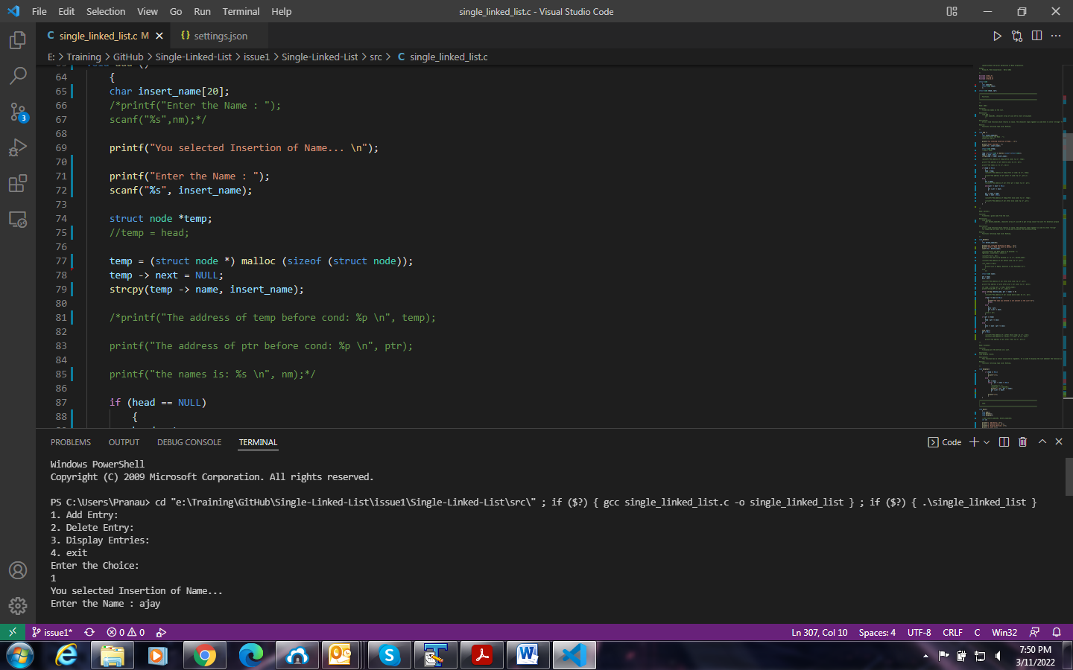

Addition of a name in the list is not working as per our requirement. Instead of adding the user entered names in list on current step, the name entered by user is added in next step, thus the finally entered name is not at all added in the list.

**Issue Log File:** addOP_issue4_20220311a.txt

**Issue Fix:**

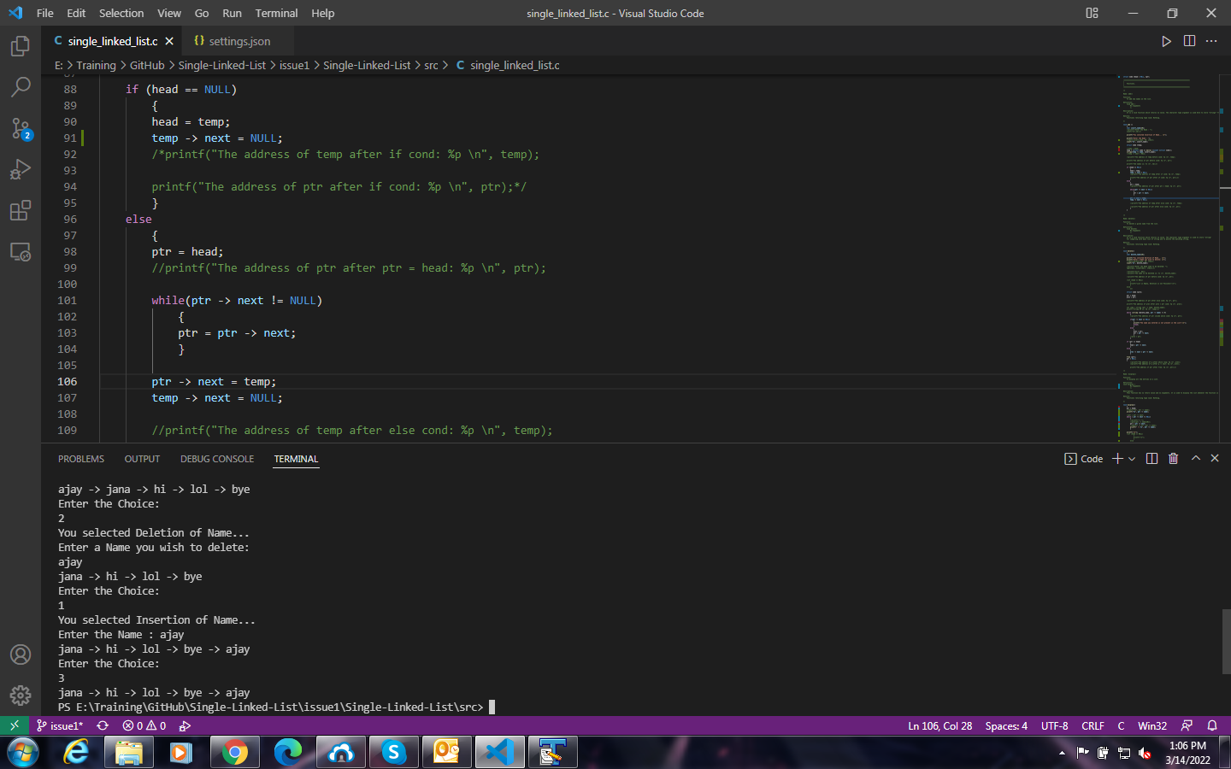

Instead of making changes in add() function, we made few changes in display() function. The changes include, removing if-else condition and alignment of code in proper sequence flow.

**Issue Log File:** addOP_issue4_fix_20220314a