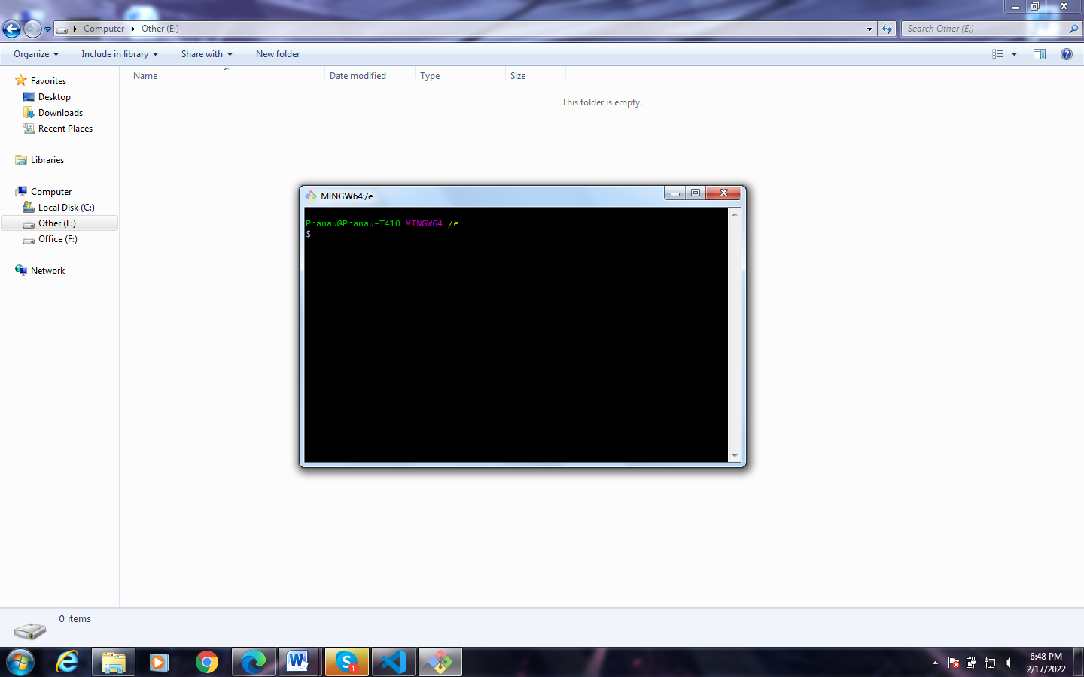

**Git installed successfully, Now I’m referring the following link:**

<https://www.jcchouinard.com/install-git-in-vscode/#:~:text=%20Install%20Git%20and%20Github%20in%20VSCode%20,in%20Git.%20To%20configure%20your%20Git...%20More%20>