In Git Bash, I learned various git commands and their working. I learned how to create folders and files, to initiate a git repository, to check status, to add a file, to commit a command, to clone a project, using various git command line.

**Some of git commands I learned and practiced today:**

git init, git touch, git status, git commit, git clone, git remote, git branch, git push, git pull, etc.

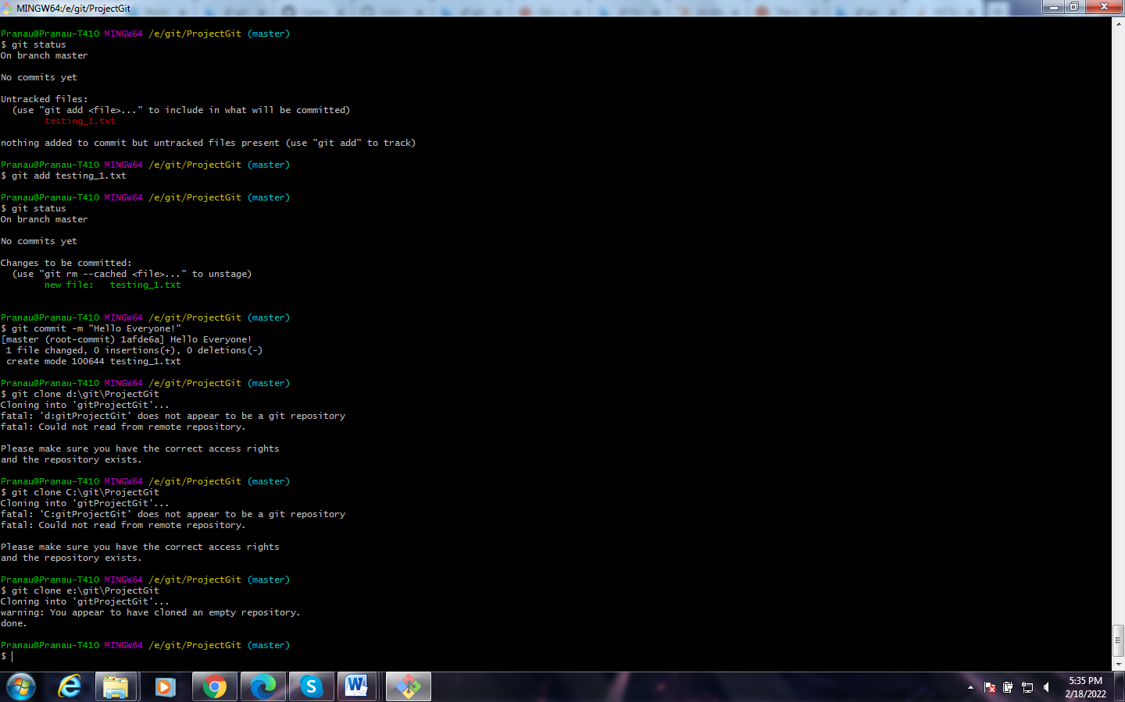

**For Reference:**

* [Git Tutorial for Beginners - Learn GitHub Basic Commands (intellipaat.com)](https://intellipaat.com/blog/tutorial/devops-tutorial/git-tutorial/#:~:text=Local%20Git%20Commands%201%20git%20init%3A%20We%20use,staging%20to%20see%20the%20change%20using%20git%20status.)
* [Git and GitHub Tutorial – Version Control for Beginners (freecodecamp.org)](https://www.freecodecamp.org/news/git-and-github-for-beginners/)

**Text file for this program:** Git-command-Practice.txt