Today I started with Github. I created my First_Repository. After creating this repository, I created a branch and modified the contents in README.md file. After modification, I tried several operations like, pulling a request, merging it to a main file, reverting the main file, cancelling a request, deleting a branch.

The following is the image of commit I’ve done in Main.

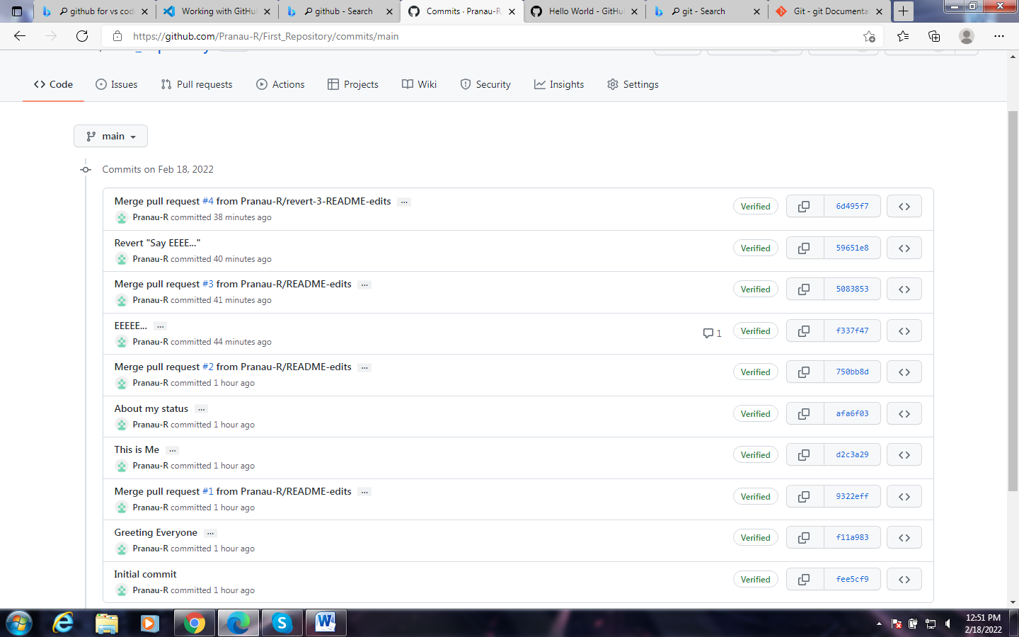

**Reference Link:**

[Hello World - GitHub Docs](https://docs.github.com/en/get-started/quickstart/hello-world)