In Git Bash, I learned various linux commands and their working. I learned how to create folders and files using command line, moving and manipulating(moving, copying, renaming, deleting) those files.

**Some commands that I learned today:**

mkdir, cd, ls, echo, cat, less, pwd, cp, rm, rmdir, etc.

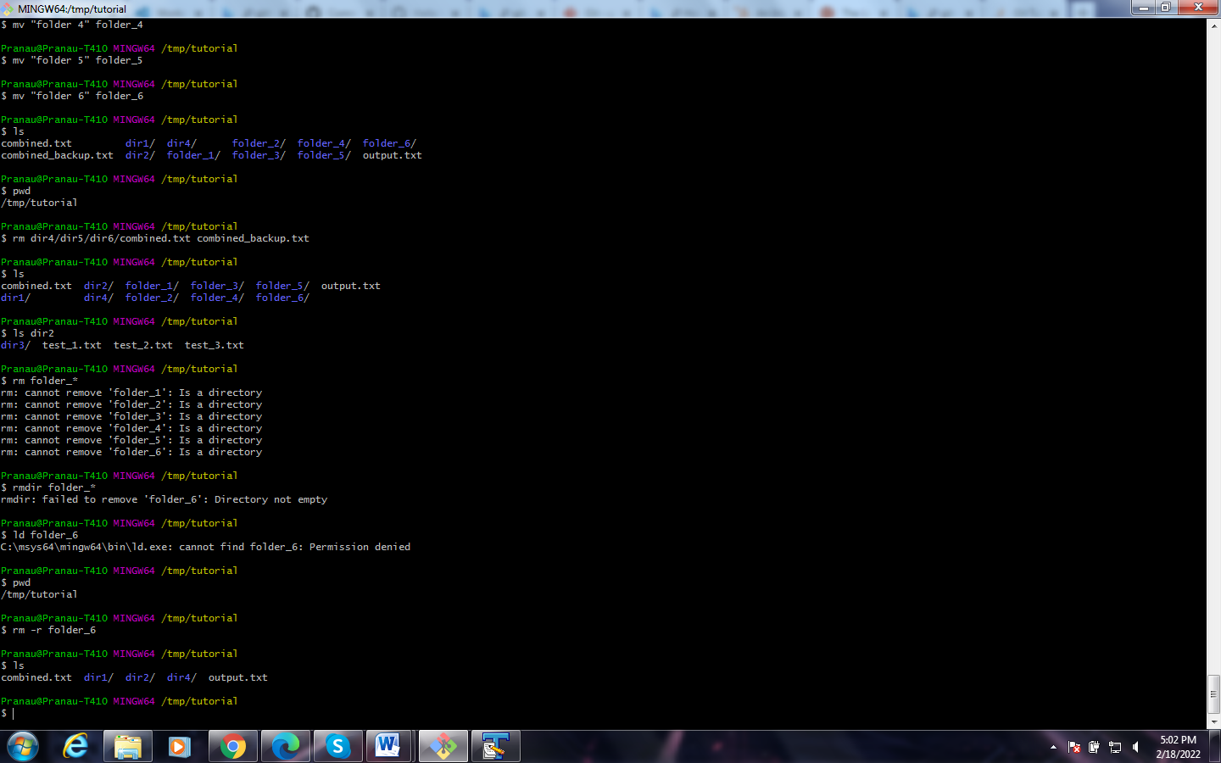

**Reference Link:**

* [An Intro to Git and GitHub for Beginners (Tutorial) (hubspot.com)](https://product.hubspot.com/blog/git-and-github-tutorial-for-beginners#:~:text=%20An%20Intro%20to%20Git%20and%20GitHub%20for,the%20command%20git%20commit%20-m%20%22Your...%20More%20)
* [The Linux command line for beginners | Ubuntu](https://ubuntu.com/tutorials/command-line-for-beginners#4-creating-folders-and-files)

**Text File:**

LinuxSystemCommands-basic.txt