**Work/Task/Title:** Program to get quotient and reminder

**Expected Result:** To enter dividend and divider, print the quotient and reminder

**Issue (Screenshot):** 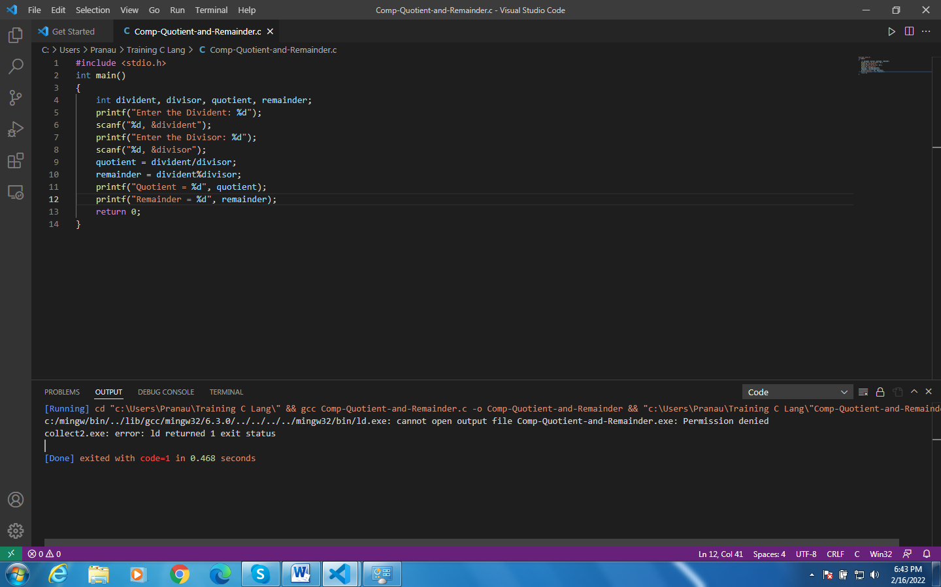

**Issue-Log-File:** issue1_log_20220216a.txt

**References:**

* <https://www.quora.com/How-do-I-resolve-the-Code-Blocks-error-ld-exe-cannot-open-output-file-permission-denied>

**Fix (if issue solved):**

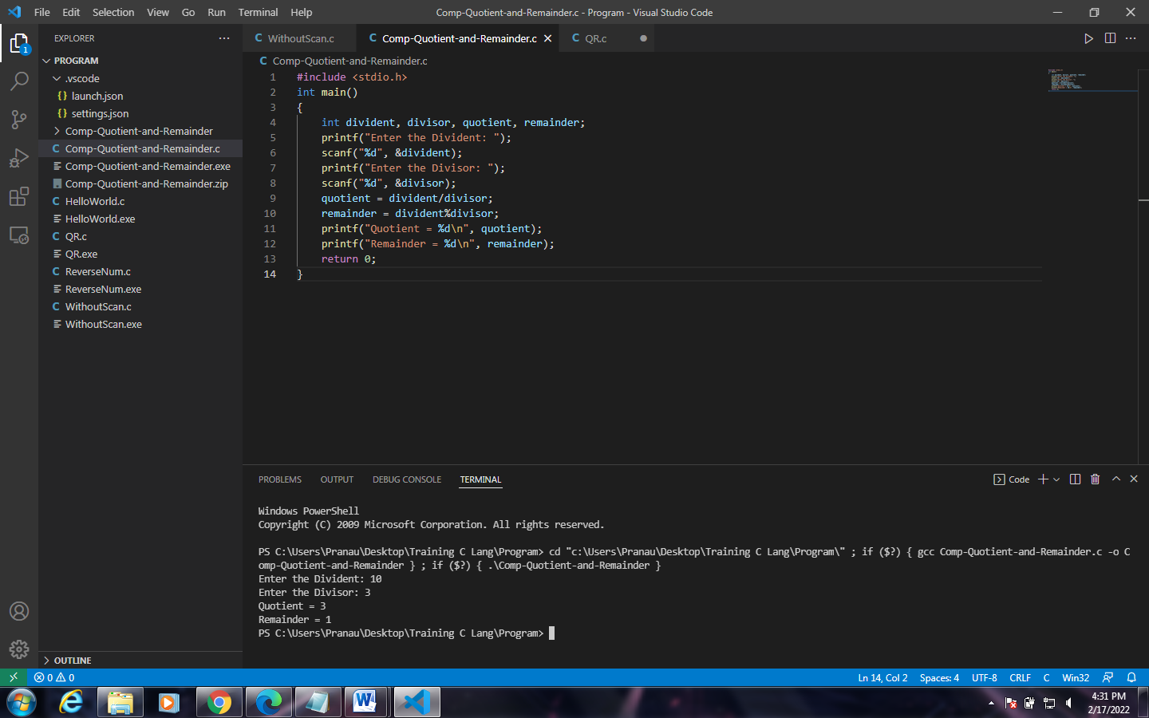

This is actually not a fix, it’s a work around. Instead of expecting the Result in Output, Here we get out result in Terminal.

**Reference:**

* <https://razzyadav620.blogspot.com/2021/10/how-to-run-code-in-terminal-in-vs-code.html>