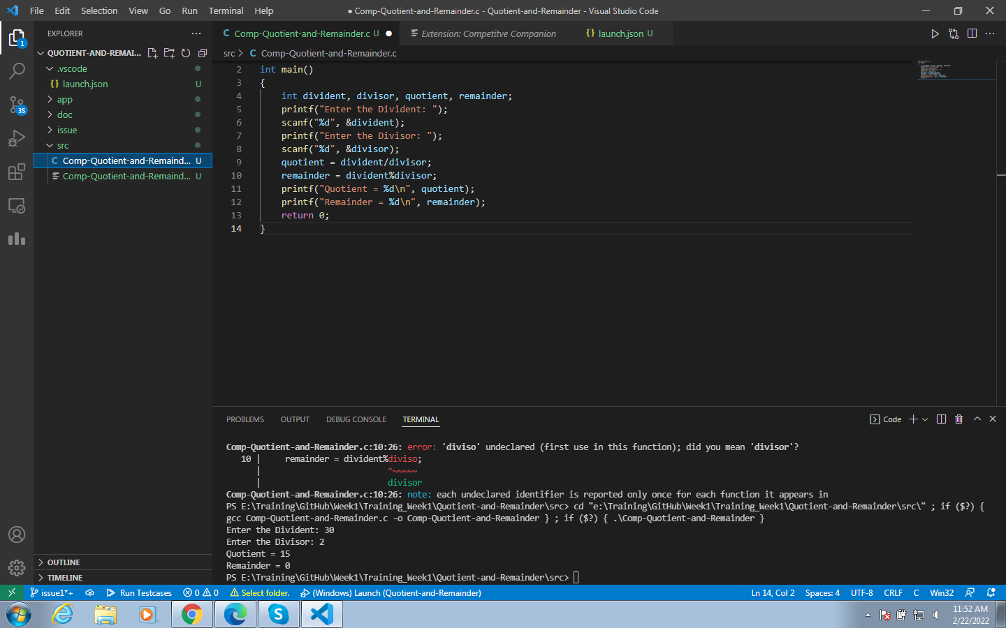

Instead of getting output in OUTPUT, we are using TERMINAL to get our desired output. Since we are getting an input here using scanf() function, we cannot get our output in OUTPUT, OUTPUT is used for displaying purpose only.

**Link Referred:**

* <https://stackoverflow.com/questions/51047167/the-output-window-in-vs-code-is-not-editable-so-how-we-can-type-the-input-when>
* <https://stackoverflow.com/questions/64925756/execution-of-code-stuck-on-running-in-vscode>