**Work/Task/Title:** Platform support for Catena 5120

**Expected Result:** The test sketch and the simple sketch have to get compiled when using Analog PIN names in BSP file.

**Issue:**

**Screenshot 1**

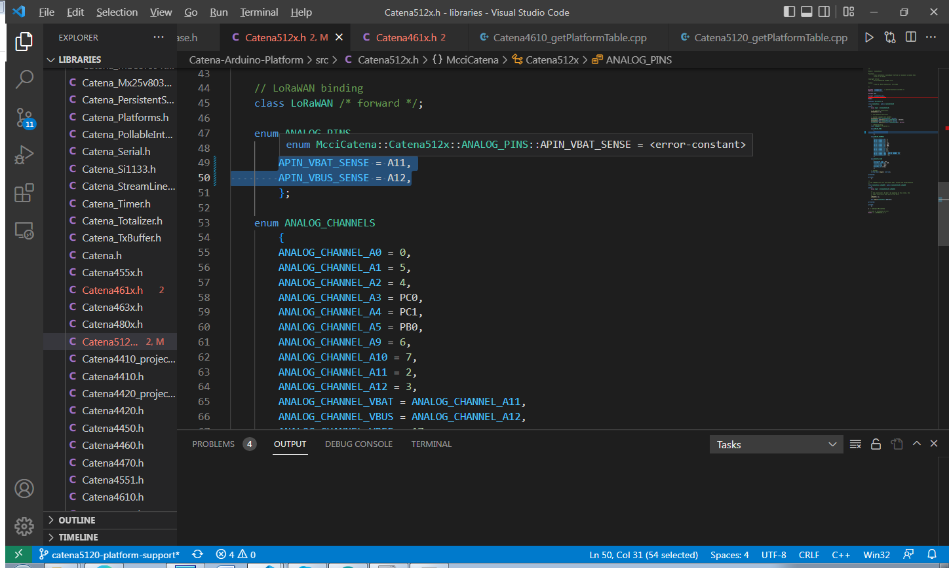

Here, when we try to use Analog PIN names such as A11 and A12 for VBAT and VBUS respectively, we are getting a compile error while compiling the test sketch as well as the simple sketch. Following image (**Screenshot 2**) is the Screenshot of compile issue in Arduino IDE.

**Screenshot 2**

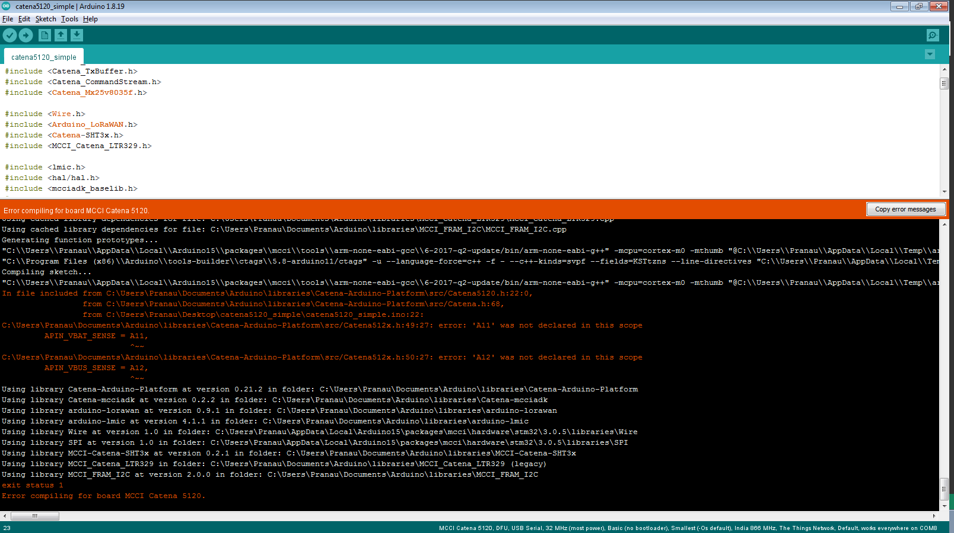

We are getting “was not declared in this scope” error.

**Issue Log File:** compile_issue1_log_20220728a

**Issue Fix (Work Around):**

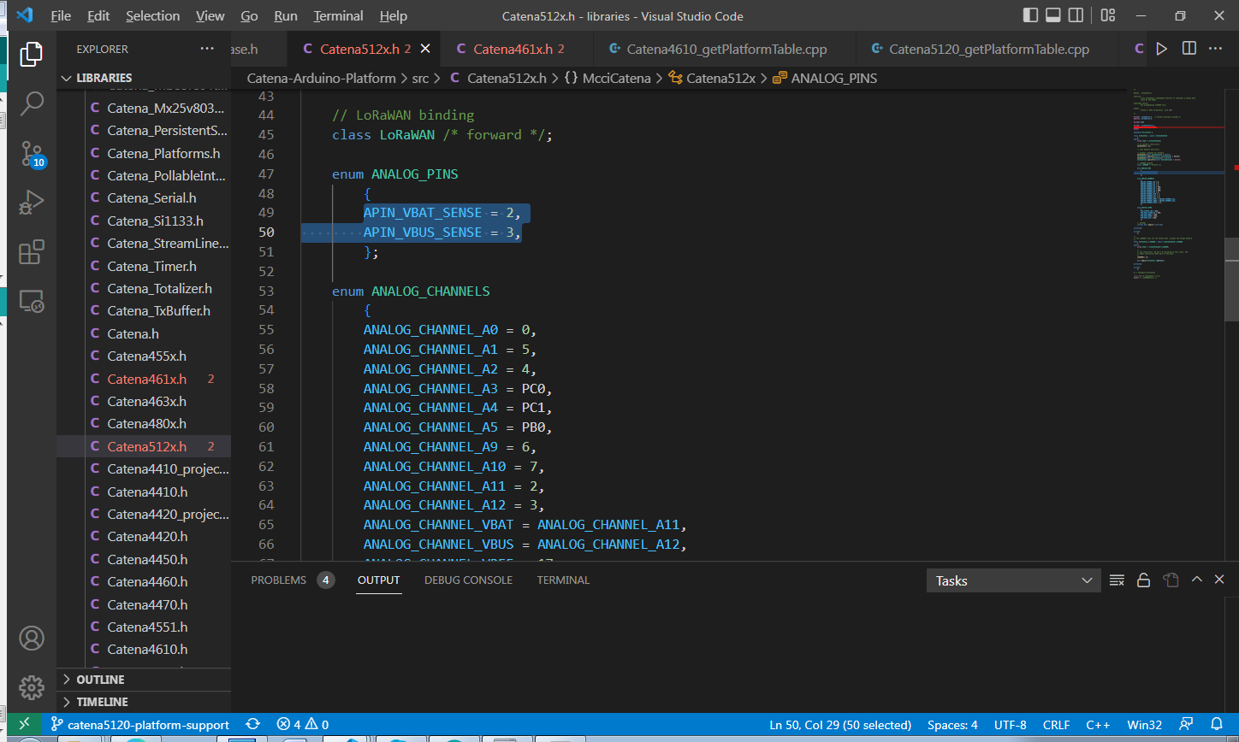

When we try to directly use the analog PIN number,

For example '2 and 3 is the analog PIN number for VBAT and VBUS instead of A11 and A12 analog name' respectively, both these sketches are compiling and producing our expected output.

