**Work/Task/Title:** Program to read data from oxygen sensor.

**Expected Result:** To compile the file and to get the required oxygen in volume percentage.

**Issue (Screenshot):**

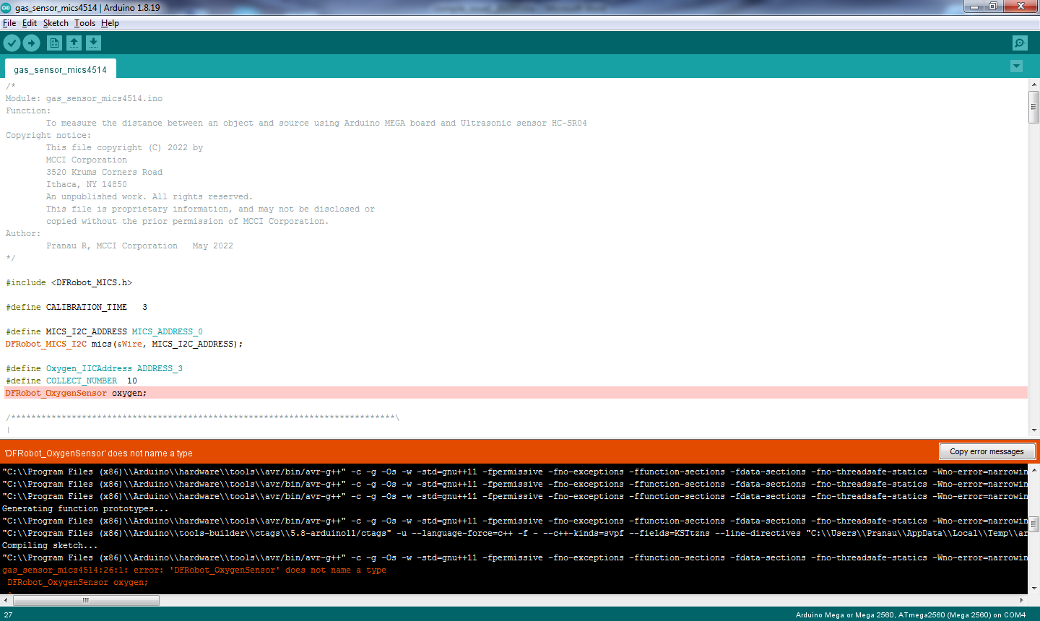

When trying to compile the sketch, it is giving an error message “does not name a type”. Compiling is un-done therefore it is a compile time error.

**Issue Log File:** compile_issue1_log1_20220516a.txt

**Issue Fix: (Screenshot)**

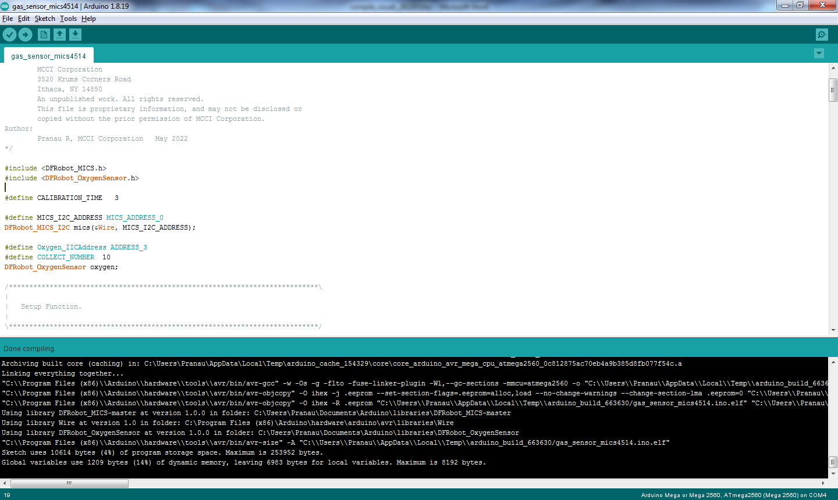

We forget to include the proper library in this sketch. Due to not adding the library and header files, the compiler throws an error. After including the proper library, it’s working as we expected.

**Issue Fix Log File:** compile_issue1_log1_fix_20220516a.txt

**Link Referred:**

[What does this mean; does not name a TYPE - Using Arduino / Programming Questions - Arduino Forum](https://forum.arduino.cc/t/what-does-this-mean-does-not-name-a-type/218547/5)