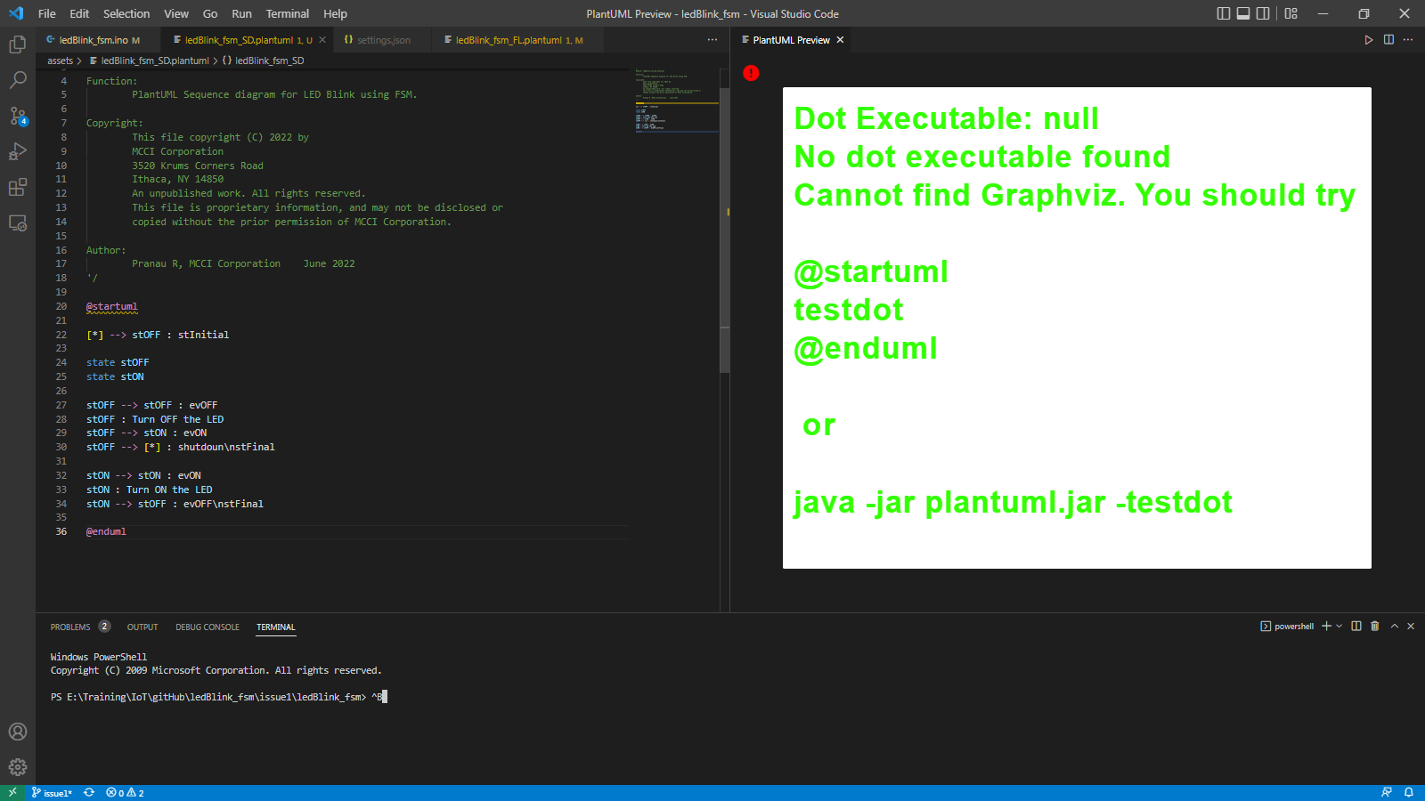

**Links Referred:**

* [Test your GraphViz installation (plantuml.com)](https://plantuml.com/graphviz-dot)
* [Frequently Asked Questions about installation (plantuml.com)](https://plantuml.com/faq-install)
* [PlantUML extension for Visual Studio Code on Windows only working with sequence diagrams - Stack Overflow](https://stackoverflow.com/questions/53856294/plantuml-extension-for-visual-studio-code-on-windows-only-working-with-sequence)
* [Can't render component diagram with PlantUML in IntelliJ - Stack Overflow](https://stackoverflow.com/questions/54413962/cant-render-component-diagram-with-plantuml-in-intellij)