**Work/Task/Title:** Plantuml state diagram for LED blink using FSM

**Expected Result:** To produce a preview image of the state diagram.

**Issue (Screenshot):**

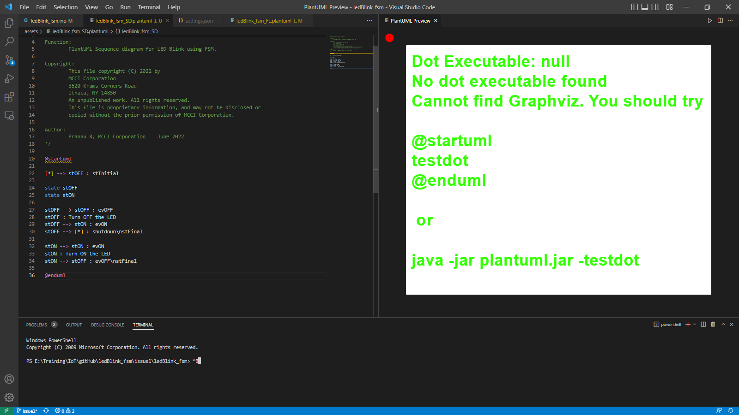

Instead of getting an preview for the state diagram plantuml program, we are getting an Error “Dot Executable: Null, No dot executable found cannot find Graphviz”.

**Links Referred:**

* [Test your GraphViz installation (plantuml.com)](https://plantuml.com/graphviz-dot)
* [Frequently Asked Questions about installation (plantuml.com)](https://plantuml.com/faq-install)
* [PlantUML extension for Visual Studio Code on Windows only working with sequence diagrams - Stack Overflow](https://stackoverflow.com/questions/53856294/plantuml-extension-for-visual-studio-code-on-windows-only-working-with-sequence)
* [Can't render component diagram with PlantUML in IntelliJ - Stack Overflow](https://stackoverflow.com/questions/54413962/cant-render-component-diagram-with-plantuml-in-intellij)

**Issue Fix (Screenshot):**

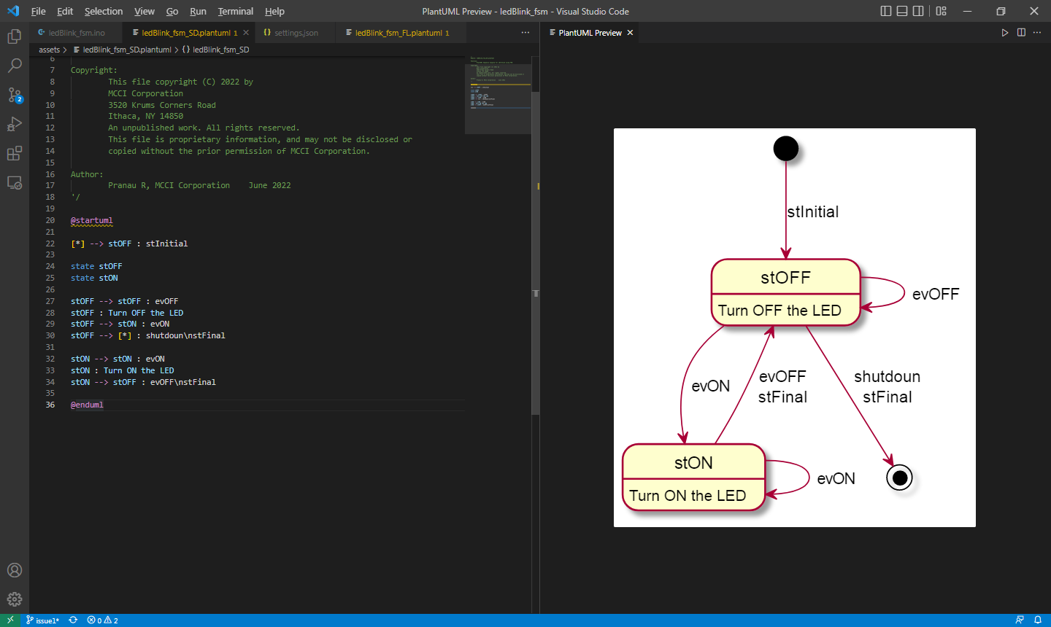

The above image is our expected output.

By doing the following steps, we attained this result.

1. Plantuml provides preview for activity diagram and sequence diagram without any additional support, but other plantuml diagrams like state diagram needs few other requirements.
2. Install the “Graphviz Interactive Preview” extension.

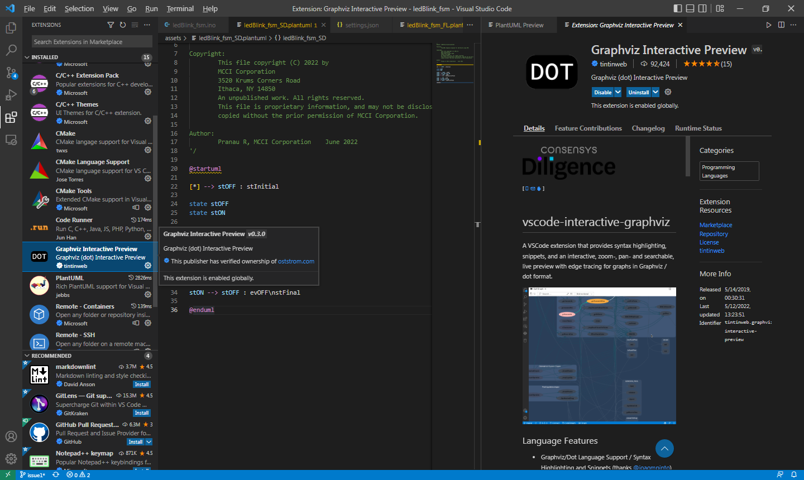

1. Go to the extension setting by clicking the settings icon given next to uninstall tab.

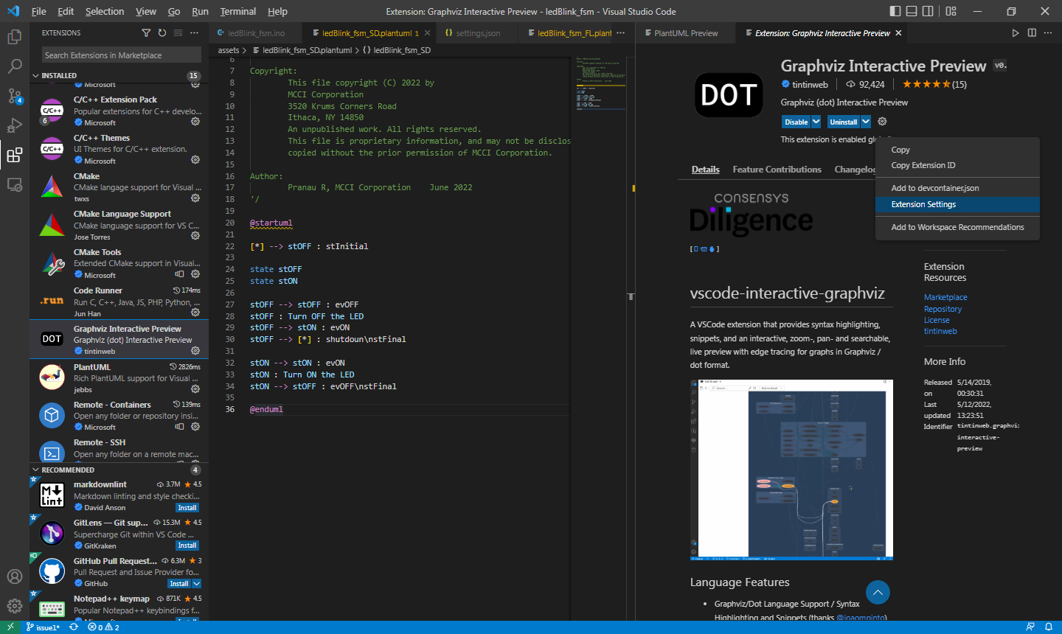

1. Inside the extension settings make the following changes;
2. Graphviz-interactive-preview: Render Lock (Uncheck this checkbox)
3. Graphviz-interactive-preview: Render Lock Additional Timeout = -1

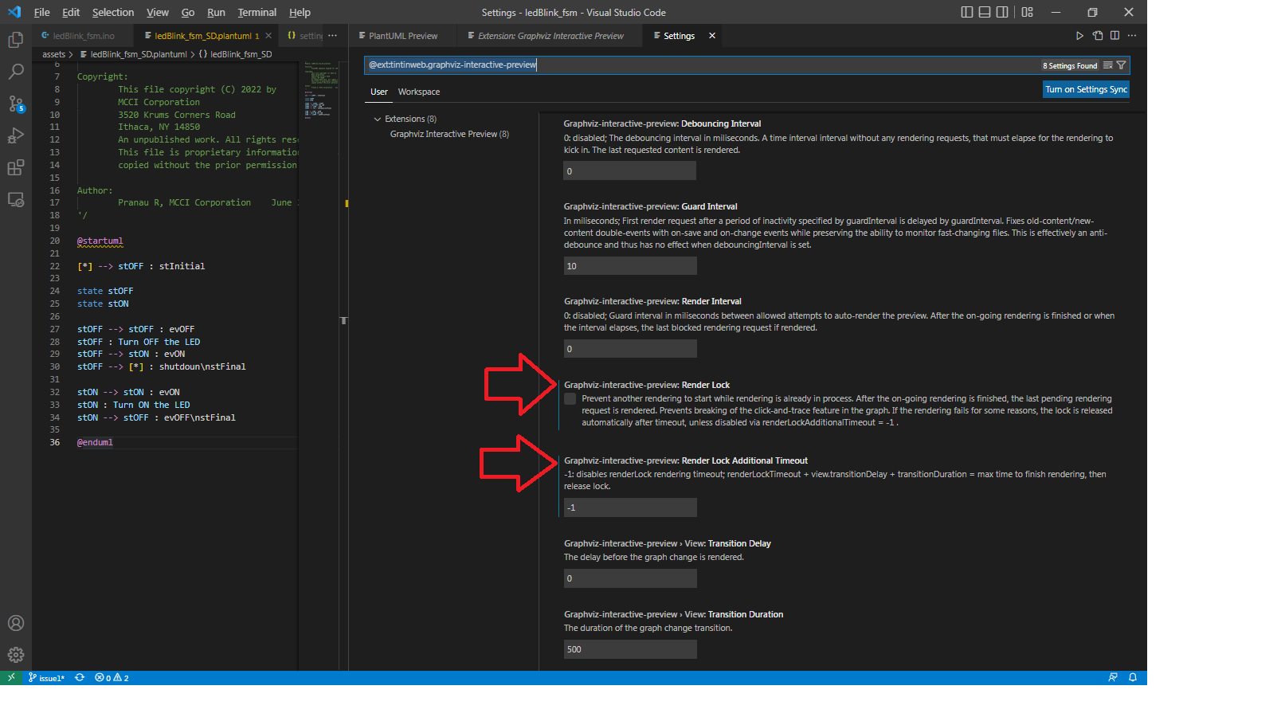

1. Now open the VSCode settings, and then Extensions.

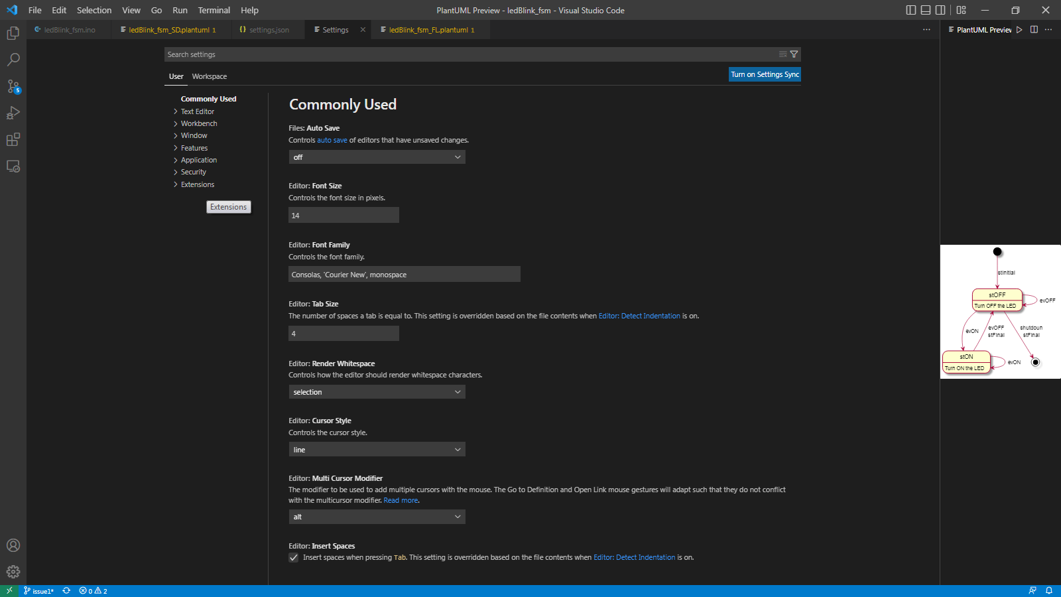

1. Inside extension, Click PLantUML Configuration.

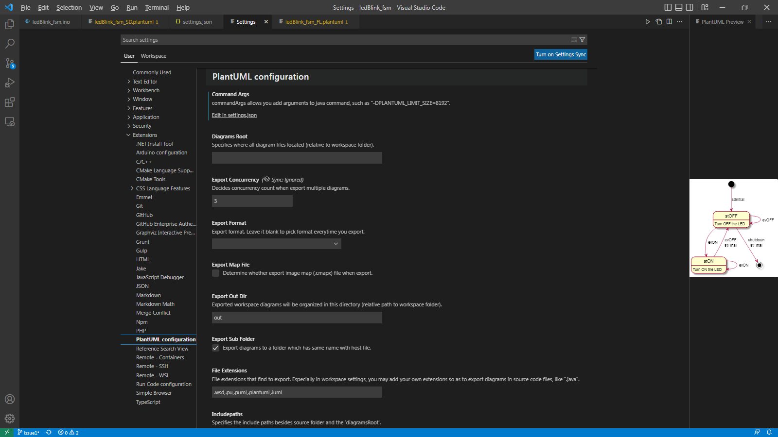

1. Now in Command Args, Click “Edit in settings.json”

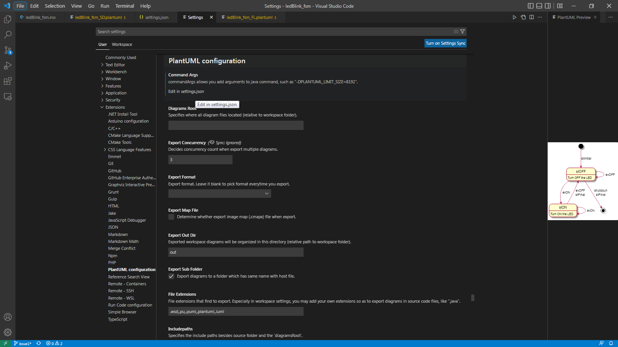

1. Then the settings.json will open in a new Tab. Inside the .json, provide a path for dot.exe file of Graphviz.

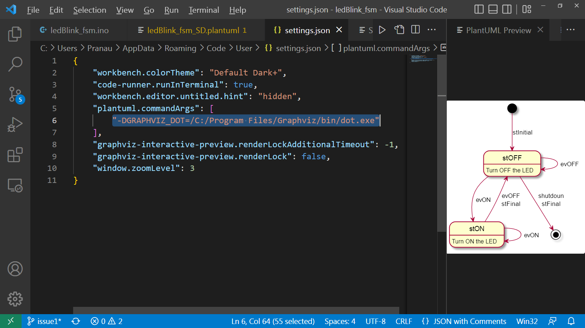

1. After providing the dot.exe path in Intelijsettings, open the User Environmental Variable Path and provide the proper dot.exe application path in there as well.

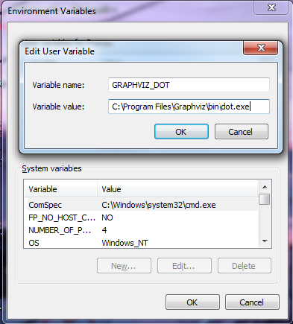

1. Thus by completing all the requirements, we get our Preview for the State Diagram.

