**Work/Task/Title:** Sketch to receive the data from transmitter board.

**Expected Result:** To compile and show the received data.

**Issue (Screenshot):**

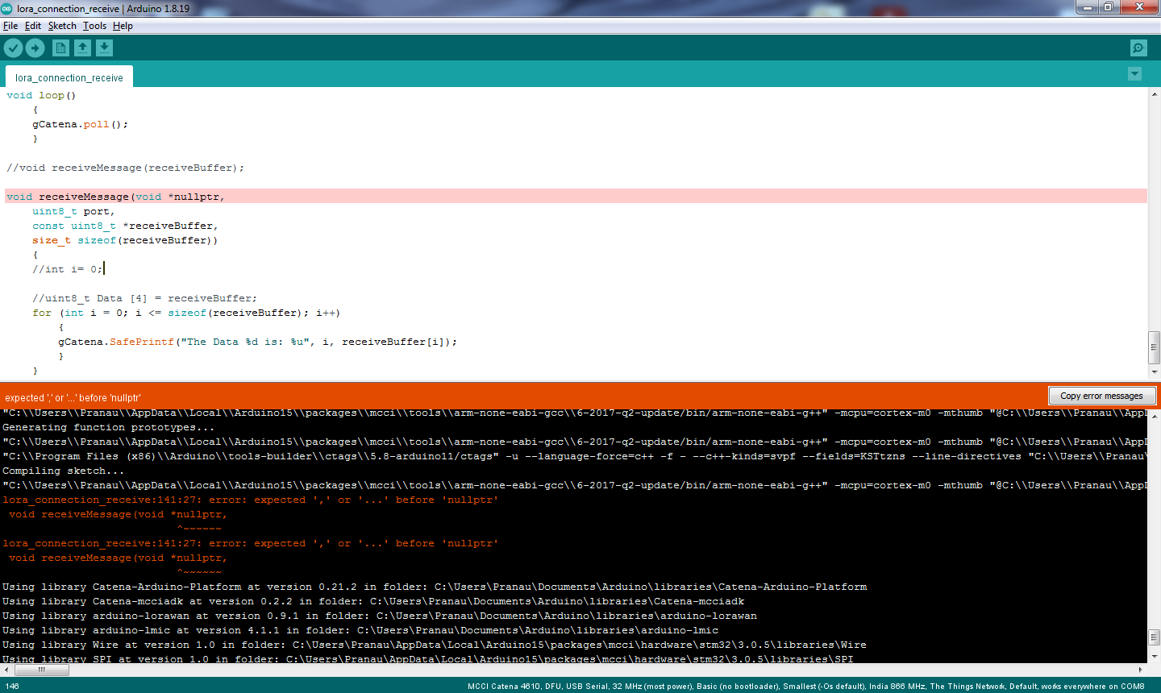

Instead of proper compiling, Here we are getting expected ‘,’ or ‘…’ before ‘nullptr’ error.

**Issue Log File:** compile_issue1_log_20220722a

**Issue Fix (Screenshot):**

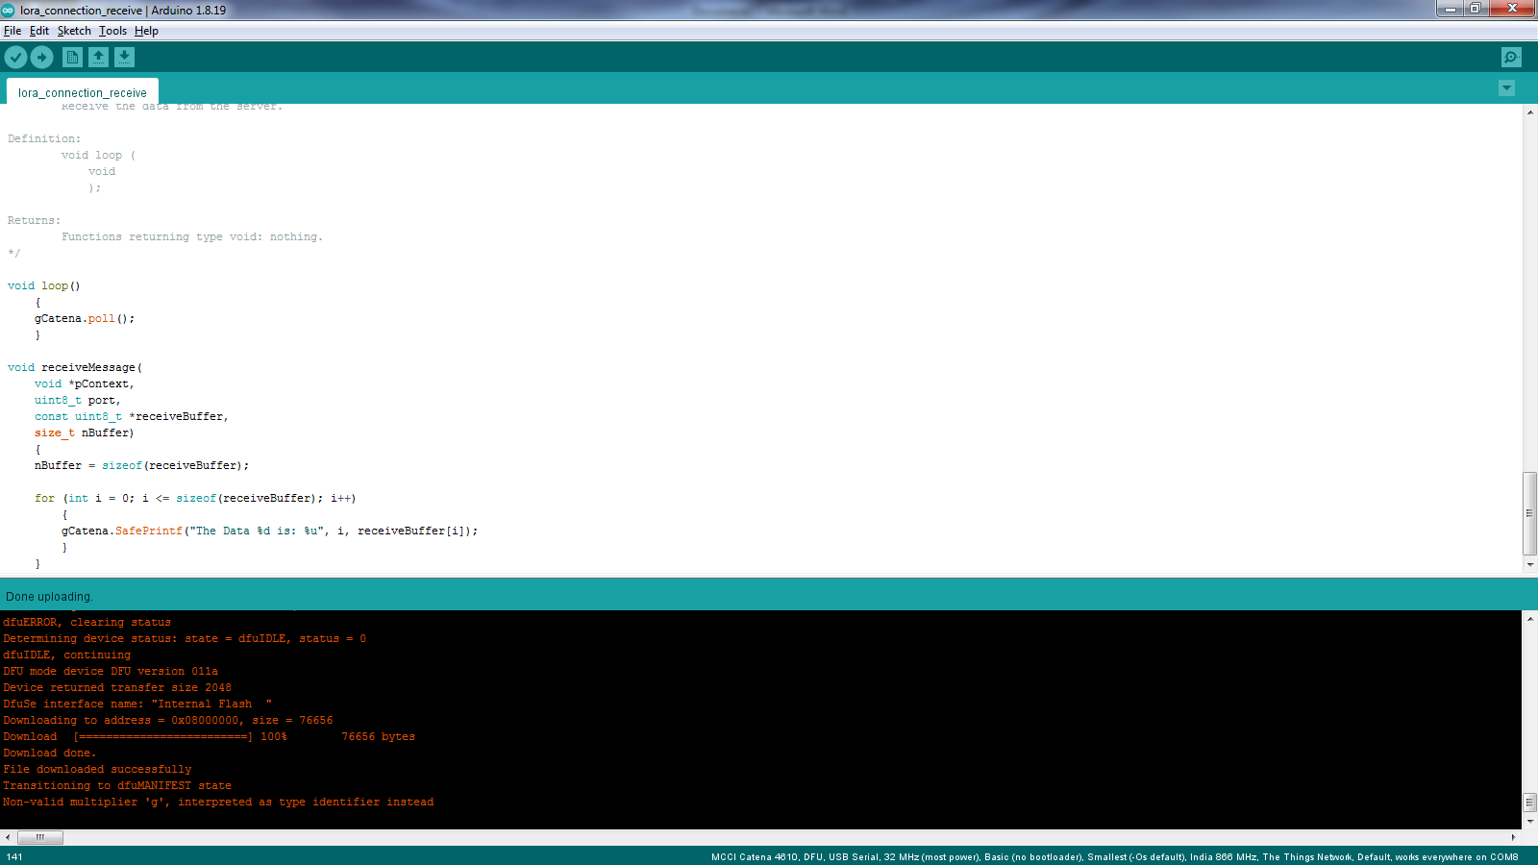

Earlier we were trying to pass a value as an argument instead of passing a variable in function definition.

For example: nullptr is equal to 0, so earlier we passed the value of pointer instead of passing a pointer.

Similarly passing sizeof(receiveBuffer) refers to a value. So instead of passing the value in a function definition, we used “nBuffer” which is a variable. Later in inside the function, we can assign nBuffer = sizeof(receiveBuffer).