**Work/Task/Title:** Program for reading oxygen measurement from oxygen sensor using Catena4610.

**Expected Result:** To get compiled and to read the measurement.

**Issue (Screenshot):**

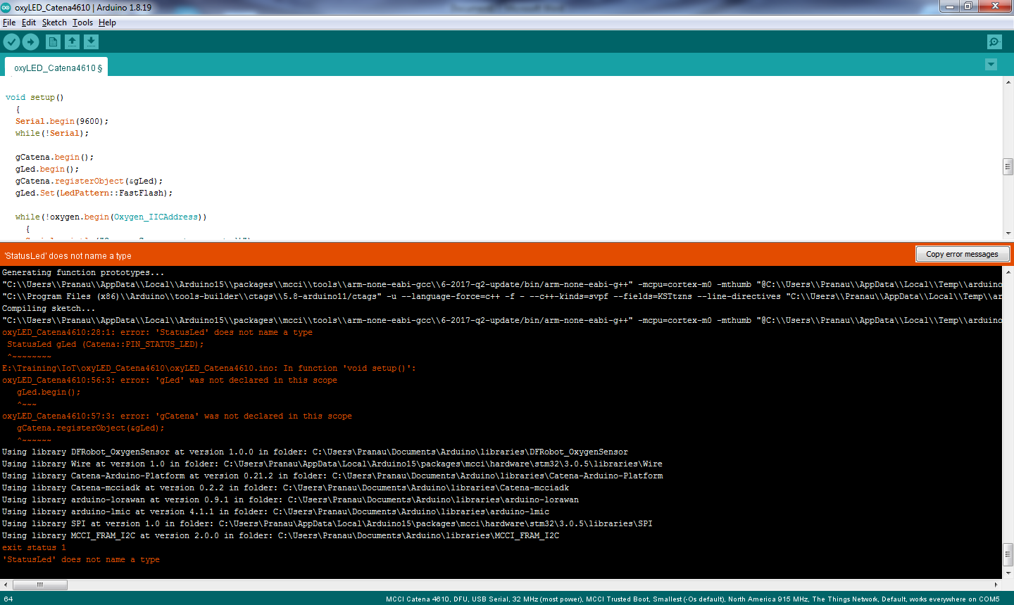

Instead of a proper compilation, we are getting a compile error stating an error message “does not name a type” and “was not declared in this scope” error.

**Issue Log File:**

* compile_issue1_log1_20220520a
* compile_issue1_log2_20220520a

**Issue Fix:**

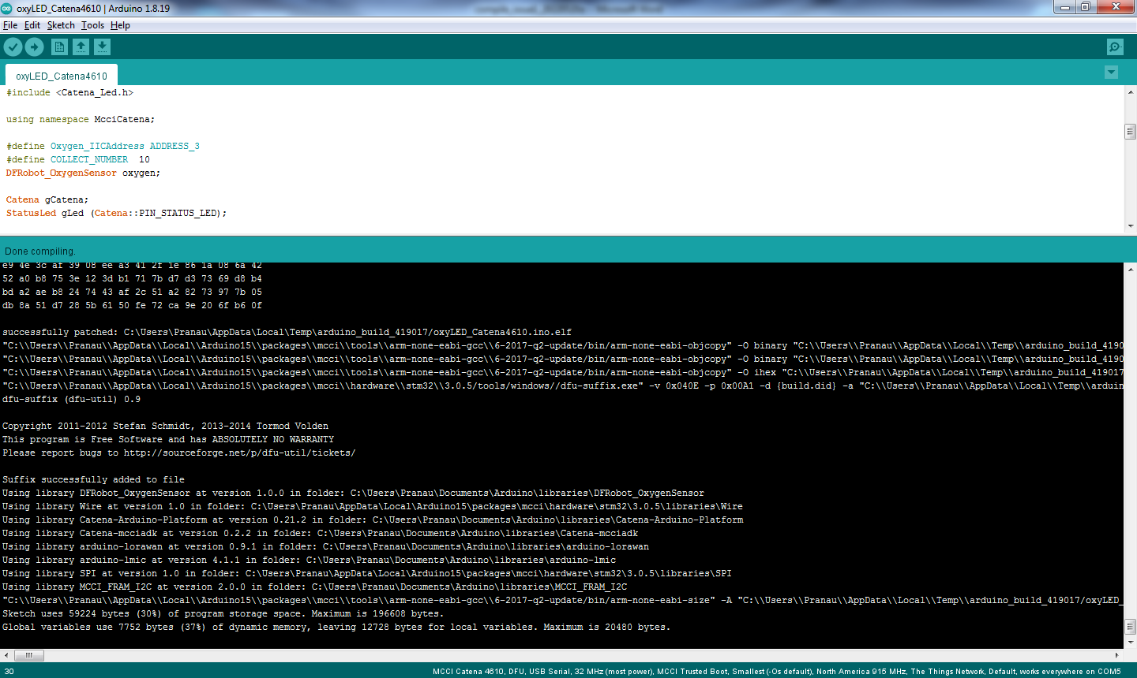

Earlier, we faced those issues because we were not using the namespace properly. Always a namespace have to be used right after including the necessary libraries and header files. Since we used namespace after declaring objects, the compiler throws an error such as “does not name a type” and “was not declared in this scope”.

**Issue Fix Log File:**

* compile_issue1_fix_log2_20220520a

**Links Referred:**

* [Why “using namespace std” is used after including iostream | by Danoja Dias | Break the Loop | Medium](https://medium.com/breaktheloop/why-using-namespace-std-is-used-after-including-iostream-dc5ae45db652)
* [What is the basic structure of a C++ program? (educative.io)](https://www.educative.io/edpresso/what-is-the-basic-structure-of-a-c-program)
* [What does 'using namespace std' mean in C++? (tutorialspoint.com)](https://www.tutorialspoint.com/What-does-using-namespace-std-mean-in-Cplusplus#:~:text=Using%20namespace%2C%20you%20can%20define,like%20containers%2C%20algorithms%2C%20etc.)