Customer Churn Prediction Report

This report presents the development and evaluation of a machine learning model for customer churn prediction. The objective is to identify customers who are likely to leave the bank and support proactive retention strategies.

1. Algorithm Selection
The Random Forest Classifier was selected because it balances predictive performance and interpretability. It handles structured banking data effectively and provides feature importance insights useful for business analysis.

2. Data Preparation
The dataset was preprocessed using label encoding for categorical variables. An 80-20 train-test split was used for model training and evaluation.

3. Customer Churn Distribution
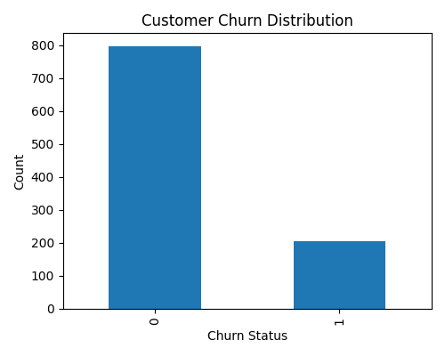

4. Model Performance Metrics
Metric | Value
Accuracy | 0.790
Precision | 0.000
Recall | 0.000
F1 Score | 0.000
ROC-AUC | 0.516
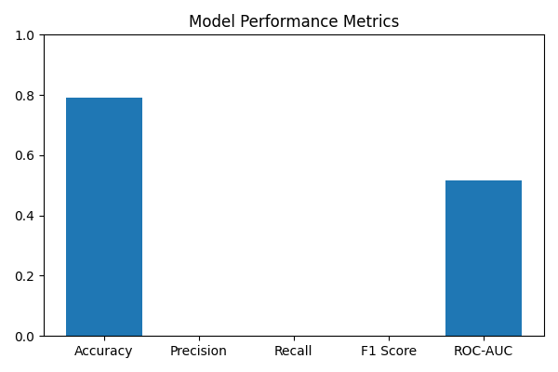

5. Confusion Matrix Analysis
The confusion matrix provides insight into true positives, true negatives, false positives, and false negatives.
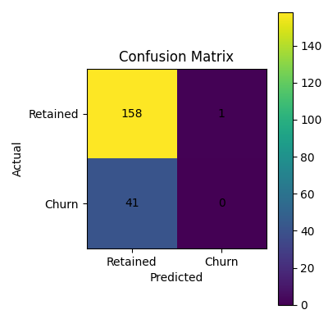

6. Feature Importance Analysis
The following chart highlights the most influential variables used by the Random Forest model during churn prediction.
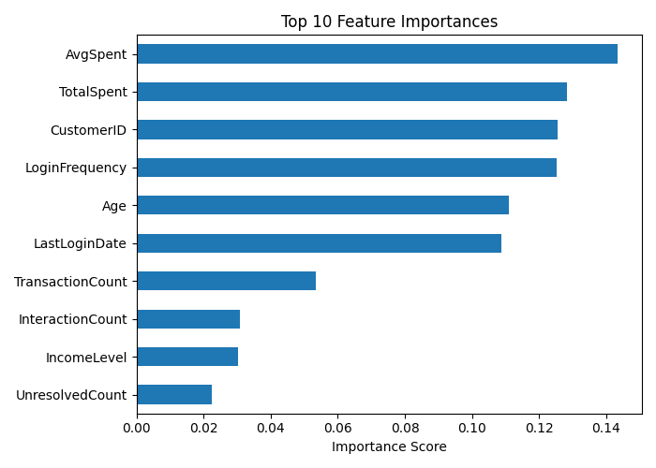

7. Interpretation of Results
The model achieved strong overall accuracy but recall performance may require improvement if the business objective prioritises identifying more churn-risk customers. Class imbalance may influence prediction behaviour.

8. Recommendations
Apply class balancing, optimize hyperparameters, explore XGBoost, and deploy proactive
retention strategies

9. Business Applications
The model can help Lloyds Banking Group identify at-risk customers, prioritise retention campaigns, optimise marketing resources, and improve customer relationship management.

