USER INTERFACE DESIGN

EXP.NO:1

TASK:TO TAKE A BAD DESIGNED USER INTERFACE FROM BROWSER AND MAKE A GOOD DESIGN USING FIGMA

REG.NO:230701235 DATE:25.01.2025

Bad design :

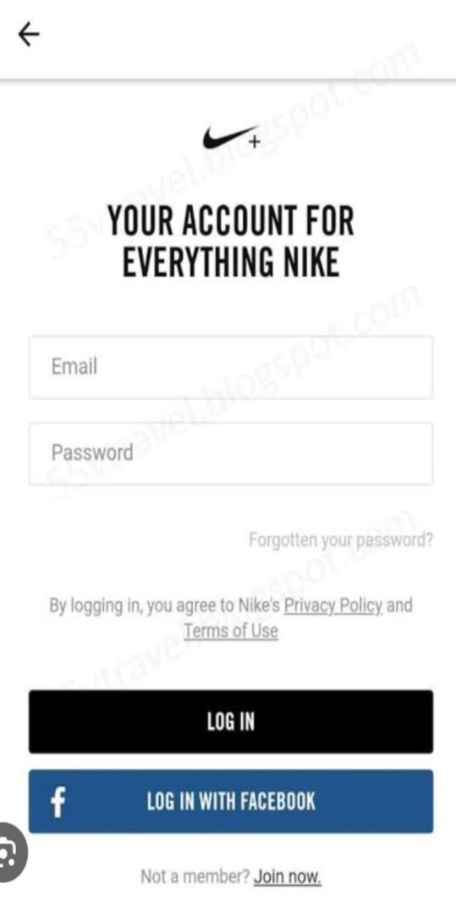

The color contrast between the text and background is poor, making it hard to read, especially for users with visual impairments.

Links like "Forgotten your password?" and "Join now" are too small, which makes them difficult to tap on mobile devices.

The buttons ("LOG IN" and "LOG IN WITH FACEBOOK") have equal weight visually, which might confuse users about the primary action to take.

Missing other login methods like Google or Apple, which are common and expected in modern login forms.

Insufficient spacing between elements makes the design feel cluttered and unpolished, reducing usability.

Good design:

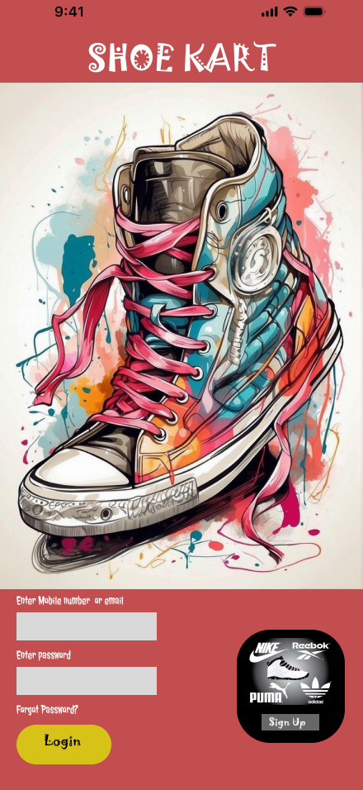

The colorful and artistic shoe graphic aligns with the brand identity and makes the interface more appealing, drawing the user's attention.

The title "SHOE KART" is prominently displayed, followed by the interactive fields and buttons, creating a logical flow for users to follow.

The background colors and button design stand out while maintaining readability. The yellow "Login" button contrasts well with the red background, making it easy to locate.

The inclusion of a custom shoe illustration adds a unique, creative touch, making the app or website feel less generic and more tailored to its purpose.

The input fields and button are larger and more spaced out, making them easier to interact with on both desktop and mobile devices.