# **AI Image Generators – Comparative Research**

## **Task 1: Comparative Research**

### **AI Image Generators Compared**

* **DALL·E 3** (by OpenAI)
* **Leonardo AI**

**DALL-E**

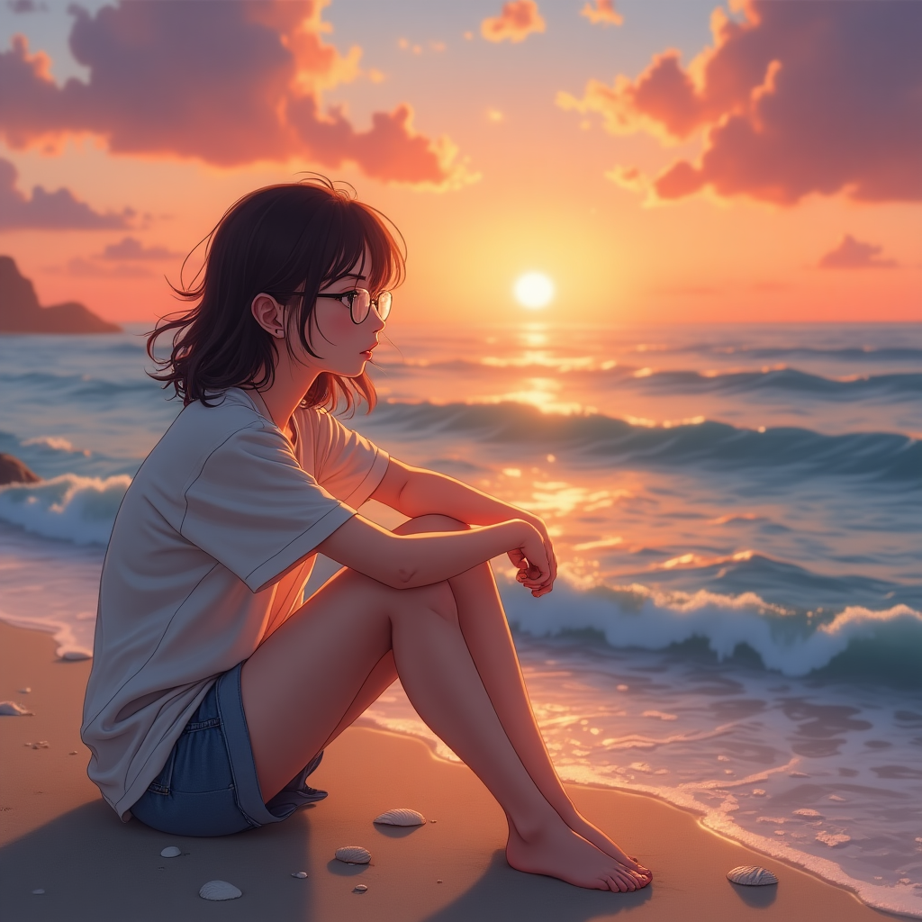

**LEONARDO AI**

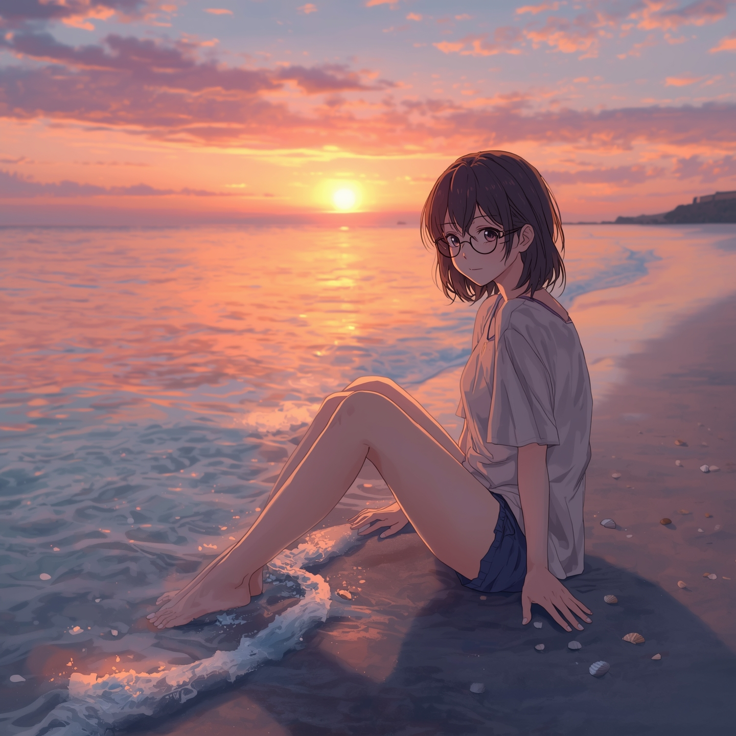

**1. Image Quality**

| **Criteria** | **DALL·E 3** | **Leonardo AI** |
| --- | --- | --- |
| **Overall Output** | High-quality, clean, and consistent images | High-quality, often more detailed and artistic |
| **Resolution** | Moderate resolution, optimized for general use | Higher resolution available with customization |
| **Best Use Case** | Illustrations, portraits, general content | Concept art, fantasy, gaming, stylized artwork |

**Conclusion:** *Leonardo AI* offers richer artistic detail; *DALL·E 3* is more stable and consistent.

**2. Prompt Accuracy**

| **Criteria** | **DALL·E 3** | **Leonardo AI** |
| --- | --- | --- |
| **Prompt Understanding** | Excellent natural language interpretation | High accuracy but more sensitive to wording |
| **Limitations** | Filters out sensitive content | Fewer filters, but still moderated |

**Conclusion:** *DALL·E 3* provides better prompt fidelity and is more user-friendly for complex descriptions.

## **3. Style Flexibility**

| **Criteria** | **DALL·E 3** | **Leonardo AI** |
| --- | --- | --- |
| **Style Variety** | Offers a range of styles (photo, sketch, art) | Offers wide aesthetic range (anime, sci-fi, realism) |
| **Creative Styles** | Subtle and moderate | Very stylized and flexible |

**Conclusion:** *Leonardo AI* excels in creative diversity and customizability.

## **4. Usability**

| **Criteria** | **DALL·E 3** | **Leonardo AI** |
| --- | --- | --- |
| **Ease of Use** | Very easy to use (via ChatGPT) | User-friendly but requires more setup |
| **Prompt Support** | Strong natural language assistance | Offers more manual customization |

**Conclusion:** *DALL·E 3* is ideal for beginners; *Leonardo* suits users with creative or technical needs.

## 

## **5. Licensing & Terms**

| **Criteria** | **DALL·E 3** | **Leonardo AI** |
| --- | --- | --- |
| **Ownership** | Users own the generated images | Users own outputs; subject to model licensing terms |
| **Commercial Use** | Allowed with ChatGPT Plus | Allowed (some terms may vary) |
| **Content Restrictions** | More content filtering | Less restrictive but still monitored |

**Conclusion:** Both support commercial use; *Leonardo AI* is more flexible but requires attention to model licenses.

## **Final Evaluation**

| **Category** | **Best Performer** |
| --- | --- |
| Image Quality | Leonardo AI |
| Prompt Accuracy | DALL·E 3 |
| Style Flexibility | Leonardo AI |
| Usability | DALL·E 3 |
| Licensing & Terms | Tie (case-dependent) |

## **Recommendation**

* Use **DALL·E 3** for accurate, clean, and simple image generation with easy usability.
* Choose **Leonardo AI** for complex creative work, fantasy art, or custom-styled visual content.