1. **What exactly is []?**

**Ans:** ‘[]’ is called as square brackets. In Python, these are used to enclose all the items represented in a list. Any items that need to be added into a list will be enclosed with a [ ], stating that all the items which are inside ‘[ ]’ comes under that list.

1. **In a list of values stored in a variable called spam, how would you assign the value 'hello' as the third value? (Assume [2, 4, 6, 8, 10] are in spam.)**

**Ans:** spam.insert(‘hello’,2)

**Note:** Let's pretend the spam includes the list ['a', 'b', 'c', 'd'] for the next three queries.

1. **What is the value of spam[int(int('3' * 2) / 11)]?**

**Ans:** spam[int(int('3' * 2) / 11)] = ‘d’

1. What is the value of spam[-1]?

Ans: spam[-1]=’d’

1. What is the value of spam[:2]?

Ans: spam [:2] = [‘a’,’b’]

**Note:** Let's pretend bacon has the list [3.14, 'cat,' 11, 'cat,' True] for the next three questions.

1. What is the value of bacon.index('cat')?

Ans: 1

1. How does bacon.append(99) change the look of the list value in bacon?

Ans: The length bacon list will be increased by a value 1 and another integer value ‘99’ will be added into the list at the last index.

1. How does bacon.remove('cat') change the look of the list in bacon?

Ans: The value given in the remove function will be removed from the list ( in this case, the value ‘cat’ 1from the list named bacon) making it to reduce the length of list by 1 and you can’t able to see the value ‘cat’ in future when you are referring the list in any of the lines of code.

1. What are the list concatenation and list replication operators?

Ans: List concatenation (+) is used to add/ combine two different/same list each other. List replication operator (*) is used to replicate the same list multiple times.

Ex: 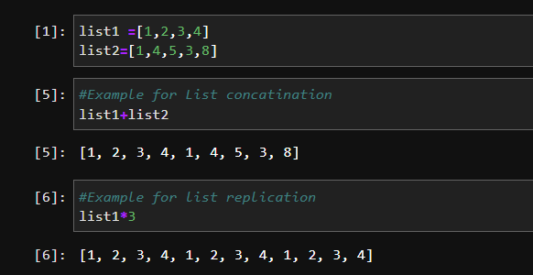

1. What is difference between the list methods append() and insert()?

Ans: List.append()- used to add any value in the list at the last index.

List.index()- used to add any value in the list at any index mentioned inside the method variable.

Ex: 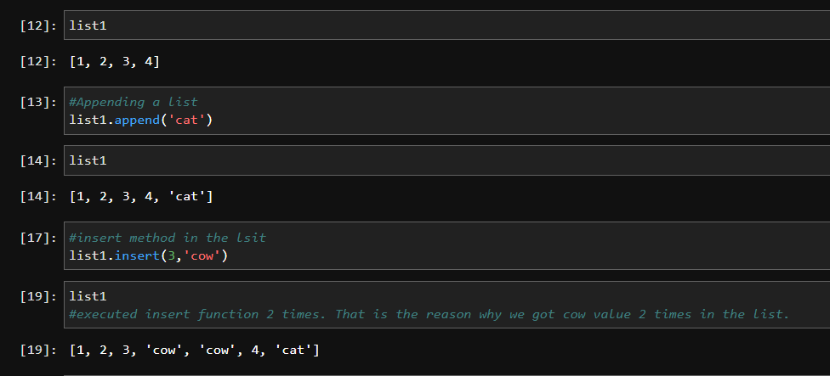

1. What are the two methods for removing items from a list?

Ans: list.pop() and list. Remove()

Ex:

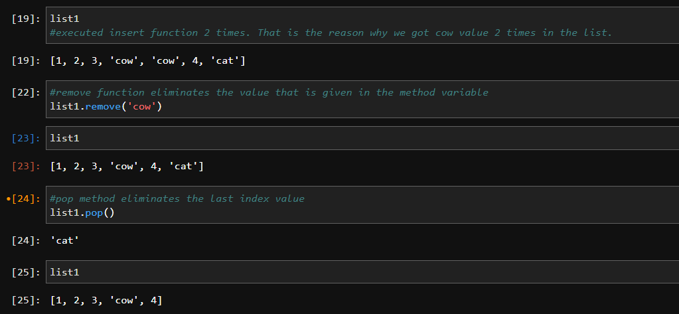

1. Describe how list values and string values are identical.

**Ans:** Every element in the list and every character in the string will be represented as one index.

1. What's the difference between tuples and lists?

**Ans:** Tuples are immutable where once you created a tuple, you cannot be able to change/ modify the data inside it. Whereas in case of list, you can do updates in the list whenever and wherever is required. The data in the list will be enclosed with square brackets “[]” and tuples will be enclosed in normal braces “()”.

1. How do you type a tuple value that only contains the integer 42?

**Ans:**  Step 1: create a tuple variable.

Step2 : Add integer value 42 inside the tuple.

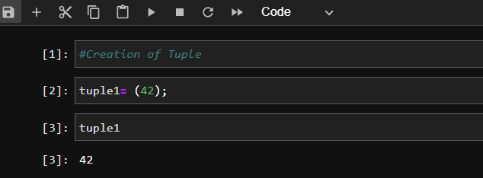

1. How do you get a list value's tuple form? How do you get a tuple value's list form?

**Ans:** You can covert data from list to tuples or vice versa by inserting the list/ tuple in the respective function as an attribute. Below is an example for better understanding from Jupyter notebook. .   
  
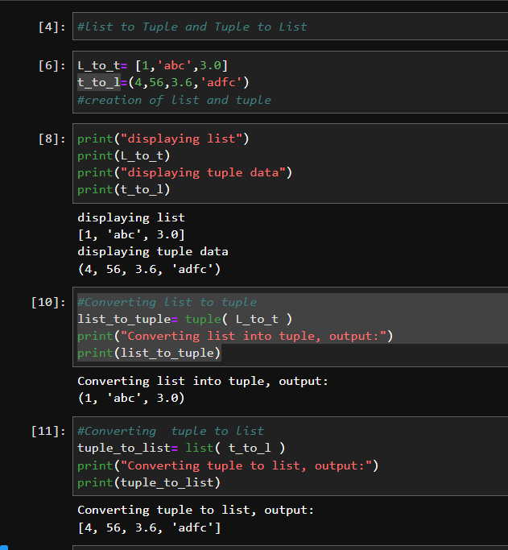

1. Variables that "contain" list values are not necessarily lists themselves. Instead, what do they contain?

**Ans:** Variables that contain list values contains the reference of the list value instead of coming as a copy. When you change the value in the list, then it’ll reflect the same in the variable that contains list value.  
  
**Ex:** 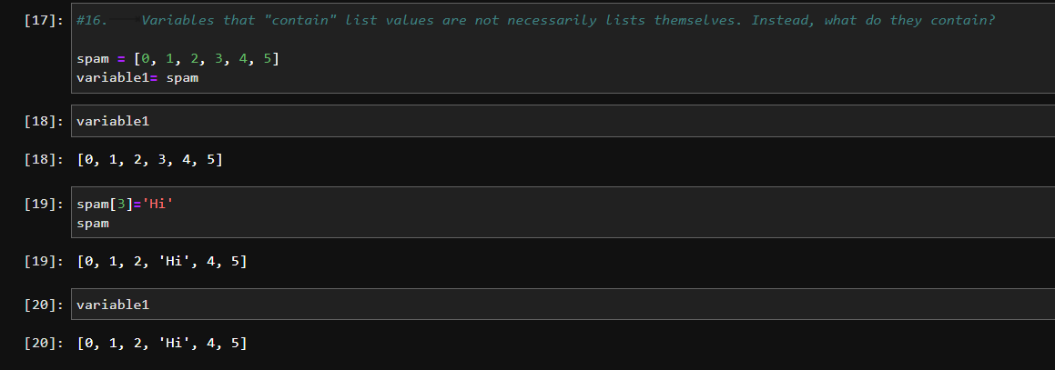

1. How do you distinguish between copy.copy() and copy.deepcopy()?

**Ans**: deepcopy() refers to only take the copy of the element ( variable/ list/ dictionary). When we update any values in deepcopy variable, this will not update any values in original variable. Whereas in copy(), the variables take reference of that parent variable and it’ll get updated whenever we do changes in the copy variable.

**EX:**

