SYNOPSIS

TE DIV : TE1 **GROUP NO. : T1_3**

**TITLE : AUTO DRIVING TEMPERATURE AND HUMIDITY SENSING ROBOT USING ARDUINO**

# OBJECTIVES :

* To design and construct an auto-driving robot platform using Arduino.
* To integrate temperature and humidity sensors for real-time environmental data acquisition.
* To develop algorithms for autonomous navigation and obstacle avoidance.
* To implement cloud storage integration for logging temperature and humidity data.

|  |  |  |  |
| --- | --- | --- | --- |
| Roll No. | Name of student | Email ID | Mob. No |
| E3106 | ANDHALE ADITYA | [adityaandhale.skn.entc@gmail.com](mailto:adityaandhale.skn.entc@gmail.com) | 7507904590 |
| C31118 | PRANAV DUMBRE | [pranavdumbre.skn.comp@gmail.com](mailto:pranavdumbre.skn.comp@gmail.com) | 9307751010 |

**INTRODUCTION :** The auto-driving temperature and humidity sensing robot we've developed leverages Arduino technology and integrates three infrared (IR) sensors, an ESP8266 WiFi module, and a DHT11 temperature and humidity sensor. This combination provides a comprehensive solution for environmental monitoring and wireless data transmission. The IR sensors play a crucial role in obstacle detection and navigation, ensuring the robot can maneuver safely in diverse environments. The ESP8266 WiFi module enables seamless wireless communication, empowering the robot to transmit collected data to remote servers or cloud platforms in real-time for monitoring and analysis. Additionally, the inclusion of the DHT11 sensor enhances the robot's capability to gather precise temperature and humidity readings, enriching its environmental sensing capabilities. Our robot offers a versatile solution applicable to various domains, including smart homes, industrial automation, agriculture, and research.

# BLOCK DIAGRAM:

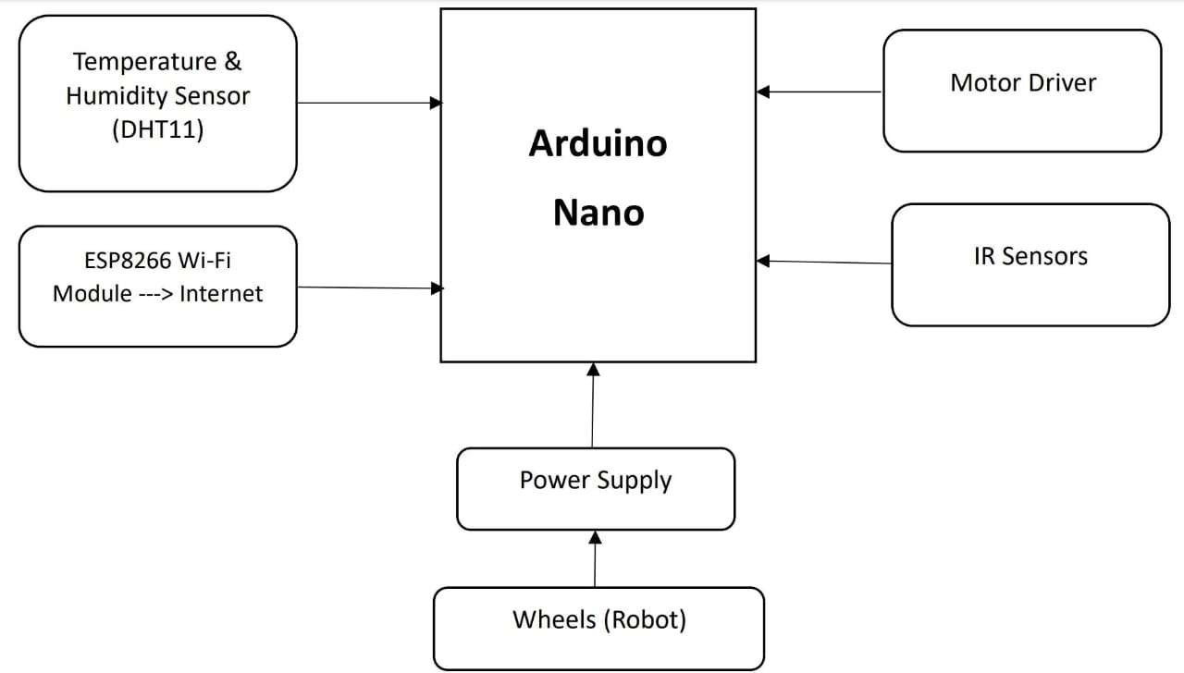

Figure 1 : Block Diagram of auto driving temperature and humidity sensing robot using Arduino

# BLOCK DIAGRAM DESCRIPTION :

The auto-driving temperature and humidity sensing robot, akin to the automatic door opening system, is designed with a focus on sensor-based automation and environmental monitoring. Utilizing Arduino as the central processing unit, the robot integrates three infrared (IR) sensors for obstacle detection and navigation, alongside an ESP8266 WiFi module for wireless communication. This enables the transmission of real-time data, including temperature and humidity readings, to remote servers or cloud platforms. Additionally, the inclusion of the DHT11 temperature and humidity sensor enhances the robot's ability to monitor environmental conditions accurately. Through the seamless integration of these components, the robot offers a versatile solution for autonomous operation and environmental sensing across various applications.

# ADVANTAGES & APPLICATIONS :

* Efficiency : By autonomously navigating environments and collecting real-time environmental data, the robot streamlines operations and contributes to optimized processes.
* Maintenance Optimization : Continuous monitoring of environmental conditions enables proactive maintenance interventions, minimizing downtime and reducing the risk of equipment damage.
* Data-driven Decision Making : Cloud-based data storage facilitates real-time data transmission for analysis, empowering stakeholders to make informed decisions based on actionable insights.
* Safety Enhancement : Real-time monitoring of temperature and humidity levels enhances safety by detecting and alerting to unsafe conditions, mitigating risks in industrial environments.

**CONCLUSION :** The auto-driving temperature and humidity sensing robot using Arduino project seeks to revolutionize environmental monitoring with autonomous navigation and real- time data collection. Its potential in industrial settings promises to optimize efficiency and compliance, opening doors to widespread adoption across industries.

# Submitted By :

|  |  |  |
| --- | --- | --- |
|  | Roll No. | Name |
| 1. | E3106 | ANDHALE ADITYA ANIL |
| 2. | C31118 | PRANAV SURESH DUMBRE |

Ms.A.R. Lokhande

# Mini-Project Guide

Mrs. S.S. Jahagirdar/Ms. K.A. Pujari

# Mini-Project Coordinator

Dr. S. K. Jagtap

# Head

**Dept. of E & TC Dept. of E & TC Dept. of E & TC**