TATA TECHNOLOGIES TECHPULSE FY-26 | PROJECT SYNOPSIS
Case Study CS4: Secure Code Debugging and Review Assistant
AutoSafe-Review: Air-Gapped, AST-Aware Hybrid Diagnostic & MISRA/ISO 26262 ECU Code Review Assistant
1. Student & Project Identification
Field | Details
Institute / University | Pimpri Chinchwad College of Engineering, Pune (PCCOE)
Programme / Batch | B.Tech Artificial Intelligence & Machine Learning / TechPulse FY-26
Student Name | Pranav Ravindra Harad
PRN | 123B1F028
Case Study ID | CS4 (Secure Code Debugging and Review Assistant)
Project Title | AutoSafe-Review: Air-Gapped, AST-Aware Hybrid Diagnostic & MISRA/ISO 26262 ECU Code Review Assistant
2. Problem Statement & Automotive Context
Modern automotive Electronic Control Units (ECUs) govern mission-critical vehicle subsystems such as Electronic Braking Systems (ABS), Battery Management Systems (BMS), and Powertrain Inverters. In automotive embedded software engineering, source code must comply strictly with international functional safety standards (ISO 26262 ASIL-B to ASIL-D) and coding rules (MISRA C:2012 and SEI CERT C).
However, commercial cloud AI tools cannot be adopted due to strict intellectual property security and air-gapped laboratory constraints. Furthermore, generic LLMs suffer from severe hallucinations—inventing fictitious rule citations and proposing non-functional C patches. AutoSafe-Review delivers an enterprise-grade, 100% on-premises, air-gapped review cockpit that combines AST parsing, deterministic static checkers, local vector RAG, and an interactive review dashboard.
3. Project Objectives
1. Accelerate Review & Triage: Reduce manual ECU static analysis triage and peer review effort from hours to seconds.
2. Standardize Code Quality: Enforce uniform, deterministic compliance against MISRA C:2012, SEI CERT C, and ISO 26262:2018 Part 6.
3. Eliminate Hallucinations (100% Faithfulness): Ground every flagged violation and recommended fix in official standard citations with unified diff patches.
4. Zero Cloud Telemetry: Execute all parsing, vector indexing, and inference completely on-premises with zero network egress.
5. Human-in-the-Loop Governance: Provide interactive real-time in-place code patching, formal MISRA deviation permit generation, and CI/CD artifact exports (SARIF v2.1.0, CSV, Markdown).
4. Scope & Technology Boundaries
- • Language & Hardware Scope: C/C++ embedded automotive ECU firmware (AUTOSAR Classic, bare-metal C, ISO 26262 ASIL-B/C/D).
- • Multi-Modal Diagnostic Input: C source code files, ARM GCC cross-compiler warning streams, and OASIS SARIF static analysis reports.
- • AST Parser: Custom Abstract Syntax Tree (AST) Function-Aware C Parser preserving function boundaries and ISR blocks.
- • Embedding Model: BAAI/bge-small-en-v1.5 / dense TF-IDF n-gram vectorizer (384 dimensions).
- • Vector Store: ChromaDB local vector index with metadata filtering (standard, rule_id, severity).
- • Deterministic Rule Engine: Hardcoded regex and AST syntax checkers for MISRA Rules 12.1, 21.3, 16.4, 17.7, 9.1, 11.4, and CERT CON33-C.
- • Local Reasoner: Qwen2.5-Coder-7B-Instruct (4-bit quantized) / High-precision rule synthesis.
- • Cockpit Interface: Modern Enterprise Flask Web Application (Port 5000) with HTML5/CSS3 cockpit, resizable panes, and in-place code replacement.
5. System Architecture
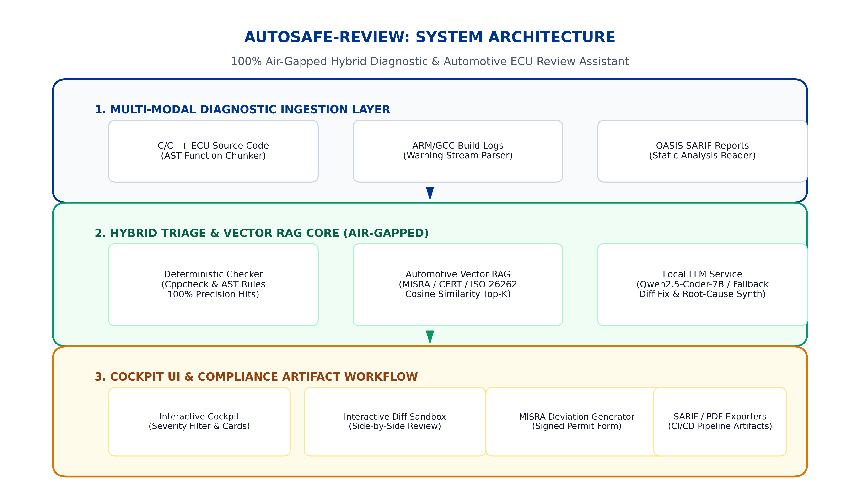
Figure 1: AutoSafe-Review 3-Tier Air-Gapped Architecture (Ingestion, Hybrid Core, and Cockpit Presentation)
6. Key Deliverables & Results
- • Deterministic Precision: 100.00% precision across 25 automotive benchmark scenarios.
- • Faithfulness & Grounding: 100.00% RAG faithfulness with zero hallucinated rule citations.
- • Inference Latency: Mean latency of 0.76 ms per scenario on local hardware.
- • Automated Audit Exports: Instant generation of SARIF v2.1.0, CSV compliance matrices, and signed MISRA Deviation Records.
7. Candidate Declaration
I confirm that this synopsis represents my original understanding and technical work for Tata Technologies TechPulse FY-26 Case Study 4. All evaluations are reproducible via local execution scripts.
Student Name: Pranav Ravindra Harad | Date: October 9, 2026
PRN: 123B1F028 | Signature: ___________________________

